Math Objectives  - Students will determine if a function is invertible.  - Students will find the inverse of an exponential function.  - Students will determine the symmetry of an exponential function and its corresponding logarithmic function.  Vocabulary  - line reflections  - symmetry  - logarithmic function  - exponential function  - inverse functions  About the Lesson  In this activity, students will investigate the inverse of an exponential function by observing a scatterplot. Students will determine that the inverse of an exponential function is a logarithmic function. As a result, students will:  - Analyze the function $f\left(x\right)=2^{x}$, its corresponding inverse function $g\left(x\right)=\log_{2}x$, and their reflection about the line $y=x$.  - Analyze the function $f\left(x\right)=e^{x}$, its corresponding inverse function $g\left(x\right)=lnx$, and their reflection about the line $y=x$.  - Graph the function $f\left(x\right)={10}^{x}$ and its corresponding inverse function $g\left(x\right)=logx$.  TI-Nspire™ Navigator™  - Send the TI-Nspire document to students.  - Use Class Capture to view and discuss the graphs.  - Use Quick Poll questions to adjust the pace of the lesson according to student understanding.  Activity Materials  - Compatible TI Technologies: TI-Nspire™ CX Handhelds,  TI-Nspire™ Apps for iPad®,  TI-Nspire™ Software |  | 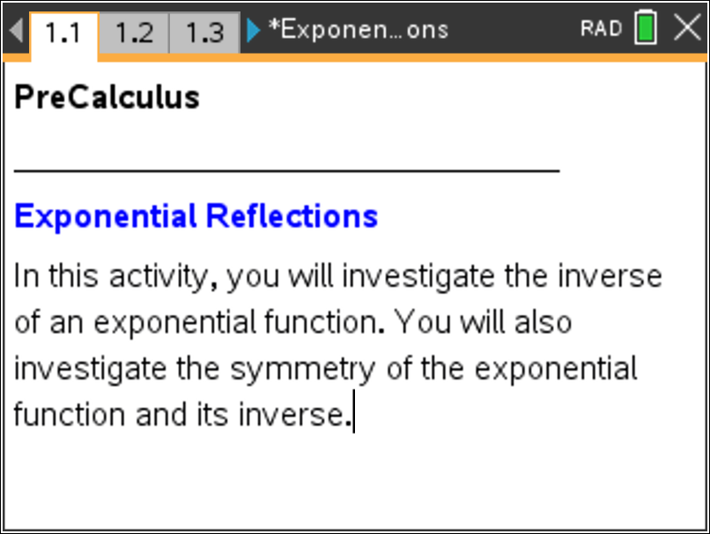  Tech Tips:  - This activity includes screen captures taken from the TI- Nspire CX handheld. It is also appropriate for use with the TI-Nspire family of products including TI-Nspire software and TI-Nspire App. Slight variations to these directions may be required if using other technologies besides the handheld.  - Watch for additional Tech  Tips throughout the activity for the specific technology you are using.  - Access free tutorials at  http://education.ti.com/calcul ators/pd/US/Online- Learning/Tutorials  Lesson Files:  Student Activity  - Exponential_Reflections_Student.pdf  - Exponential_Reflections _Student.doc  TI-Nspire document  - Exponential_Reflections.tns
Open the TI-Nspire document Exponential_Reflections.tns  In this activity, you will investigate the inverse of an exponential function. You will also investigate the symmetry of the exponential function and its inverse. | 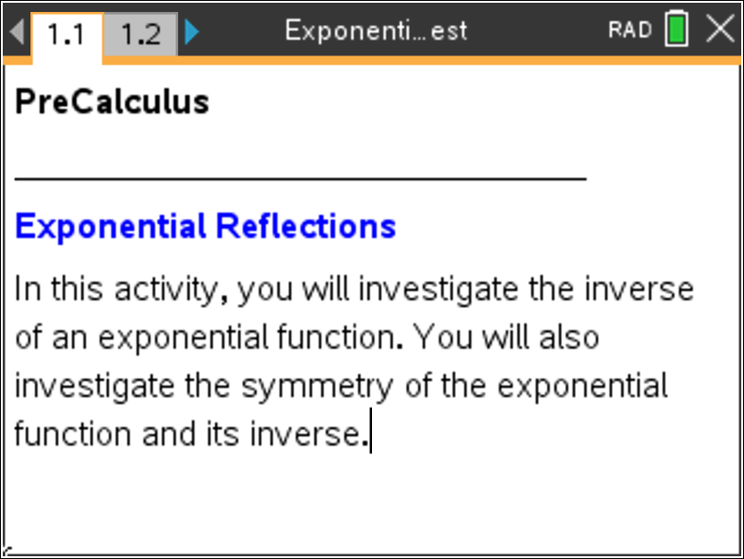
Move to page 1.2.

Problem 1 – Reflecting an Exponential Function
1. The exponential function $f\left(x\right)=2^{x}$ is displayed.  A function is invertible if each output value is mapped from a unique input value. Is the function $f\left(x\right)=2^{x}$ invertible? What would the inverse of this graph look like? Sketch the function $y=2^{x}$ and its inverse on the grid to the right.  Answers: Yes, the function $f\left(x\right)=2^{x}$ invertible. Since the graph of the function $f\left(x\right)=2^{x}$ is increasing, concave up and has a horizontal asymptote of $y=0$, the inverse graph would be increasing, concave down, and have a vertical asymptote of $x=0$. Students may also notice that the inverse passes through (1, 0) and has a domain of (0,∞) and a range of (−∞∞). The sketch drawn by the students should be similar to the calculator screen shot to the right. | 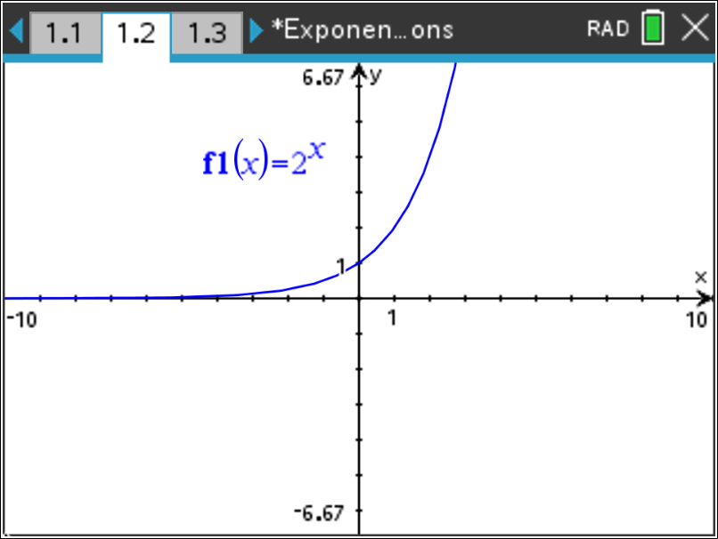  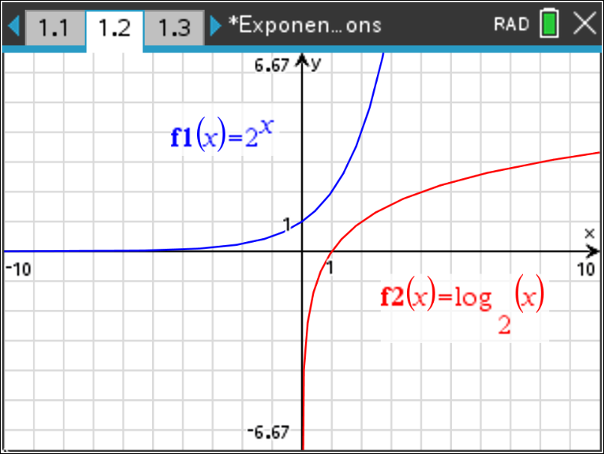
Tech Tip: For gridlines press b and select 2 View, 6 Grid, then 3 Lined Grid.
2. Press / T to access a table of values for your function.  Record the y-values under the original y-value column in the table below. Recall that if the function $f\left(x\right)=2^{x}$ consists of input-output pairs $\left(a,b\right),$ then the inverse function consists of input-output pairs $\left(b,a\right).$  Next record the inverses of each point by switching the x- and y-values and recording the results in the inverse columns in the table below.  Press / T again to return to a full screen of the graph. | 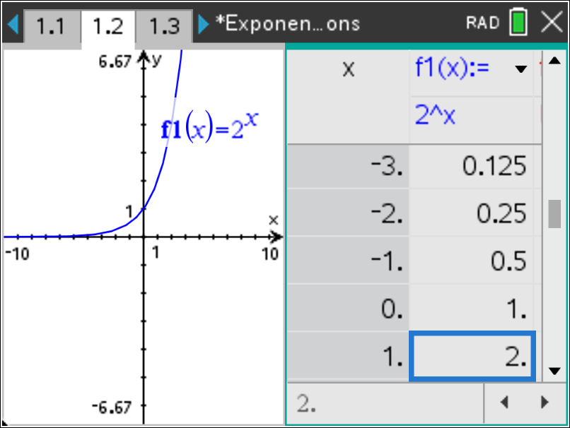
Answers:

Original x-value | Original y-value | Inverse x-value | Inverse y-value
–2 | 0.25 | 0.25 | –2
–1 | 0.5 | 0.5 | –1
0 | 1 | 1 | 0
1 | 2 | 2 | 1
2 | 4 | 4 | 2
3 | 8 | 8 | 3

Move to page 1.3.

3. Enter the inverse values in invx and invy. Move back to page 1.2.  To set up the scatter plot of the two lists, press b and select 3 Graph Entry/Edit and then 6 Scatter Plot. For the x, press h and select invx. For the x, press h and select invy. Press ·.  Do your plotted points appear to be on the graph of the inverse function that you sketched in Question 1?  Answers: The plotted points should appear to be on the graph sketched by the students in Question 1. | 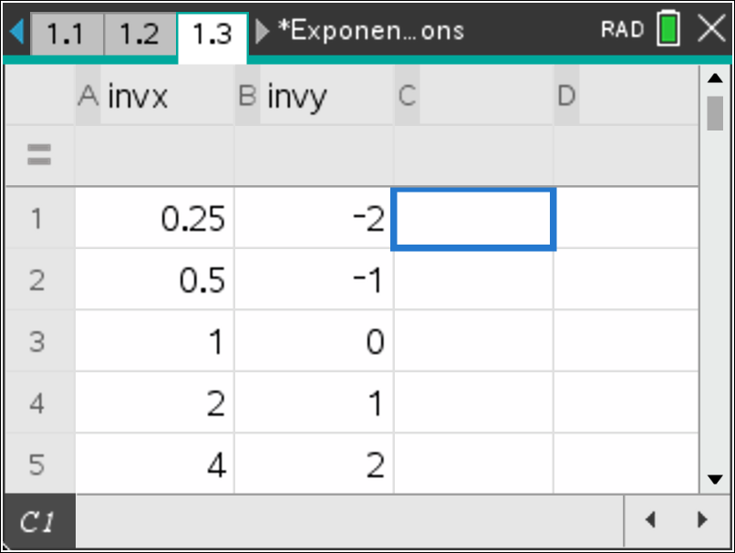  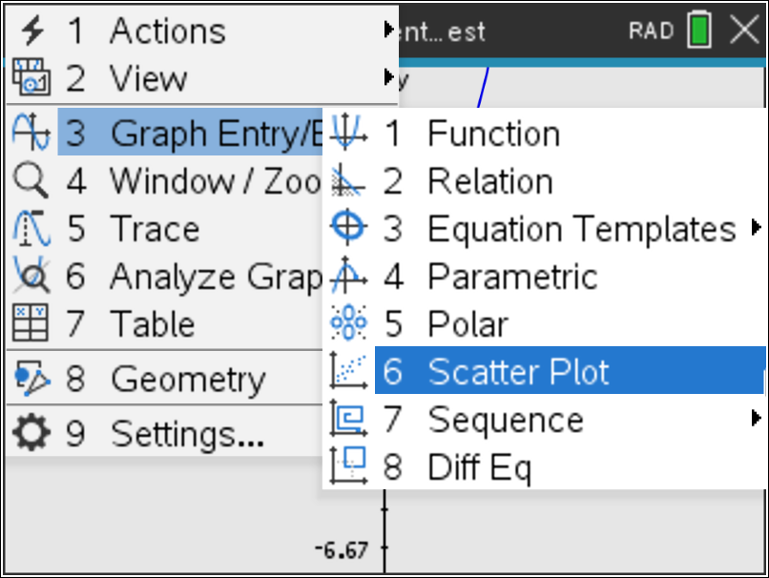  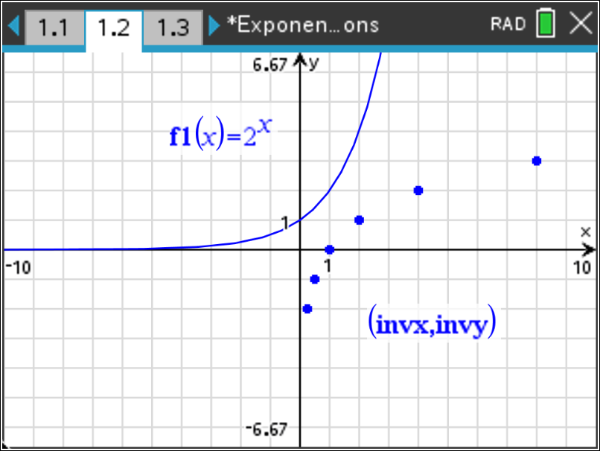
4. The inverse of a general exponential function $f\left(x\right)=b^{x}$ is a logarithmic function of the form
$g\left(x\right)=\log_{b}x.$ Write the inverse of $f\left(x\right)=2^{x}$.

Answer: $g\left(x\right)=\log_{2}x$ or $f^{-1}\left(x\right)=\log_{2}x$

5. Check your result by graphing this function in $f2\left(x\right)$ to see if it passes through all the plotted points. Also graph the identity function $f3\left(x\right)=x$. Are the two graphs symmetric with respect to the line $y=x?$  Note: To return to graphing a function, press b and select 3 Graph Entry/Edit and then 1 Function. The $\log_{b}x$ is found by pressing / Ö.  Answer: Yes, the graphs are symmetric with respect to the line $y=x.$ The graphs appear to be reflected across the line $y=x.$ | 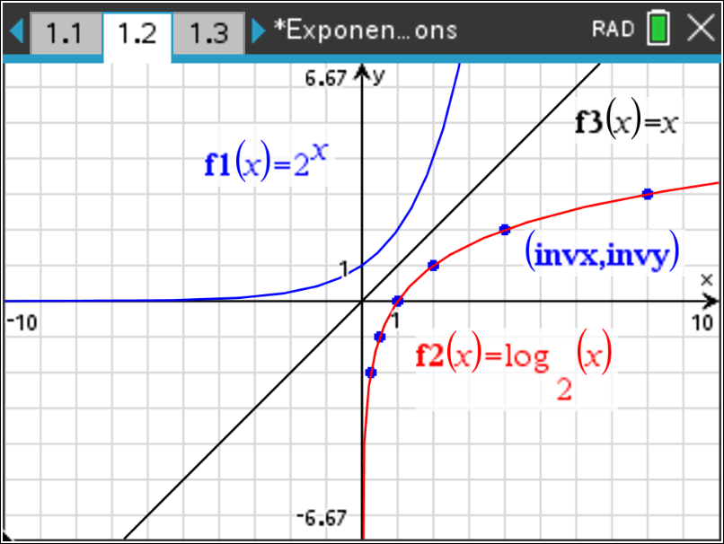
Move to page 2.1.

Problem 2 – The inverse of $f\left(x\right)=e^{x}.$ This function has a natural base of e.
6. Graph $f1\left(x\right)=e^{x}.$ Repeat the steps of Problem 1 using $f\left(x\right)=e^{x}.$  What is the inverse of $f\left(x\right)=e^{x}.$  Note: The inverse of $f\left(x\right)=e^{x}$ is called a Natural Logarithmic function.  Answer: $g\left(x\right)=lnx$ or $f^{-1}\left(x\right)=lnx$ | 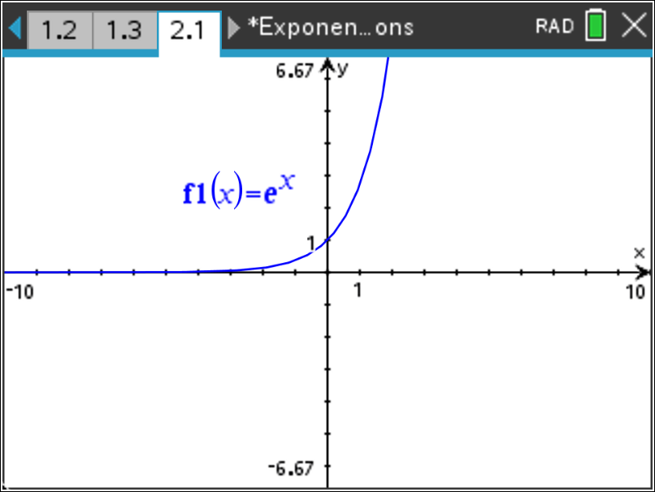  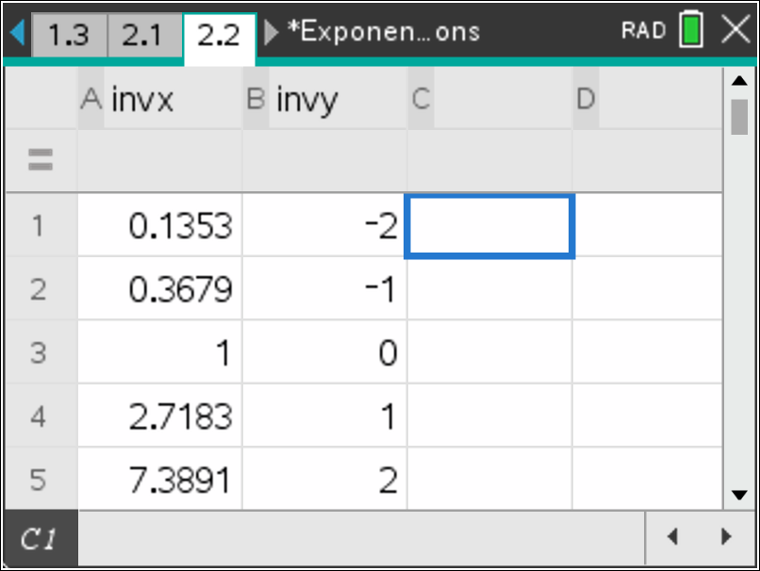  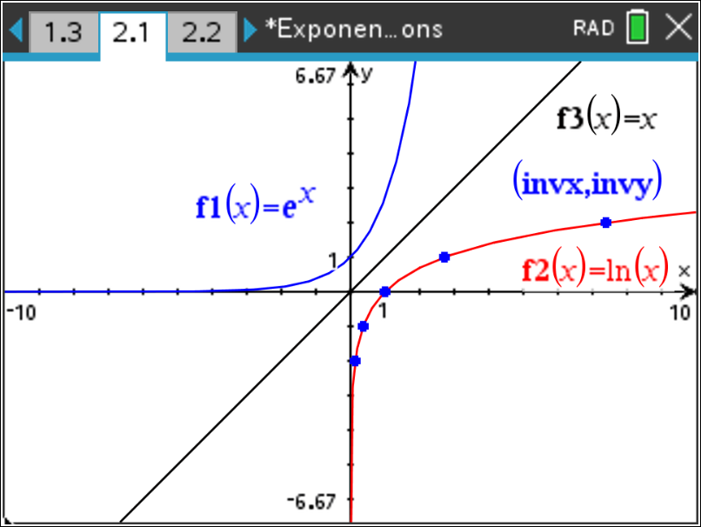
Teacher Tip: Students will likely write $g\left(x\right)=\log_{e}x$ and may use this notation to graph the logarithmic function. This is a good time to have students notice the relationship on the keypad of the u key and / Õ and that $g\left(x\right)=\log_{e}x$ should be written as $g\left(x\right)=lnx$.

Teacher Note: These are the table values if the students make a table while completing Problem 2.

Original x-value | Original y-value | Inverse x-value | Inverse y-value
–2 | 0.1353 | 0.1353 | –2
–1 | 0.3679 | 0.3679 | –1
0 | 1 | 1 | 0
1 | 2.7183 | 2.7183 | 1
2 | 7.3891 | 7.3891 | 2
3 | 20.086 | 20.086 | 3

Move to page 3.1.

Problem 2 – The inverse of $f\left(x\right)={10}^{x}$.
7. Graph $f1\left(x\right)={10}^{x}$.  Find the inverse of $f\left(x\right)={10}^{x}$. Check the symmetry of the function and its inverse by graphing.  Note: The inverse of $f\left(x\right)={10}^{x}$ is called a Common Logarithmic function.  Answer: $g\left(x\right)=logx$ or $f^{-1}\left(x\right)=logx$ | 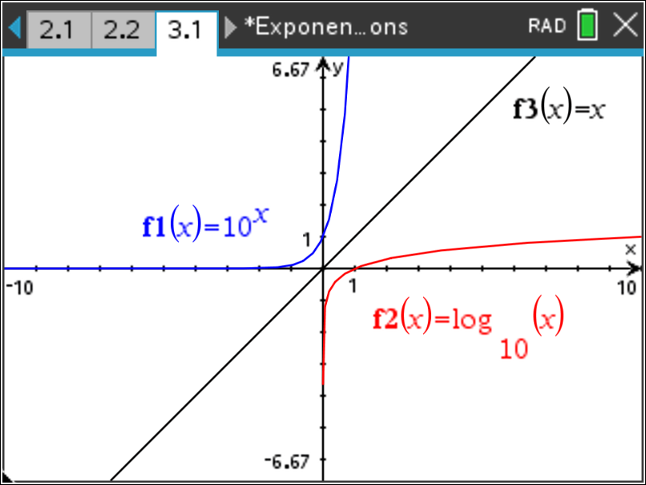
Teacher Tip: Students will likely write $g\left(x\right)=\log_{10}x$ and may use this notation to graph the logarithmic function. This is a good time to have students notice the relationship on the keypad of the s key and / Ö and that $g\left(x\right)=\log_{10}x$ should be written as $g\left(x\right)=logx$. By default, if no base is entered when using / Ö the base is 10.
Teacher Tip: Students may notice that the graph of the common logarithmic function appears to stop as the graph approaches the y-axis (as x approaches 0 from the right.). This is a great opportunity to investigate a table of values to convince the students that the graph does not stop. See Optional Notes.

Optional Notes: Press / ¿. Select 4 Add Lists & Spreadsheet. Press / T to switch to a table of values for your logarithmic function. Make sure you select the correct function from the list. Press b, 2 Table, and 5 Edit Table Settings. Change Independent to Ask and explore values that approach 0 from the right. | Pres 