Open the TI-Nspire document Balanced_Systems_of_Equations.tns.  In this activity, there are two balance scales representing a system of two linear equations. The expressions on the two sides of each balance scale correspond to the two sides of an equation. You can use the points on the arrows under the number line to manipulate what values are substituted for x and for y. When a scale is balanced, the two sides are equal. | 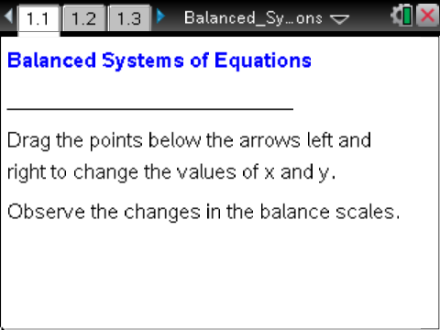

Move to page 1.2.
- Move the arrows until x = 3 and y = 6. Describe what each scale looks like. Why are they in this position?

- What does it mean if a scale is “balanced”? If x = –1, what value of y will balance the left scale? The right scale?

- Find three ordered pairs (x, y) that balance the left scale. Describe the strategy you used.

- Find three ordered pairs (x, y) that balance the right scale. How was your strategy for this problem the same or different from the one you used in problem 3?

- Find values for x and y that satisfy the conditions in the table below.

Values |  | Is it Balanced?
x | y | Left Scale | Right Scale
 |  | Yes | No
 |  | No | Yes
 |  | No | No
 |  | Yes | Yes

- Compare your table from question 5 with a partner’s table. Were any of your answers the same? If so, which ones? Discuss why some of them might be the same and some might be different.

- What is the significance of the last row of the table in problem 5?

Move to page 1.3.

8. How many solutions are there for this system of equations? How do you know?

Move to page 1.4.

9. How many solutions are there for this system of equations? How do you know?

