Open the TI-Nspire CX II document Basic_Transformations.tns.  In this activity, you will manipulate sliders to change the values of parameters in trigonometric functions and to determine the effect that each change has on the shape of the graph. You will then use this knowledge to write equations for sine and cosine functions. | 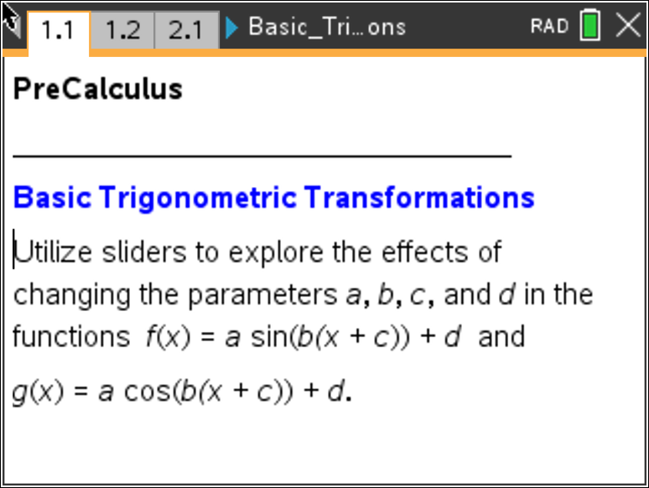

Move to page 1.2.

1. Drag the sliders to change the values of a and b in the function f(x) = a sin(bx).
a. Describe how the values of a and b affect the shape of the graph.

b. What happens to the graph if a is negative?

c. Complete the following statement:
For a ≠ 0 and b > 0, the graph of f(x) = a sin(bx) has an amplitude of ___________ and a period
of ___________.

Move to page 2.2.

2. Drag the slider to change the value of d in the function f(x) = sin(x) + d.
a. Describe how the value of d affects the shape of the graph.

b. Complete the following statement:
The graph of f(x) = sin(x) + d has a vertical translation of ___________.

Move to page 3.2.

Move to page 4.2.

4. Drag the slider to change the values of a, b, c, and d in the function f(x) = a sin(b(x + c)) + d.
a. Which of the four parameters have an impact on the horizontal translation of the graph?

b. Complete the following statement:
For a ≠ 0 and b > 0, the graph of f(x) = a sin(b(x + c)) + d has a horizontal translation of _________.

5. For functions of the form f(x) = a sin(bx + c) + d or g(x) = a cos(b(x + c)) + d, with a ≠ 0 and
b > 0,
a. the amplitude is _________.

b. the period is _________.

c. the horizontal translation is _________.

d. the vertical translation is _________.

Move to page 5.4.

6. The function shown on this page has the equation f1(x) = –1.5sin + 4. Write an equation for a cosine function that will have the same graph.

Move to page 5.5.

7. The function shown on this page has the equation f2(x) = 3sin(2x) – 5. Write an equation for a cosine function that will have the same graph.

8. a. Write an equation for a sine function with an amplitude of 4, a period of 12, a horizontal translation of 2, and a vertical translation of 3.

b. Write an equation for a cosine function with the same parameters as the sine function in part (a).

9. a. Write an equation for the sine function whose graph is shown in the figure below.
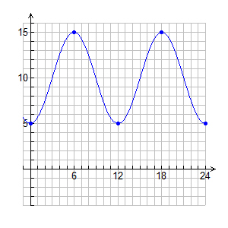
b. Utilize a cosine function to write an equation for the same graph.

Further Real World Extension

Day $(θ)$ | 8 | 9 | 10 | 11 | 12 | 13 | 14 | 15 | 16
Illumination $f(θ)$ | 0.08 | 0.03 | 0.0 | 0.01 | 0.04 | 0.10 | 0.18 | 0.28 | 0.38
Day $(θ)$ | 17 | 18 | 19 | 20 | 21 | 22 | 23 | 24 | 25
Illumination $f(θ)$ | 0.48 | 0.59 | 0.68 | 0.77 | 0.84 | 0.91 | 0.95 | 0.98 | 1.00

10. The table above gives the percentages of illumination of the moon on a nightly basis in the month
of March 2024. The function $f$ given by $f\left(θ\right)=a\sin\left(b\left(θ+c\right)\right)+d,$where $a, b, c,$and $d$ are
constants, is used to model these data with $θ$ representing the day of the month (March 1 = 1,
March 2 = 2, etc.). $f(θ)$ represents the percentage of the illumination of the moon on that day,
written as a decimal. Assume that the period of $f$ is 29.5 days. Based on the data in the table, find
the values for $a, b, c,$and $d.$

$a$= _______________

$b$ = _______________

$c$ = _______________

$d$ = _______________

11. Using the information in question 10, describe what each parameter, $a, b, c, and d,$ mean in the context of the illumination of the moon.

$a=$ ____________________________________________________________________

$b=$ ____________________________________________________________________

$c=$ ____________________________________________________________________

$d=$ ____________________________________________________________________

