Problem 1 – Graphical Riemann Sums  Consider the function f(x) = –0.5x² + 40.  Suppose we want to find the area bounded by this function and the x-axis from x =1 to x = 3. We can approximate this area with different rectangles: left, right, and midpoint Riemann sums. Using the AREAPPRX program, we can approximate this area using the three different Riemann sums mentioned above.  To begin, run the program by pressing ¼ and arrowing down until you reach the AREAPPRX program. Then press Í. And press Í again.  You will be prompted to provide four pieces of information. The first one asks you to enter the function after the Y=. After entering the function and pressing Í, you will be prompted to provide the lower bound (the x-value of the left endpoint), followed by the upper bound (the x-value of the right endpoint). Finally you will be prompted for the number of subintervals, N, which represents the number of rectangles (or trapezoids) to use. This time we will use 4 rectangles. The sums for the four different types of approximations are displayed. |  | 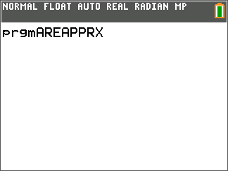  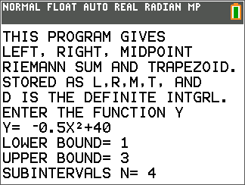
Example 1: Record the following three types of approximations below.
Using 4 rectangles:
Left Riemann sum = _____________
Right Riemann sum = _____________
Midpoint Riemann sum = _____________

Restart the program and calculate the same three area approximations from x = 1 to x = 3 using 12 rectangles and record the results below.
Using 12 rectangles:
Left Riemann sum ≈ _____________
Right Riemann sum ≈ _____________
Midpoint Riemann sum ≈ ____________

Let’s compare our answers to the result we get using the definite integral command on the calculator. Press ‘ to obtain a fresh screen. Then type » 9:fnInt followed by Í.  Enter the lower and upper boundaries as 1 and 3 respectively as well as the expression –0.5x² + 40 as shown to the right. Be sure to enter X in the last field to denote that you are integrating the function with respect to x.  Example 2:  ___________  Compare this answer with the approximations above. | 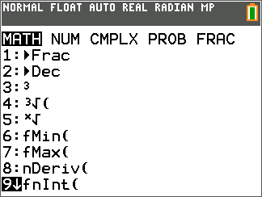  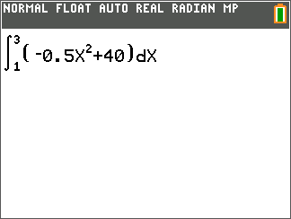
1. Letting y = – 0.5x² + 40 again, run the AREAPPRX program from x = 0 to x = 4 and use 4 rectangles. How do the left, midpoint, and right Riemann sums compare? Explain why.

2. Describe what happens to the left, midpoint, and right Riemann sums as you increase the number of subintervals, n.

3. Is the midpoint Riemann sum an over or under approximation if the graph is:
a. Increasing and concave down? ____ over _____ under
b. Increasing and concave up? ____ over _____ under
c. Decreasing and concave down? ____ over _____ under
d. Decreasing and concave up? ____ over _____ under
After graphically exploring (especially with a small number of subintervals), explain why.

Problem 2 – Summation Notation
Examine the function Y1(x) = –0.5x² + 40.
4. The thickness of each rectangle is . If a = 1, b = 6, and n = 5. What is ∆x?

5. Expand by writing the sum of the five terms and substituting i = 1, 2, 3, 4, and 5.

6. Explain why this is the summation notation for LEFT Riemann sums and not the RIGHT.

7. Let y(x) = –0.5x² + 40, a = 1, and b = 6. Write the sigma notation and use the HOME screen (y
z[quit]) to evaluate the left Riemann sum for 10, 20, 50, and 100 subintervals.

a. n = 10

b. n = 20

c. n = 50

d. n = 100

Extension – Area Programs
Use the Area Approximation program AREAPPROX to answer the following questions.
8. Let y(x) = x², a = 1, and b = 6. Write the results for midpoint and trapezoid area approximations when:
a. n = 10
b. n = 50
c. n = 100

9. Compare the above midpoint and trapezoid values with the actual area.

