PROJECT OVERVIEW: Building Paper Bridges
In this project students will collect data to explore the linear relationship between force, mass and acceleration due to gravity. In the context of a challenge, students are engaged by a competition to determine which group can build the strongest bridge, and then they predict and verify a model for the system prior to making any measurements on the system. Finally, the students will collect the data and
determine how well their model fits the outcome they observe.
PROJECT OUTLINE:
The goal:
The goal here is to find out two things: First, which group builds the strongest bridge while following the guidelines, and then, to verify that the model they predict for relating mass and force makes sense. The intent is for students to model the system prior to building or taking measurements. Students should think about what kind of data they are collecting, how increasing the mass in the cup will show up in the force measurements and how the two relate. The coolest part – the slope, and y-intercept will have real
meaning.
The challenge:
Build the strongest bridge using only a sheet of paper. Students use a single sheet of paper to fold the strongest bridge they can.
Materials list (per group):
- 1 – 8.5”X11” sheet of paper
- 1 – sheet of graph paper
- 20 washers (or other small weights)
- 1 – popsicle stick
- 12” to 24” of string or fishing line
- 1 – ½” screw eye
- 1 – small paper cup
- 1 – Vernier Dual Range Force sensor (in 10N mode
- 1 – Vernier EasyLink™ adapter

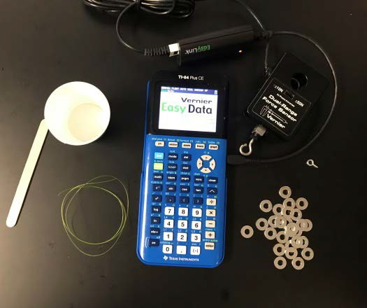
Rules for building your bridge:
- You must span a gap of 8”
- You have 1 sheet of 8.5”X11” paper and no other materials (no tape, no glue, etc.)
- Your bridge must have a “guardrail” that is at least 0.5” high on both sides
- You have one “car” represented by the popsicle stick
- The “car” is at the very middle of the bridge while data is collected
- The screw eye goes through the bridge and attaches to the car and the force sensor hangs from the screw eye
- Secure the cord for the force sensor so it doesn’t interfere with the data collection.

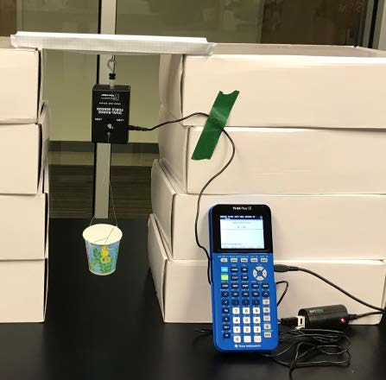
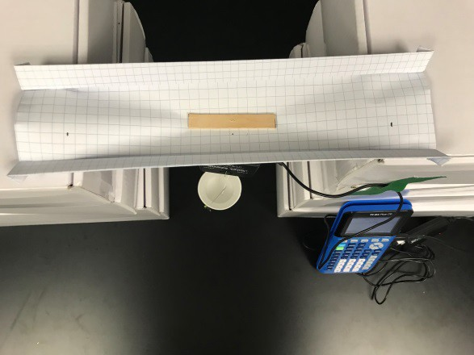

Think it through and build a mathematical model:
Students should decide what type of relationship they expect to see between force measured and the mass of washers in the cup. Have them write a generic equation to model this relationship.

Ready for Data Collection:
Once students have a model they think will work. Then they should begin collecting data. First, they should measure with a balance, the mass in kg of the force sensor and cup. They should also measure the mass in kg of a single washer. Ask how they expect to see this information turn up in their data.
Setting up EasyData App:
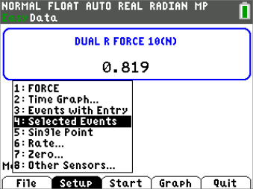
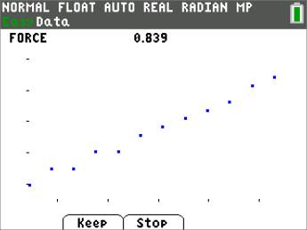
With the setup as pictured below, plug the sensor into the calculator using an EasyLink™ cord. The EasyData app will open and you will need to setup the force sensor by selecting Setup, and then choosing 4. Selected Events.
Data Collection:
For data collection students select Start, and then select Keep to store a data point. Students should start with one washer in the cup and take a data point. Then, adding washers one at a time, take a data point with each new washer until they run out of washers or the bridge breaks.
Interpreting the Data:
From Easy Data, the data will be stored in L1 and L2, (number of washers and force in newtons respectively.) Have students create a scatterplot of newtons vs. number of washers and discuss whether the model they wrote fits the relationship they see in their data. Using the regression capability of their calculator, they should make a linear regression model using L1 as the independent variable, and L2 as the dependent variable.

Ask students:
- What is the slope? What does it represent?
- What about the Y-intercept? What does it represent?
Fun Physics Extension:
Instead of graphing newtons vs. washers, multiply the number of washers L1 by the mass in kg of a single washer and store in L3. Then multiply the force from L2 by negative 1 since the force is in a downward direction, and store in L4. Then plot a new plot of newtons vs. “kg in the car” (L3, L4).
Ask students:
- What does the slope of this relationship (kg, newtons) represent? Could you have guessed it?
- Compare the y-intercept to the first model. Why do you think that happens?
Changing Factors (extension):
Challenge students to change different factors in the setup and see how that impacts the outcome. Possible things to change:
- Length of the span
- Length of the popsicle stick
- Size of the washers
- Sheets of paper
- Height of the “guardrail”
