Problem 1 – Ellipses
Ellipses are seen throughout the universe. Read page 1.2 and explore by moving the point on page 1.3. After reading page 1.4, write the equation of the standard form of the ellipse.

Write the equation that expresses the relationship between a, b, and c, the distance the focal point is from the center.

On page 1.5, manipulate the moveable points, b and c, and observe the changes to both the results of the equation and the graph of the ellipse.

1. What is the value of c, the distance from a focus point to the center, for the ellipse ?

On page 1.7, move the center point of the ellipse and observe the changes to the equation.

2. Considering the standard form of the equation of an ellipse with the horizontal axis as the major axis, , what happens as the ellipse is moved to the left?

3. Considering the standard from of the equation of an ellipse with the horizontal axis as the major axis, , what happens as the ellipse is moved up?

On page 1.10, sketch the conic given by selecting b > Graph Entry/Edit > Equation > Ellipse.  4. For the ellipse , will the ellipse be stretched more vertically or horizontally? The major axis will be… | 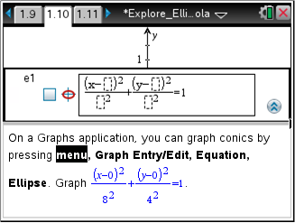
Page 1.12 will allow you to explore the location of the focus for the ellipse from Question 4. To do this, select b > Analyze Graph > Analyze Conics > Foci.

5. What is the center and the vertices for the ellipse ? Use what you know about the standard from for an ellipse. Then, check your answer visually by graphing the ellipse on the right side of the page.
center: _________ vertices: ________ , ________

On page 1.14, use b > Analyze Graph > Analyze Conics > Center and b > Analyze Graph > Analyze Conics > Vertices to further confirm your findings in Question 5.

6. For , give the location of its foci.
foci: _________ , __________

Problem 2 – Hyperbolas
After reading page 2.1, write the equation of the standard form of the hyperbola.

Write the equation that expresses the relationship between a, b and c, the distance of a focal point from the center of a hyperbola.

On page 2.2, graph the hyperbola, and use b > Analyze Graph > Analyze Conics to reveal its foci, vertices and asymptotes.

7. Which expression best describes the slope of the asymptotes of a hyperbola?

8. What are some of the similarities and differences between an ellipse and a hyperbola?

