Student Worksheet for G.G.55 Investigate, justify, and apply the properties that remain invariant under rotation about a point. ANGLE MEASURE

After turning on your handheld press  | Select CabriJr.  
scroll down to Open |  scroll to ROTATE2  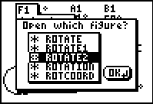
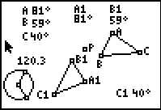 | ∆A1B1C1 is the image of ∆ABC under a rotation about point P.  The measures of the angles of the triangles have been indicated.  You will move the vertices of ∆ABC and the radius points on the circle to draw conclusions about the image ∆A1B1C1

- Select, grab and drag either radius point on the circle
What is changing? ______________________________________________
What is remaining the same? _______________________________________
- Select, grab and drag point A.
What is changing? ______________________________________________
What is remaining the same? _______________________________________
- Select, grab and drag point B.
What is changing? ______________________________________________
What is remaining the same? _______________________________________
3) Select, grab and drag point A, B, C or either radius point. As you move your selected point, stop and record 5 successive trials by entering the measures of the angles in the table below.
Trial #
1
2
3
4
5

- What seems to be true about the measures of and ? __________________
- Name two other pairs of angles that demonstrate this same property. ______________________________________________________
- Under the transformation glide reflection is angle measure preserved? ______________
- In your own words explain what it means when a property is preserved.
_____________________________________________________________________

