Problem 1 – Finding points of inflection graphically
The graph of f1(x) is shown on page 1.3 with the minimized slider for ‘show’ set equal to zero. What are the approximate x-values where the graph changes concavity? Mark them on the screen to the right. | 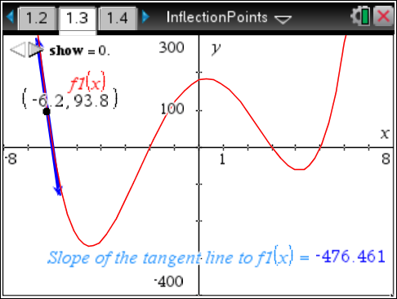
The points you approximated are the points of inflection. Click the minimized slider for ‘show’ to change it to ‘show=1.’ This is the graph of the first derivative of f1(x). Where are the points of inflection found on this graph? How do the points of inflection relate to the graph? Mark them on the screen to the right. |  | 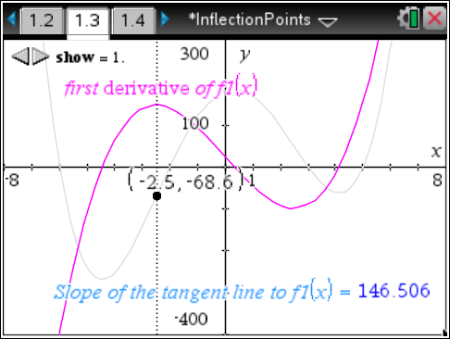
Choose ‘show=2’ for the second derivative of f1(x). Where are the points of inflection located on this graph? How do the points of inflection relate to the graph? Mark them on the graph to the right. |  | 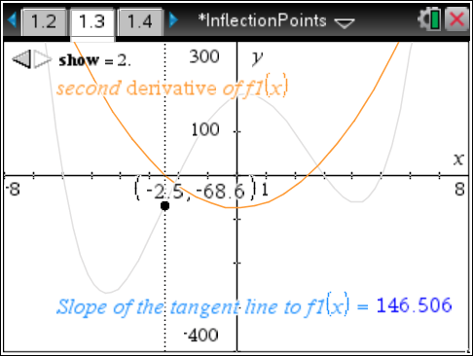
Now summarize your findings.
- Where can you find points of inflection on the graph of a function?

- Where can you find points of inflection on the graph of the first derivative of a function?

- Where can you find points of inflection on the graph of the second derivative of a function?

Problem 2 – Test your knowledge
On page 2.2, you will see the graph of the first derivative of a function.  - Where are the points of inflection for the function? Mark them on the first derivative graph to the right. How did you find them? |  |  | 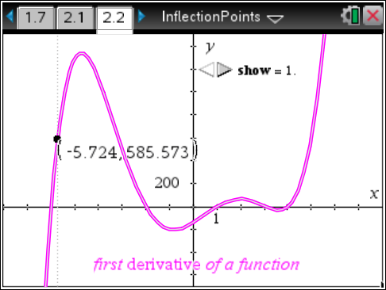
On page 2.2, choose ‘show=2’ to display the graph of the second derivative for the same function.  - How did you verify your solution using the graph of the second derivative? |  |  | 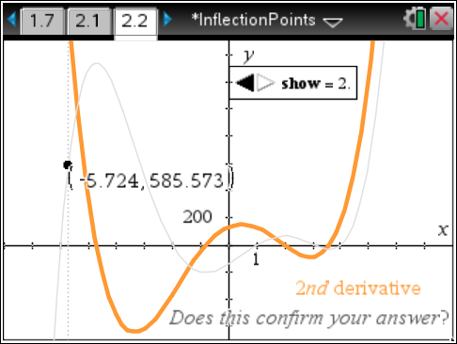

Problem 3 – Finding points of inflection algebraically
Advance to page 3.1. A function and its first and second derivatives are shown. You need to find the points of inflection for the function.  - Which equation would you chose to find the points of inflection algebraically and why? | 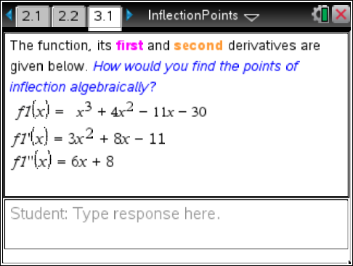
- Algebraically, how could you find the points of inflection using the first derivative?

- Algebraically, how could you find the points of inflection using the second derivative?

- Will this method always work?

- Find the points of inflection algebraically. What are the points of inflection?

