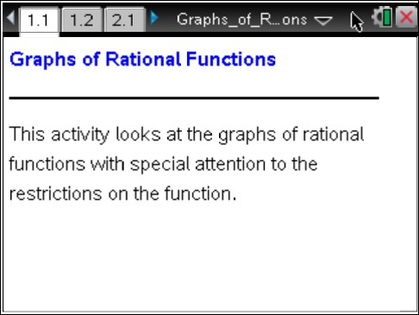
Math Objectives
- Students will determine the domain and range of a rational function.
- Students will describe the end behavior and the graph of a rational function near its asymptote.
- Students will connect the horizontal translation of a graph of a rational function to its equation.
- Students will find the equations of a rational function with specified asymptote(s) or restriction(s).
Tech Tips:
- This activity includes screen captures from the TI-Nspire CX handheld. It is also appropriate for use with the TI-Nspire family of products including TI-Nspire software and TI-Nspire App. Slight variations to these directions may be required if using other technologies besides the handheld.
- Watch for additional Tech
Tips throughout the activity for the specific technology you are using.
- Access free tutorials at
http://education.ti.com/calcul
ators/pd/US/Online- Learning/Tutorials
- Students will look for regularity in repeated reasoning (CCSS Mathematical Practice).

Vocabulary

- end behavior | - positive or negative infinity
- asymptote | - domain and range
- horizontal shift
About the Lesson
- This lesson involves investigating the graphs of rational functions.
- As a result, students will

  - Describe the end behavior of the graph of f (x) = 1
x
and what

is happening near the asymptote.
  - Horizontally translate the graph of f (x) = 1
x

and determine

the relationship between the equation of the asymptote and the equation of the rational function.
  - Write the equations of graphs of rational functions with two asymptotes.

TI-Nspire™ Navigator™ System
Lesson Files:
Student Activity Graphs_of_Rational_Functions2_ Student.pdf
Graphs_of_Rational_Functions2_ Student.doc
TI-Nspire document Graphs_of_Rational_Functions2. tns
- Use Class Capture and Live Presenter to demonstrate using the TI-Nspire document, monitor students’ progress, demonstrate one or many graphs at the same time, and discuss specific cases.
- Use Quick Poll to assess students’ understanding of the concepts throughout or after the lesson.

Activity Materials
- Compatible TI Technologies: TI-Nspire™ CX Handhelds,  TI-Nspire™ Apps for iPad®,  TI-Nspire™ Software

Discussion Points and Possible Answers

Tech Tip: Grab the point P by pressing /x or by holding the click button. Drag the point left or right along the line. Moving the point from the left side to the right will fill in the graph of the rational function. Move slowly near the asymptote to be able to see what happens. You may want to do this as a class to start the lesson.

Teacher Tip: It may be the first time that students have connected the graphs of rational functions and their asymptotes to the algebraic equations. Students may need to be reminded that division by zero is a
mathematical impossibility.

TI-Nspire Navigator Opportunity: Class Capture and/or Live Presenter
See Note 1 at the end of this lesson.
Move to page 1.2.  Grab and drag point P across the screen from left to right.  1 a. Move slowly toward the y-axis from the left. Record what is happening to the graph. What is happening to the x-value? What is happening to the y-value? | 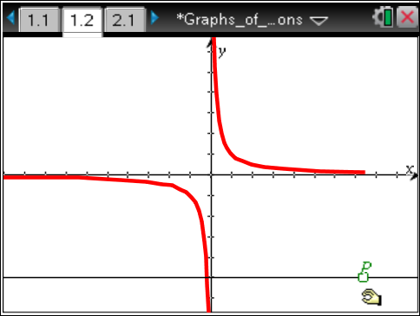
Answer: As you move across the screen toward the y-axis from the left, the graph is decreasing. The value of the function is always negative. The x-value is approaching zero, while the y-value is becoming infinitely small (approaching negative infinity).

b. Move slowly away from the y-axis toward the right. Record what is happening to the graph. What is happening to the x-value? What is happening to the y-value?

Answer: As you move across the screen from the y-axis toward the right, the graph is decreasing. The value of the function is always positive. The x-value is becoming increasingly large (approaching positive infinity), while the y-value starts at an infinitely
large number and then approaches zero.

- Given the equation for the graph: f (x) = 1 .
x
  - Explain how the graph changes as the x-value comes closer and closer to zero from the negative side and from the positive side.

Answer: As x approaches zero from the negative side, the graph decreases and the y- value approaches negative infinity. As x approaches zero from the positive side, the graph increases and the y-value approaches positive infinity.

  - Why is there an asymptote at x = 0 ?

Answer: Division by zero is undefined. The asymptote represents the fact that the rational function, f (x) = 1 is not defined at x = 0 and the value of the function is approaching
x
positive or negative infinity when the x-value approaches zero from either side.
Teacher Tip: When the equation has a factor in the denominator that divides into the numerator with no remainder, there will be a hole in the graph, not an asymptote. The function is still not defined at the x-value of the hole but the function will be approaching a specific value from either side. This may not be the time to mention this possibility but if a student asks, discuss the difference between an asymptotic discontinuity and one
that is a hole or removable discontinuity.
c. What is the restriction on the domain of the function? Why?

Answer: The restriction on the domain is x ≠ 0 . Since you cannot divide by zero, the denominator in the rational function cannot be equal to zero.
Teacher Tip: Students may confuse the equation of the asymptote and the
restrictions on the domain. They often will write the equation of the asymptote as x ≠ 0 .
d. Explain how the graph changes as the x-value becomes infinitely large (approaches positive infinity). Why does this happen?

Answer: The value of the graph approaches zero when the x-value becomes infinitely large. It will always be a positive number and never quite equal zero. When you look at the equation, the number one is being divided by a larger and
larger number. It will go in fewer and fewer times.

Teacher Tip: Have students think of what is happening to the sequence of
numbers: 1 , 1 , 1 , 1 , 1 ,...
10 100 1000 10000 100000
e. Explain how the graph changes as the x-value becomes infinitely small (approaches negative infinity). Why does this happen?

Answer: The value of the graph approaches zero when the x-value becomes infinitely small. It will always be a negative number and never quite equal zero. When you look at the equation, the number (negative) one is being divided by a larger and larger number. It will go in fewer and fewer times.
Teacher Tip: Have students think of what is happening to the sequence of
numbers: − 1 ,− 1 ,− 1 ,− 1 ,− 1 ,...
10 100 1000 10000 100000
f. What is the restriction on the range of the function? Why?

Answer: The function f (x) = 1 will never equal zero. There is no number that can divide
x
into one a zero number of times.
Teacher Tip: Because division is the inverse of multiplication, 1 = 0
x
implies that the product of x and 0 would have to be 1. Impossible!

Teacher Tip: You may want to introduce the idea of a horizontal asymptote. Although some functions may pass through the horizontal asymptote somewhere in the domain, it is the end behavior of the function
that determines the horizontal asymptote.

Move to page 2.1.  Grab and drag point P across the screen left and right. Notice the equation of the function listed below the graph.  3. Why are the asymptotes dotted and not solid lines?  Answer: The asymptotes are not part of the graph. The dotted lines represent the value that x approaches but never  actually reaches. | 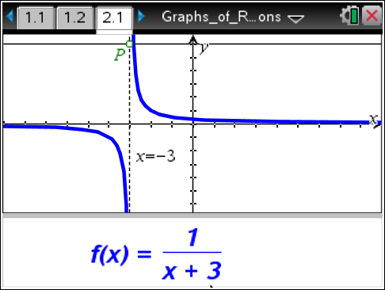

- Explain the relationship between the equation of the asymptote and the equation of the rational function.

Answer: The equation of the asymptote is the solution to setting the denominator in the rational function equal to zero. This represents the restriction on the domain of the function.

- What transformation is being done to the graph of the rational function f (x) = 1 as you move
x
point P?

Answer: The graph of the rational function is being horizontally translated or shifted left or right.

- Move point P so that the asymptote is x = 3 . Explain how the graph changes as the x-value becomes infinitely large or small (approaches positive or negative infinity). Is this answer different from your answers to question 2a and b?

Answer: The value of the graph approaches zero when the x-value becomes infinitely large or small. It will never quite equal zero. When you look at the equation, the number one (positive or negative) is being divided by a larger and larger number. It will go in fewer and fewer times.
This answer is the same as that for question 2. The end behavior is the same for all rational
functions of the form f (x) = 1 .
x ± a
Teacher Tip: You may want pose this question: What do you think the
graph of f (x) = −1 , x ≠ 3 will look like and why? What does the graph of
x − 3
f (x) = 2 , x ≠ 3 look like? Have them reason about the values of f (x) for
x − 3
x-values close to 3 on either side as well as for large and small x-values.
7. Write an equation of a rational function with a vertical asymptote at x = −2 . What is the restriction on the domain for the equation?

Answer: A possible answer would be: f (x) = 1 , x ≠ −2 .

x + 2
Teacher Tip: This is only one of many equations that satisfy the conditions given. The equation could be shifted vertically and/or stretched or compressed vertically. You may want to poll the class to see if there are
different answers given to this question.

8. What would be the equation of the function f (x) = 1 , x ≠ −1 after a horizontal shift of 3 units
x + 1
to the right? Include the new restriction.

Answer: A horizontal shift of 3 units to the right will result in the equation f (x) = 1 , x ≠ 2 .

x − 2
Teacher Tip: Remind students that a horizontal shift of 3 units to the right is accomplished by subtracting 3 units from the x term. The asymptote or
restriction will both shift right 3 units.
Move to page 3.1.  Grab and drag points P1 and P2 across the screen from left to right. Notice the equation of the function listed below the graph. | 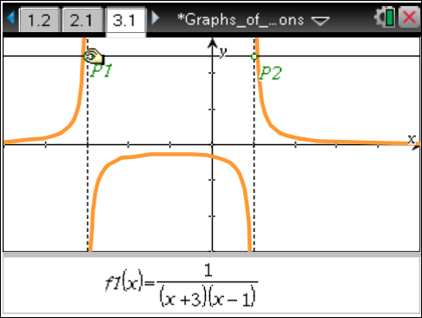
9. What would be an equation of a rational function with the restrictions x ≠ ±1 ?

Answer: An equation would be: f (x) = 1 , x ≠ ±1 .

(x − 1)(x + 1)
Teacher Tip: Students may notice that the graph has a portion that disappears when the asymptotes are close together. You might want to address the fact that the part of the graph is still there, it is just outside of
the viewing window.
10. a. Describe what happens when P1 = P2.

Answer: When the two points are equal, the two asymptotes are also equal, so there is only one restriction on the domain of the function.
Teacher Tip: Students may notice that the graph is always positive. You may want to look at the equation of the rational function when P1 = P2. The two factors in the denominator are the same. It could be written as a
square, for example: f (x) = 1 = 1 . Since a squared value
(x − 1)(x − 1) (x − 1)²
is always positive, the graph is always above the x-axis.

b. If P1 = P2 = 2, how does the graph differ from the graph of f (x) = 1 , x ≠ 2 ?
x − 2

Answer: A function when P1 = P2 = 2 is f (x) = 1 , x ≠ 2 . The graph of this function is
(x − 2)2
always positive. It looks similar to the graph of f (x) = 1 , x ≠ 2 with the negative branch
x − 2
reflected up above the x-axis. The values are not the same but students may not recognize that.

11. How does the graph of the function f (x) = 1 differ from the rational functions we have looked at
x² + 1
in this activity? You may want to use the Graph feature of the Scratchpad to explore this function or add a Graphs page to the activity.

Answer: The graph of the rational function f (x) = 1 does not have a vertical asymptote or
x² + 1
any restriction on the domain. The denominator x² + 1 will never equal zero since a squared number cannot be negative.
Teacher Tip: The graph of f(x) = 1 will still have a horizontal
x² + 1
asymptote of y = 0 . Students are not expected to know what the graph will
look like, just that there will be no vertical asymptote as there is no restriction on the domain.
TI-Nspire Navigator Opportunity: Quick Poll
See Note 2 at the end of this lesson.

Wrap Up
At the end of the discussion students should know:
- The relationship between the equation of a rational function and the asymptotes in the graph of the function.
- The effect of a horizontal shift on the graph and equation of a rational function.
- How to find an equation of a rational function that has given asymptote(s) or restriction(s).

Assessment

Sample Questions:

- The restrictions on the function f (x) =
1

(x − 3)(x + 2)
are:

  - x ≠ −3 and x ≠ −2
  - x ≠ 3 and x ≠ 2
  - x ≠ −3 and x ≠ 2
d. x ≠ 3 and x ≠ −2

- The vertical asymptotes of the graph of the function f (x) =
a. x = −1and x = 5
1

(x + 1)(x − 5)
are:

- x = 1and x = −5
- x ≠ −1and x ≠ 5
- x ≠ 1and x ≠ −5

- The equation of a rational function with restrictions
x ≠ 0 and x ≠ −1 is:

- f (x) =

- f (x) =
1

(x − 1)(x + 1)
1

(x + 1)(x + 1)

c. f (x) =
1
x(x + 1)

d. f (x) =
1

x(x − 1)

TI-Nspire Navigator

Note 1
Questions 1–11, Class Capture and/or Live Presenter: Demonstrate the procedure for using the TI-Nspire document, monitor students’ progress and display one or more graphs to discuss.

Note 2
Question 11, Quick Poll: Assess the students’ understanding of the concepts either during or after this lesson. Sample questions are provided above.

