Population growth can be modeled using various  exponential functions. In this activity, students will use two different methods to find the best model for given data. The data will represent the midyear world population from the years 1950 – 2023, where year 1 represents the year 1950.  The data will be downloaded from the file WORLDPOP.8xp. | 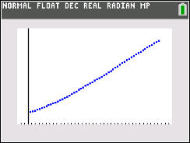
____________________________________________________________________________________

Problem 1 – Find an exponential equation by hand using two points.
In this part, you will find an exponential equation using two points. Begin observing the data.  Press prgm, 1: TI-Basic, and choose WORLDPOP. When the screen displays Done, the world population data will be loaded into lists L1 and L2.  Press stat, 1: Edit… to view the data.  - What kind of function would best model the data? |  | 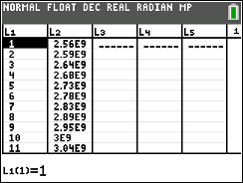
To examine the data, make a scatter plot.  Press 2nd, y = and select Plot 1. Adjust the settings to those shown at the right. Press zoom and select  9: ZoomStat to view the plot in an appropriate window. |  | 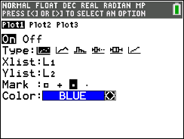
- Now find an exponential model to fit the data by using two points (x1, y1) and (x2, y2). To do this on the graph, press trace and use the left and right arrows to see the coordinate values.
- Pick two points that are spread throughout the data and write the values in the space provided:
Coordinate 1: x1 = _______ y1 = ______________________
Coordinate 2: x2 = _______ y2 = ______________________
The general formula for an exponential function is y = a(b^{x}) where a is the initial value
and b is the multiplier or in this case the growth rate.
- Find the equation through the two points by substituting the values into the general exponential formulas:
y1 = a(b^{x1}) ________ = ____________
y2 = a(b^{x2}) ________ = ____________
Then divide the equations and solve for b.
________________________
- What happens to the value of a when the two equations are divided?

- What is your value of b?

Store this value by pressing sto, alpha, apps (B), enter.
- According to your b value, by what percent is the world population growing?

Now substitute the value of b back into either of the equations above to find the value of
a. Follow the steps above to store this value as A.
- What is your value of a?

- What is your exponential equation?

- Look at your equation, what is your initial population?

To graph your equation with the data, press y = and enter the expression shown at the right. Press graph.  - How well does your equation model the data? Explain.  - What will the population be in the year 2030?  - What was the population in the year 1890?  Problem 2 – Finding the exponential regression. | 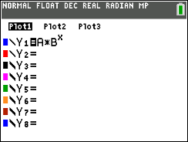

Now you will find an exponential regression equation to fit the data.  - Press stat, move to the CALC menu and select  0: ExpReg, make sure the X and Y lists are L₁ and L₂, respectively, store the equation in Y₂, and press enter.  - Discuss with a classmate which model seems to fit the data more accurately. Summarize your discussion here. | 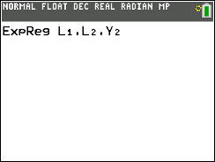

This lists the values for a and b in the general formula y = a(b^{x}).
Press graph to see both equations and the scatter plot.
- What is the exponential regression equation?

- What is the initial population?
- By what percent is the world population growing?

- How do these two values compare with the ones in Problem 1?

- How well does the exponential regression equation model the data?

- What will the population be in the year 2030?

- What was the population in the year 1890?

- Which model do you feel is best? Why?

- How would you find out what year the world’s population will reach 8.9 billion people?

- Graphically use the exponential regression equation to find the year.

Problem 3 – Extension beyond population
A botanist has been studying the rare plant called the Lady’s Slipper Orchid that was at first thought to be extinct but was once again discovered in the 1930s. She is trying to foster its growth. In 2020 (t = 3), she has 36 plants, and in 2024, she has 108 plants.
The number of plants being cultivated and studied can be modeled by the function $L\left(t\right)=a∙b^{t}$, where $L(t)$ is the number of plants during year $t$, and $t$ is the number of years after 2017.
- (a) Use the given data to write two equations that can be used to find $a$ and $b$.

(b) Find the values of $a$ and $b$ as decimal approximations.

(c) Use your function, $L(t)$, to approximate the number of plants the botanist will have in
2028.

(d) Using your function, $L(t)$, when will the number of plants reach 200 plants.

