Problem 1 – The Geometric Mean
1. After calculating the product of the lengths of 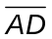 and 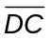 and the square of the length of 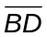, record the information in the table. Change the length of and/or , and record the information again.

Length of | Length of | AD × DC | Length of | BD²

2. The figure on page 1.4 can be used to find an estimated value of a radical, such as 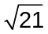. What value is created for the length of if AD = 1 and DC = 3?

3. What would the lengths of and be in order for the length of segment to be exactly:
a. 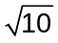 b. 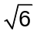 c. 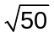 d. 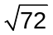

Problem 2 – Similar Triangles
4. Write a similarity relationship for the three triangles in the figure. Can you prove this relationship?

5. What other proportions are true about the figure besides 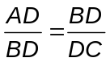?

6. Identify other geometric means that occur when an altitude is constructed to the hypotenuse of a right triangle.

Exercises
Use the figure below to answer the following questions. ∠ABC is a right angle and 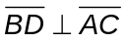.
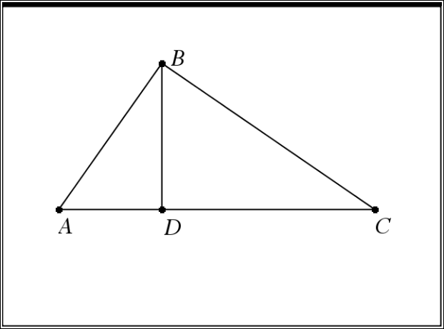
Write a proportion using a geometric mean and solve the problem.
1. If AD = 3 inches, and DC = 27 inches, find the length of .

2. If AD = 4 inches, and BD = 8 inches, find the length of .

3. If AD = 6 inches, and DC = 9 inches, find the length of .

4. If AD = 5 cm and DC = 10 cm, find the lengths of , 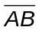, and 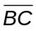.

5. If BD = 2 cm and DC = 8 cm, find the lengths of , , and .

