TI-Nspire Activity: A Transformations Quiz
By: Leigh T Baker

Activity Overview
A three problem quiz testing students on calculator use and understanding of transformations both graphically and algebraically.

Concepts
Understanding transformations of parent graphs by looking at the equation
Understanding transformations of parent graphs by looking at the graphs
Understanding the connections between algebraic and graphical transformations

Teacher Preparation
Download the following .tns files
transformations quiz.tns
transformationsquizanswerkey.tns

The Classroom.
Open the transformations quiz document
This file can either be downloaded to each student’s calculator using the Connect-to-Class software, or it can be used with the teacher software to project the file for students to view.

The Document
The first page of the document is a question and answer page. It requires the student to explain what transformations will take place based on the equation. The second page of the document requires the student to graph the transformations one at a time to verify their algebraic solution. Each graph should be clearly labeled, including the parent graph.

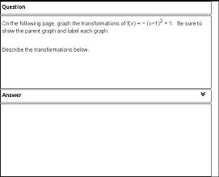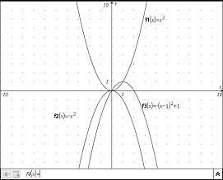

The great thing about the document is that it can edited to encompass all types of transformations and their parent graphs. By using copy and paste, and changing the equation, any number of transformations can be added.

A new problem, not a new page, should be added each time a problem is added. If this step is not followed, then all the graphs will show up on one graphing page.
To create a new problem, type /c, 4:Insert, 1:Problem.

