Focus: Create addition patterns.
Predictable Patterns with Addition
Collecting and Organizing Data

Starting Number Number (addend)

______________ _______________

Hundred Chart
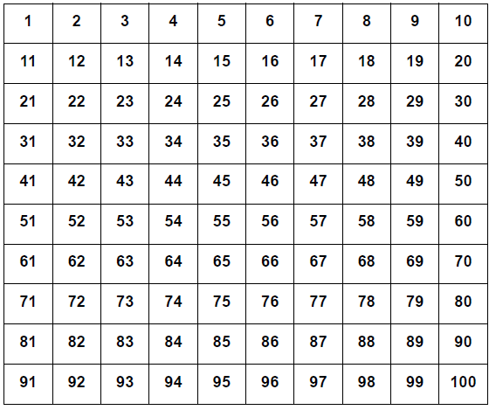
Questions we thought of while we were doing this activity:

