Introduction  Speed, time, and distance are related in the physical world and in a mathematical way. In this activity, you will  - Create distance-time plots or graphs  - Calculate the slope of the graphs  - Relate the slope to the physical world | 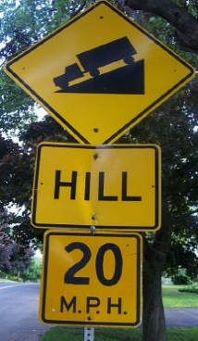
You'll Need
- TI 84 Plus CE, with Vernier EasyData™ App
- CBR 2™ motion sensor unit with mini-USB connecting cable

Using the CBR 2™ motion sensor and EasyData™ App  1. Connect the handheld with the CBR 2 using the USB cable. EasyData will immediately open, and the CBR 2 will begin collecting distance data every time it clicks. In the EasyData app, the tabs at the bottom indicate the menus that can be accessed by pressing the keys directly below. To go to File to select New, press o. To change the Setup, press q. To Start, press q. To see the Graph, press r. To Quit the app, press s. | 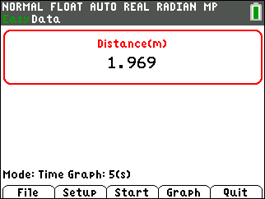
2. To change the amount of time the CBR 2 collects data for each trial, press p to change the and select Time Graph. Ask your teacher for the time of data collection. | 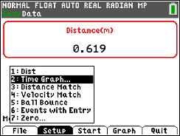
3. the settings by pressing q and enter the values shown or the ones provided by your teacher. When the changes are done, press s to the settings. This determines the range of the x-axis. | 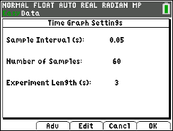
To change the range of the y-axis so that it will remain the same during all four trials, select (p) and select Scaling by pressing Á. Then the Live Graph Settings by entering the Ymin and Ymax as shown. Be sure to say No to Auto Scale After Collect. This keeps the scales of the x-axis and y-axis the same from trial to trial automatically. | 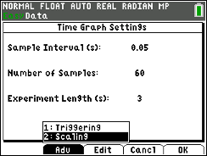
With these settings in place throughout this activity, you can compare the graphs that you make. Select (s) to return to the main screen. | 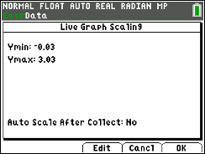
4. You will be walking four distance time graphs. After each graph is displayed, if you are not satisfied with your graph, select 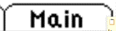 (s). Note: When you select , you will get a warning message, “The selected function will overwrite the latest run.” As soon as you select, , the CBR2 will immediately start collecting data.

5. For each trial, you will be asked to record the coordinates of two points that are on your graph and your starting distance. Use the arrow keys |~ to move through the data. The x- and y-coordinates are shown at the top. The coordinates of the point at the end of the graph at the right are (5 sec., 0.748 m). | 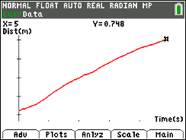
Trial 1
1. Start your walk at about 0.15 meters (6 inches) to about 0.25 (10 inches) from the CBR 2. Prepare to walk directly away from the CBR 2 at a slow but steady speed. Taking small steps can help to produce good results. Once data collection begins, move in this manner for 3 seconds. If you are not happy with the graph, repeat according to the directions in Step 4 above.
2. When you have a good graph, use the arrow keys to move through the data and record the following in the table below after sketching your graph:
- your starting distance
- the coordinates of a point (x₁, y₁) in the first half of the walk
- the coordinates of a point (x₂, y₂) that is in the last half of the walk.
Trial 2
3. Start your walk at about 0.15 m to about 0.25 m from the CBR 2. Prepare to walk directly away from the CBR 2 at a moderate but steady speed. Using larger steps than in Trial 1 can help produce good results. When data collection begins, move in this manner for 3 seconds. Repeat if desired.
4. When you have a good graph, use the arrow keys to move through the data and record the following in the table below after sketching your graph:
- your starting distance
- the coordinates of a point (x₁, y₁) in the first half of the walk
- the coordinates of a point (x₂, y₂) that is in the last half of the walk.
Trial 3
5. Start your walk at about 1.5 m to 2.5 m from the CBR 2. Prepare to walk directly toward the CBR 2 at a slow but steady speed. Taking small steps can help to produce good results. Once data collection begins, move in this manner for 3 seconds. Repeat if desired.
6. When you have a good graph, use the arrow keys to move through the data and record the following in the table below after sketching your graph:
- your starting distance
- the coordinates of a point (x₁, y₁) in the first half of the walk
- the coordinates of a point (x₂, y₂) that is in the last half of the walk.
Trial 4

7. Start your walk at about 1.5 m to 2.5 m from the CBR 2. Prepare to walk directly toward the CBR 2 at a medium but steady speed. Taking larger steps than Trial 3 can help to produce good results. Once data collection begins, move in this manner for 3 seconds. Repeat if desired. Adjust your starting point if you get too close to the CBR 2 before the 3 seconds are up.

8. When you have a good graph, use the arrow keys to move through the data and record the following in the table below after sketching your graph:
- your starting distance
- the coordinates of a point (x₁, y₁) in the first half of the walk
- the coordinates of a point (x₂, y₂) that is in the last half of the walk.

Looking at the Results
Enter your data in this table after each trial and make a sketch that resembles the graphs that you made. Round the coordinates to two decimal places.
Trial | Starting Distance | Graph of Motion | x-coordinate  (sec) | y-coordinate  (m) | Slope  (m/s)
1 | m | Close to far away, slow | x₁ =  x₂ = | y₁ =  y₂ =
2 | m | Close to far away, medium speed | x₁ =  x₂ = | y₁ =  y₂ =
3 | m | Far away to close, slow | x₁ =  x₂ = | y₁ =  y₂ =
4 | m | far away to close, medium speed | x₁ =  x₂ = | y₁ =  y₂ =

The slope or steepness of a line is defined as the amount of vertical change divided by the amount of horizontal change between two points on the line.
The equation is:
slope = where (x₁, y₁) and (x₂, y₂) represent two points.

1. Compare and Contrast:

Compare | The Distance-Time graphs of: | Contrast
 | Trial 1 and Trial 2
 | Trial 3 and Trial 4
 | Trial 1 and Trial 3
 | Trial 2 and Trial 4

2. What effect does changing speed have on the Distance-Time plot?
3. What effect does changing direction have on the plot?
4. Complete the statements to summarize the relationships between motion and the characteristics of the graph and the slope.
a. The faster the speed, the _______________ the slope.

b. Moving away from the CBR 2 makes a plot with a _______________ slope, and moving

toward the CBR 2 makes a plot with a _______________ slope.
Going Further
1. Calculate the slope of a line given the 2 points (1.5, 2.08) and (6, 4.93).

2. Explain why the units of slope in this activity are meters per second (m/s).

3. Would the value of the slope change if the formula was changed to the following?
slope =
Explain why or why not.

4. Exit the EasyData App, and press o. Based on the data (slope and starting distance) of your last walk, enter the equation of the line that would match the plot of your walk. Make sure Plot1 is on and press s.  Equation: |  | 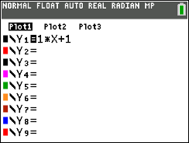
5. Study the distance-time graph below. Write a story that would match the graph. You can use your own choice of units (miles/feet/kilometers or minutes/hours/days). Be creative.
