Overview
In this activity, you will create a table and graph for a binomial distribution for a given sample size and given probability of success.

Materials
• TI-84 Plus CE™ calculator or TI-84 SmartView™ Computer Software

Part 1—Prep  1. Press Stat > Edit. You will add a new column by pressing 2nd > Del (Ins). Press 2nd > Alpha and name the column S for successes. Repeat this process and name the second column PDF.  Note: To obtain capital letters on the handheld, press the Alpha key, then the letter.  Part 2—Creating a Table for Binomial Distribution  2. Move the cursor to the top cell for the Column labeled S, and press 2nd > Stat > OPS > 5: seq(. Fill in the template with  (x, x, 0, 50, 1).  Press · to create a list of integers from 0 to 50 progressing in steps of 1. | 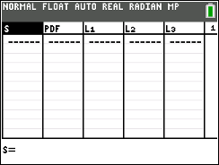  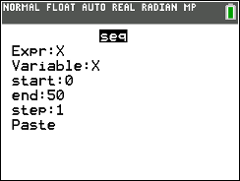
Assume that you have 50 binomial trials, where the probability of success is 0.30.  3. Move the cursor to the top cell for the Column labeled PDF, and press 2nd > Vars > A: binompdf( . Fill the template with  (50, 0.30, S).  Note: When filling in the template and using the data from the first column, make sure to press 2nd > Stat to see the list names (S). | 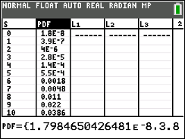
Press · to create a binomial distribution for integers from 0 to 50 where the probability of a success is 0.30.  Part 3—Creating a Graph of a Binomial Distribution  4. Press 2nd > Y = > · to open the stat plot. Turn the plot on, select the histogram, select S for the XList, and PDF for the Freq. You choose the color. | 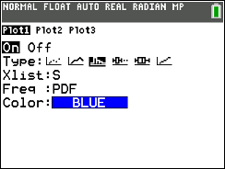
5. Press Window and change your settings to what you see to the  right. Press Graph. | 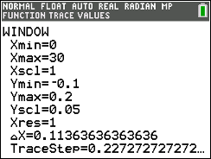
The screen to the right shows the resulting graph of a binomial distribution. | 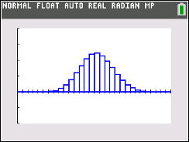
6. Students: Go to the Binomial Pdf Eye Color worksheet, and follow your teacher's directions to answer the questions.

