SCATTERPLOTS AND LINES OF BEST FIT

- Given the table of values, create a scatterplot to show the relationship between height and shoe size. Be sure to label each axis appropriately.

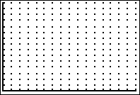
HEIGHT (in.) | SHOE SIZE
72 | 13
70 | 11
63 | 10
73 | 12
70 | 12
60 | 4.5
62 | 6
65 | 7
66 | 7.5
64 | 7
73 | 12.5
64 | 6.5
65 | 7.5
72 | 11.5

- Using a straight edge, draw a fitted line for the data.

3. Select two points on the fitted line. _______________ _______________

- Use the two points to determine the equation of the fitted line. Round answers to
two decimal places.

5. Use the fitted line to predict your shoe size based on your height. How does this
compare to your actual shoe size? (Hint: Shoe sizes are given in men’s sizes.
Ladies add 1.5 to the shoe size found to convert to a ladies shoe size.)
- Enter the data into the statics editor of your graphing calculator.
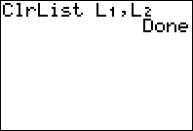
Clear lists: 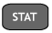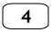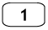
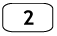

Enter the independent variable, height, as L1.

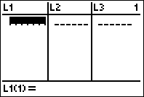
Enter each data item
followed by

Repeat the process to enter the dependent variable, shoe size, as L2.

- Create a scatterplot of the data.
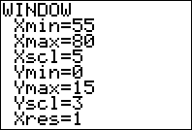
Adjust the window to fit the data.
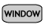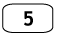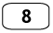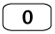
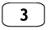

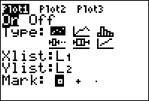
Turn on the scatterplot function.
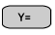

View the graph. 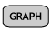

- How does the calculator’s graph of the scatterplot compare to your graph in #1?

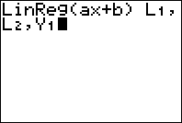
- Determine the regression equation for the line of best fit. Store the equation in the Y= Editor of the calculator.



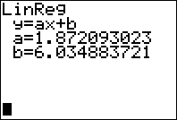

(This is only an example screen.)

- View the graph of the scatterplot with the line of best fit.

- How does the calculator’s linear regression line compare to your fitted line?

- Which method for determining the linear model for a set of data do you prefer? Explain why you prefer this method, be specific.

