In this activity, you will investigate the effect of changing the values of a and b in the polar equations $r=a±b*sin\left(θ\right)$and $r=a±b*cos\left(θ\right)$, where $a>0$ and $b>0$. You will also explore the relationship between the polar curve $r=a±b*sin\left(θ\right)$ (or $r=a±b*cos\left(θ)\right)$and the sinusoidal function $f\left(x\right)=a+b*sin\left(x\right)$ (or $f\left(x\right)=a±b*cos\left(x\right)$). |  | 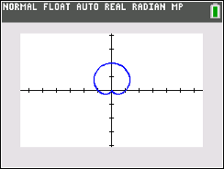
To set your calculator to Polar mode, press z and select POLAR as shown to the right. Also set your graphing calculator to Radian mode by selecting RADIAN on this screen as well.  To graph a polar equation on your graphing calculator, press o  and enter your equation. The „ key produces θ in your equation when you are in Polar mode. |  |  | 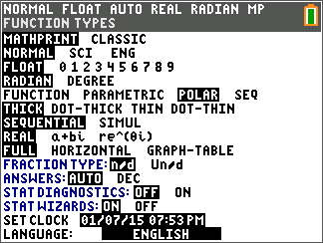
- Graph the following by editing $r1$ to observe each graph. Press q and select 4: ZDecimal.
$i) r1=1+1*sin\left(θ\right)$ $ii) r1=1-1*sin\left(θ\right)$
$iii) r1=2+2*sin\left(θ\right)$ $iv) r1=2-2*sin\left(θ\right)$
$v) r1=3+3*sin\left(θ\right)$ $vi) r1=3-3*sin\left(θ\right)$

Why do you think these graphs are called cardioids?

- What similarities do you notice about the equations of the six graphs?

- How do the addition and subtraction signs affect the graphs?
- Graph the following by editing $r1$ to observe each graph. Press q and select 4: ZDecimal.
$i) r1=1+1*cos\left(θ\right)$ $ii) r1=1-1*cos\left(θ\right)$
$iii) r1=2+2*cos\left(θ\right)$ $iv) r1=2-2*cos\left(θ\right)$
$v) r1=3+3*cos\left(θ\right)$ $vi) r1=3-3*cos\left(θ\right)$

How are the equations different from those in Problem 1? How does this difference affect the graph?

 | Limaçons have different shapes depending on the ratio $\frac{a}{b}$. We have already seen the cardioid graph that is the result when $a=b$ (or $\frac{a}{b}=1$).
- Graph the following by editing $r1$ to observe each graph. Complete the table with the values of $a$, $b$, and $\frac{a}{b}$ as you observe each graph.

Limaçon | $$a$$ | $$b$$ | $$\frac{a}{b}$$
$$i) r1=1+3*cos\left(θ\right)$$
$$ii) r1=1+2*cos\left(θ\right)$$
$$iii) r1=3+2*cos\left(θ\right)$$
$$iv) r1=2+1*cos\left(θ\right)$$
$$v) r1=3+1*cos\left(θ\right)$$

 | - If the ratio $\frac{a}{b}<1$, the limaçon has a special feature. Describe the shape of the limaçon.
 | - One of the polar curves in the table above has a ratio which satisfies $1<\frac{a}{b}<2$. Write an equation of another polar curve for which $1<\frac{a}{b}<2$. Graph your limaçon and describe the shape of the limaçon.
 | - Write an equation of a limaçon in which the ratio $\frac{a}{b}>2$. Graph your limaçon and describe the shape of the limaçon.
- The graph of the sinusoidal function $f\left(x\right)=2+2*sin\left(x\right)$ is shown below. The x-scale for the gridlines is π/6.

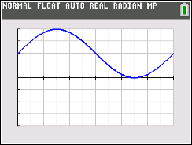

Graph the limaçon given by $r1=2+2*sin\left(θ\right)$. Press yq to access format. In the first row, use the right arrow to highlight PolarGC and press Í. Press r and then the right arrow to move your cursor. Observe the change in the r and θ values.
On the interval from x = 0 to x = 2π of the sinusoidal function, the maximum occurs at $x=\frac{π}{2}$ and the minimum occurs at $x=\frac{3π}{2}$.
How do the $y-$values at these two points correspond to the $r-$values on the cardioid?

- The graph of the sinusoidal function $f\left(x\right)=1+2*sin\left(x\right)$ is shown below. The x-scale for the gridlines is π/6.

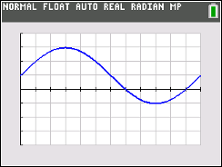

Graph the limaçon given by $r1=1+2*sin\left(θ\right)$. Press r and then the right arrow to move your cursor. Observe the change in the r and θ values. Explain why the polar curve $r=1+2sin\left(θ\right)$ has an inner loop in the interval $\frac{7π}{6}≤ θ ≤\frac{11π}{6}.$

- The graph of the sinusoidal function $f\left(x\right)=2+1*sin\left(x\right)$ is shown below. The x-scale for the gridlines is π/6.

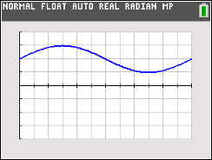

Graph the limaçon given by $r1=2+1*sin\left(θ\right)$. Press r and then the right arrow to move your cursor. Observe the change in the r and θ values. Explain why the polar curve does not contain the point located at the pole.

