Solving Multi-Step Equations
Ready, set….solve! You will create a fast-paced game to help practice solving multi-step equations. If the player’s math skills are on point, they will out run the computer. Make too many mistakes, and the calculator will win the race. Your code will generate questions for the user to answer until either the user or the computer wins. Once there is a winner, the computer will display the race and declare a winner. | Objectives:
Programming Objectives:
- Use functions to generate strings and integers
- Use the randint() function to generate random integers.
- Use the TI-Draw library to plot circles
- Use loops to repeat code
- Use if statements to make selections
- Use the sleep function to animate the plot
Math Objectives:
- Practice solving multi-step equations.
Math Course Connections: This activity is recommended for Pre-Algebra or Algebra 1.
In this program, you will generate random equations in three different forms.
Form 1: Two-step equations such as: 3x + 8 = 14 or 5x – 1 = -16
Form 2: Distribution equations such as 3(2x – 5) = -9
Form 3: Distribution equations with an additional coefficient such as -2(4x – 1) + 2 = 4
The program will ask a series of questions. If the user answers a question correctly, the user will “run” fast. If the user answers a question incorrect, they slow down. The computer answer runs each leg of the race using random probability.
Example 1:
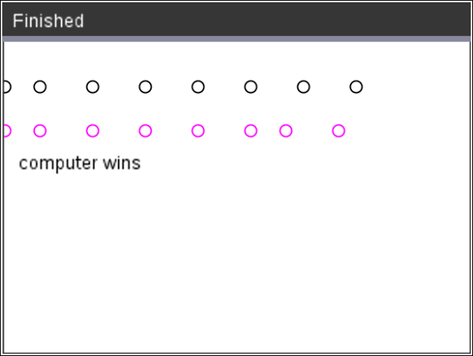 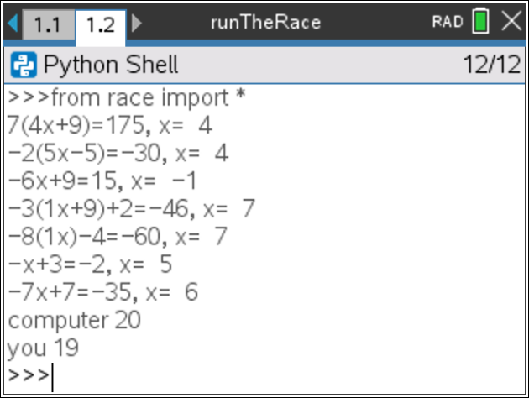

Example 2:
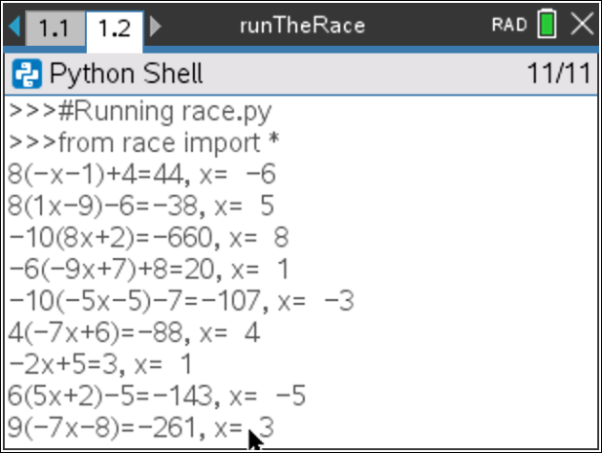 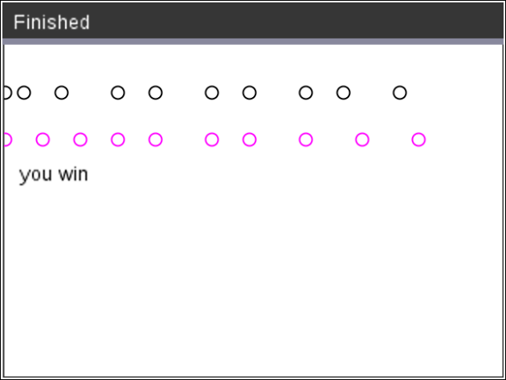 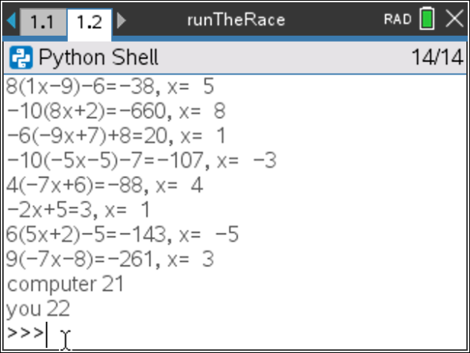
- The first step will be to create a python Geometry Graphics document.  Create a new python project named “race”.  Select “Geometry Graphics” from the type menu. |  | 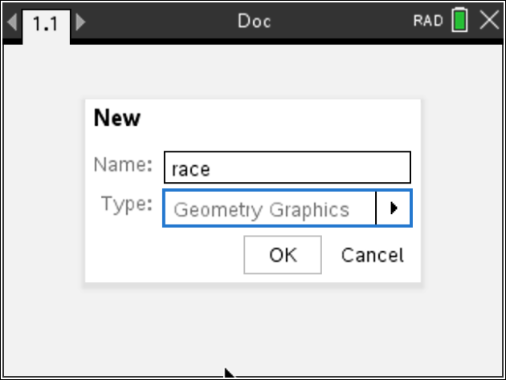
- You will need one more library, the random library.  The random library contains the randint() function.  Place your cursor on the line below the import ti_draw  Menu> Random> from random import * |  | 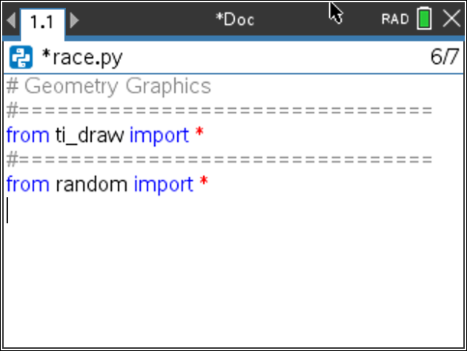
- The game will generate various single variable equations to solve.  The most basic form, will be of the form ax + b = c.  To help minimize code later, you will create a function definition.  Menu > Builts-ins > Functions < def function()  Change the name of the function to ax_b. Leave the argument empty.  The “_” key is in the ? key next to the G. |  | 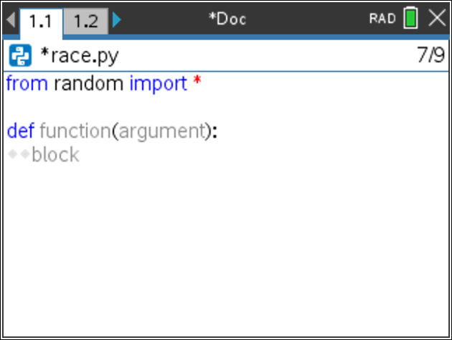  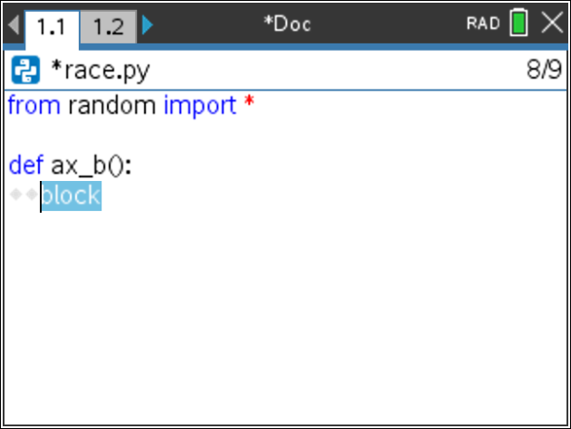
- This function generates equations in the form ax + b = c.  You will generate random integer values for a, x, and b.  You will generate integers between -10 and 10. If a is 0, set a = 1.  a = randint(-10,10)  if a == 0:  a = 1  b = randint(-10,10)  x = randint(-10,10)  Menu > Random > randint  Menu > Built-ins > Control > if  Notice the diamond pattern in the example on the right. All lines that are in the definition have indentation depths of at least two diamonds. This tells the computer the lines are part of the definition. The line a = 1, needs to have 4 diamonds because this line is part of the definition AND it is part of the if statement. |  | 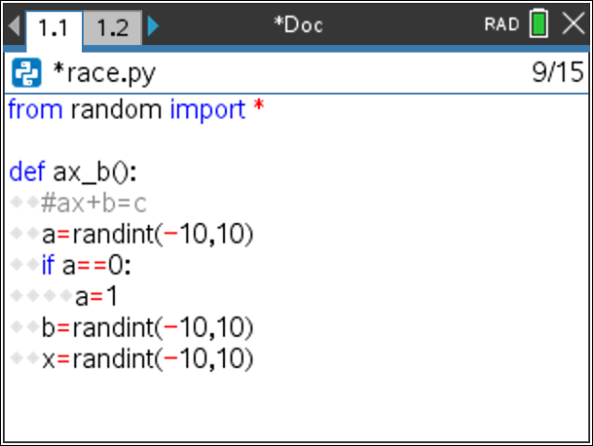
Teacher Tip:
Make sure students follow the two diamond indentation pattern. If students indent improperly, the code will not execute correctly. Make sure students use an == to check if a equals 0.
- The value of c is ax + b. Add the line  c = a*x + b  In math, you can write c = ax + b. However, in programming, this will cause an error. The compiler thinks ax is a variable. You must type c = a*x+b so the compiler knows to multiply the variable a with the variable x. |  | 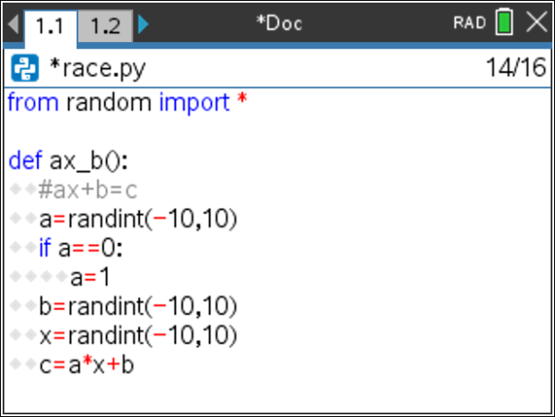
- Now to create a string display to show the equation.  If a is a 1, you should display just “x”.  If a is a -1, you should display “-x”.  For any other values of a, you should display “ax”.  We can assume the display is “x”, then over write the value if necessary.  disp = “x”  if a == -1:  disp = “-x”  elif a != 1:  disp = str(a) + “x”  Since a is an integer and “x” is a string, you must change the integer to a string before adding the two together using str(a) + “x”.  Menu > Built-ins > Control > if  Menu > Built-ins > Control > elif  Menu > Built-ins > Type > str  [ctr] [=] has both the == and the != |  | 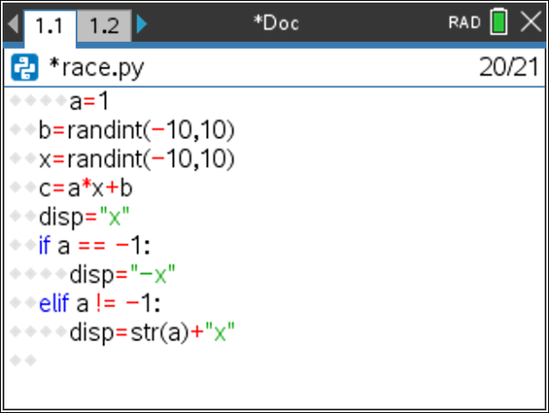
- If b is not a 0, add b to the display.  If b is positive, you need to add both a “+” and the string value of b.  If b is negative, you only need to add the string value of b, this will also add the needed “-“ sign by default.  if b > 0:  disp += “+” + str(b)  elif b < 0:  disp += str(b)  *Make sure you used the += after display. You want to add to the existing  display not replace it. |  | 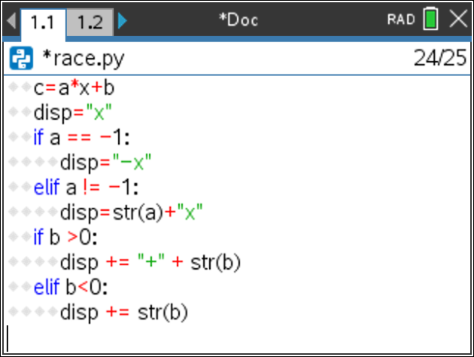
- Lastly, return the disp, x, and c.  return disp, x, c  Menu > Built-ins > Function |  | 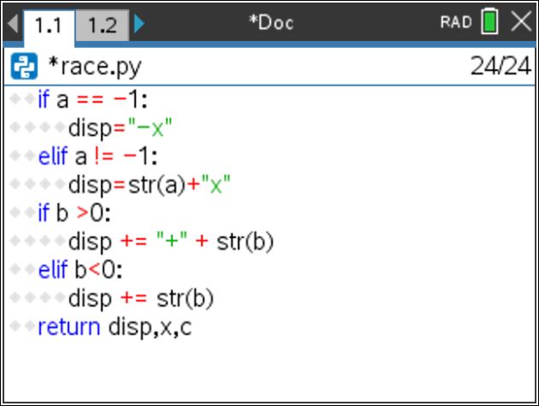
- Let’s try your function out.  Execute your program [ctrl] [r]  The screen will look blank. Press the [var] key and select ax_b  Or  Type ax_b().  Press [enter].  The sample to the right displays:  10x – 7, 8, 73  That means  10x – 7 = 73…….the value for x should be 8. Let’s verify by substitution.  10*8 – 7 =  80 – 7 =  73 = 73  Make sure your values work as well.  We successfully have a function to generate ax+b, x, c |  | 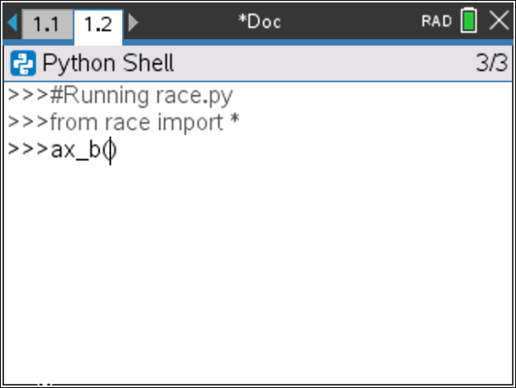  Sample:  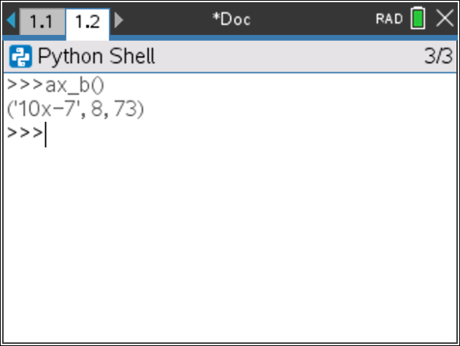
- Now that you have a function to generate ax+b, you can use this function to generate equations of the form ax+b=c and d(ax+b) = c.  Let’s write the first type.  Create a new function named type1  Menu > Built-Ins > Function > def function |  | 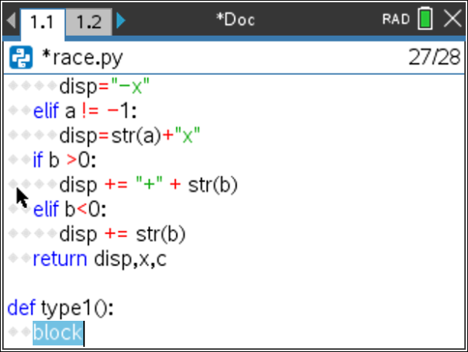
- Use the ax_b function to generate the left side of the equation, the x and c.  disp, x, c = ax_b()  **Make sure you have commas between disp, x and c.  Did you place a () behind ax_b? |  | 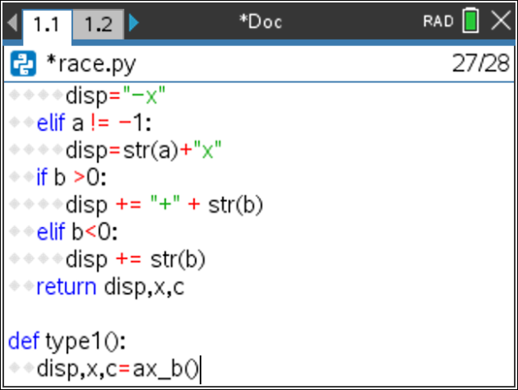
- You need to add the “=c” to the end of the display. c is an integer, so you will need to change it to a string before you can add it to “=”.  disp += “=” + str(c) |  | 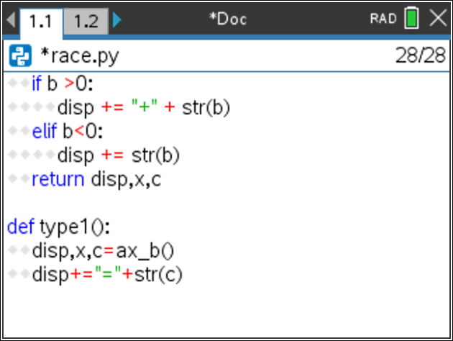
- Now, return both the display and the x value.  return disp, x |  | 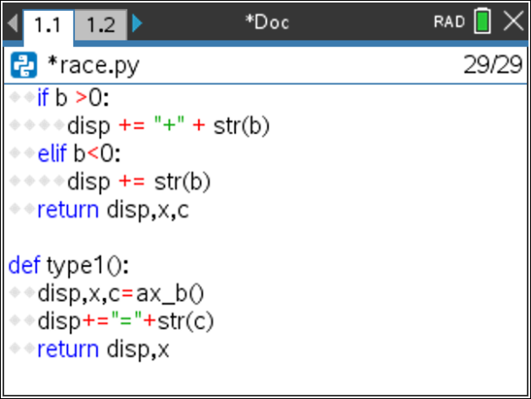
- Notice your type1 function only has three lines of code. The function ax_b() did a lot of the work. Your type2 function will be of the form d(ax+b) = c. It will also use the ax_b information to make coding shorter.  Add a function named type 2. |  | 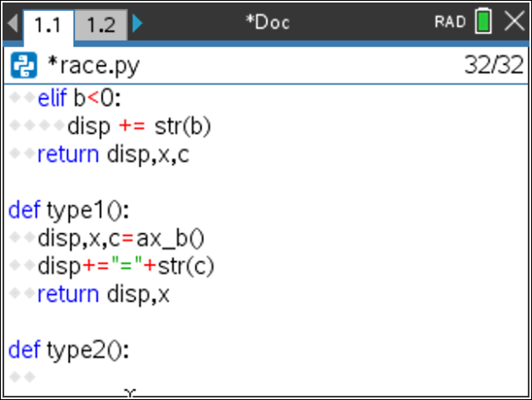
- Use the ax_b function to generate the left side of the equation, the x and c.  disp, x, c = ax_b()  **Make sure you have commas between disp, x and c.  Did you place a () behind ax_b? |  | 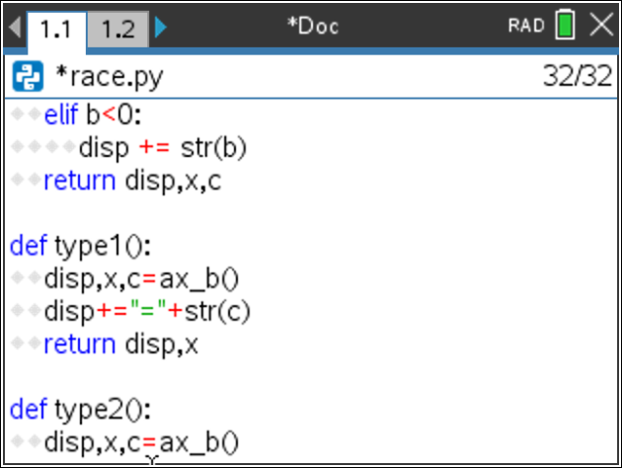
- This type will be of the form d(ax + b) = c.  We want d to be between [2,10] or [-10,-2]  You will use an if..else statement to make this happen.  You will “flip a coin”, if randint(0,1) == 0, d will be positive, otherwise d will be negative.  if randint(0,1) == 0:  d = randint(2,10)  else:  d = randint(-10,-2)  *Remember, randint is Menu > Random > randint |  | 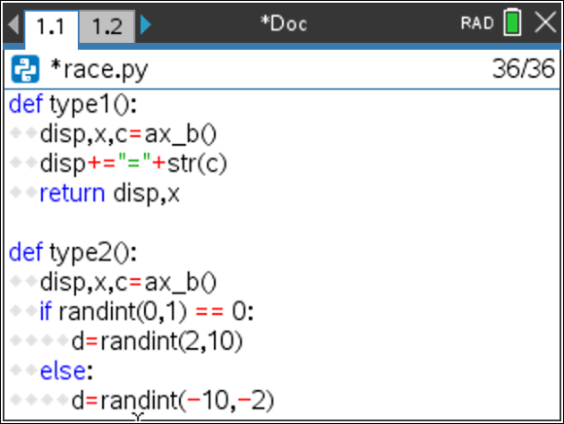
- Multiply the total by d and add it to the display:  c = c*d  disp = str(d) + “(“ + disp + “)=” + str(c) |  | 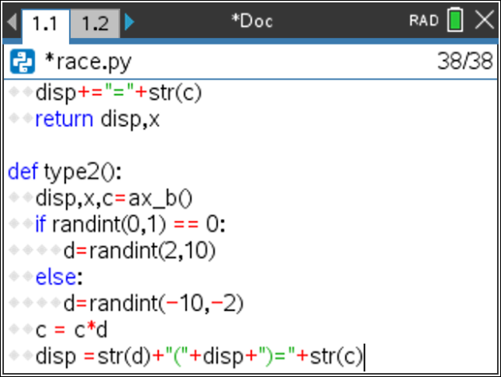
- Return both the display and x.  return disp, x |  | 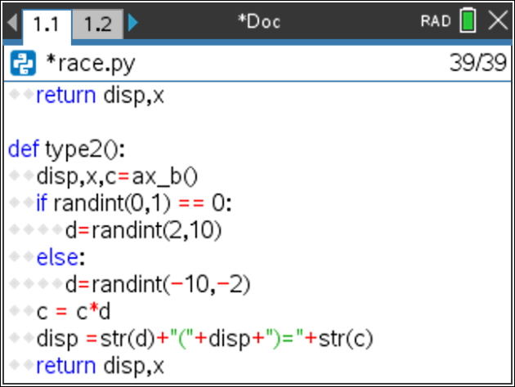
- Using type2, you can easily make a type3 problem that looks  like d(ax + b) + e = c.  Create a new function type3 |  | 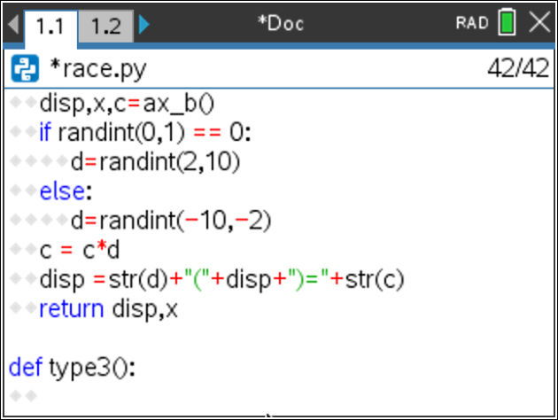
- Put your cursor at the beginning of the first line of the code for type2.  Hold the shift key down while pressing the down arrow to select all the code in the definition. The code should highlight in blue similar to the picture to the left.  Copy the code. [ctrl] [c] |  | 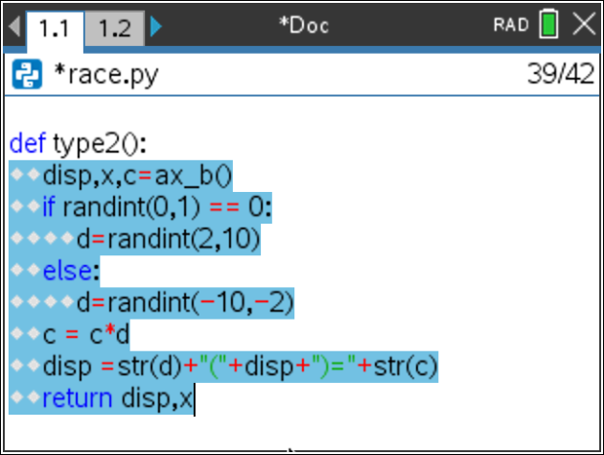
- Paste the code into type3(). [ctrl] [v] |  | 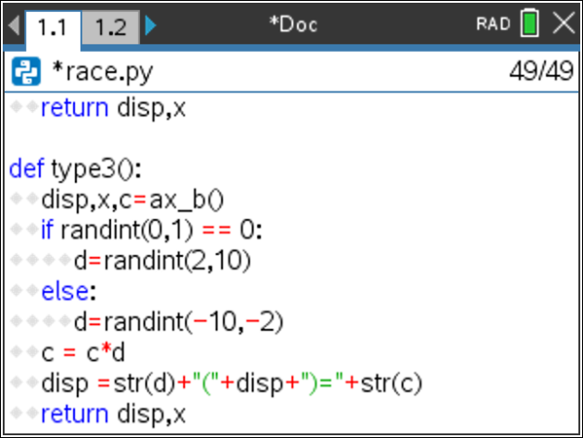
- Insert 4 lines between the if for the d value and the line c = c*d.
Variable e should be either [1,10] or [-10,-1]. Therefore the if statement is similar to the if for the variable d.
if randint(0,1) == 0:
e = randint(1,10)
else:
e = randint(-10,-1)
- Add the e to the total. Change the line c = c*d to  c = c*d + e |  | 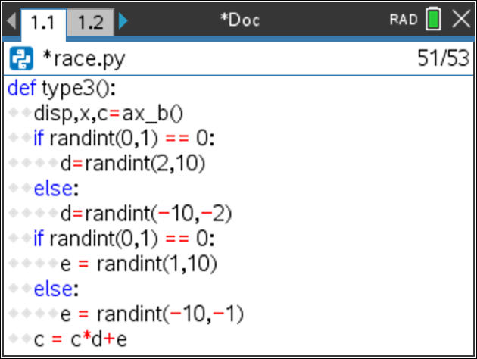
- Modify the display so it includes e. If e is positive, you’ll need to add a “+” as well as the value of e.  if e > 0:  disp =str(d)+"("+disp+")+"+str(e)+"="+str(c)  else:  disp =str(d)+"("+disp+")"+str(e)+"="+str(c) |  | 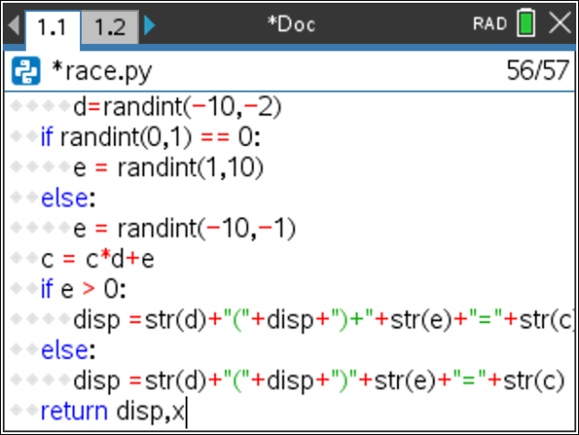
- Now that you have functions to generate random questions, you are ready to code the race.
The race layout will be:
while both players have scores under 20:
Ask a question
If the user is correct, add 2 or 3 steps, otherwise go 0 or 1 steps.
The computer moves 1 to 3 steps.
Display the race

- Create distance ran variables for the computer and the user.  Set each one equal to 0.  cx = 0  ux = 0 |  | 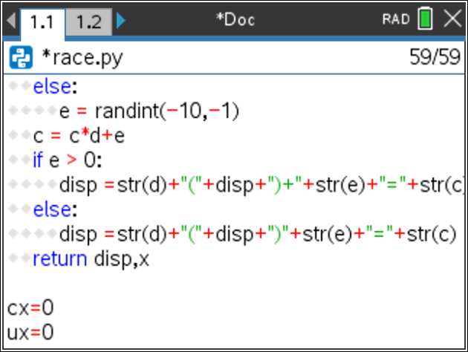
Teacher Tip:
Make sure cx and ux are not indented.
- Add two list variables to keep track of each round.  cxlist = [0]  uxlist = [0] |  | 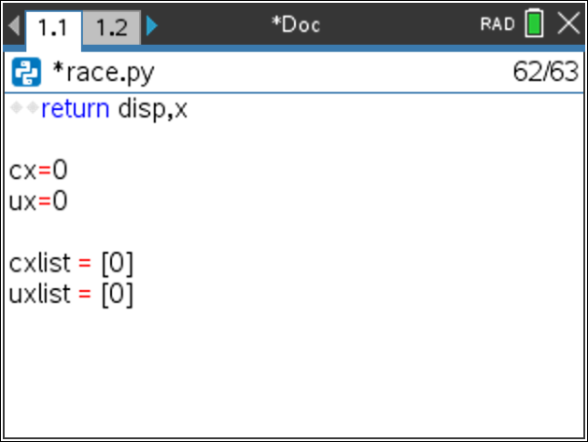
- While both players have scores under 20, continue play.  while cx<20 and ux<20:  Menu > Built-ins > Control > while  [ctrl][=] and |  | 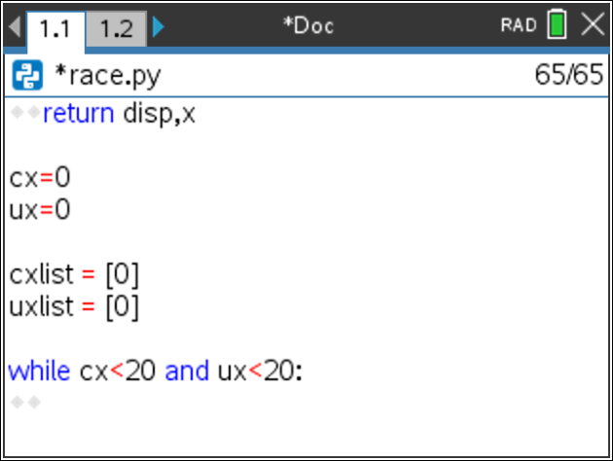
- Generate a number n from 1 to 3. Use this number to make use of the type functions to generate the question display and value for x.  n = randint(1,3)  if n ==1:  disp,x = type1()  elif n ==2:  disp,x = type2()  else:  disp,x = type3() |  | 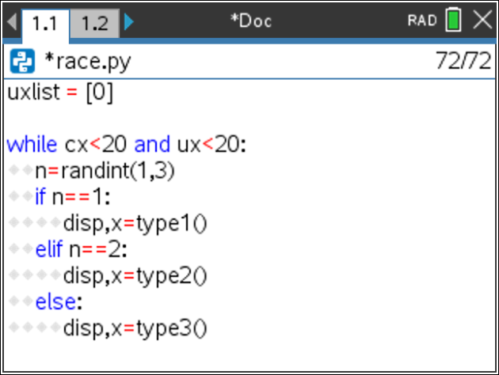
- Ask the user the question. Store the repose as u.  u = int(input(disp+”, x= “))  Menu > Control > Type  Menu > Control > I/O |  | 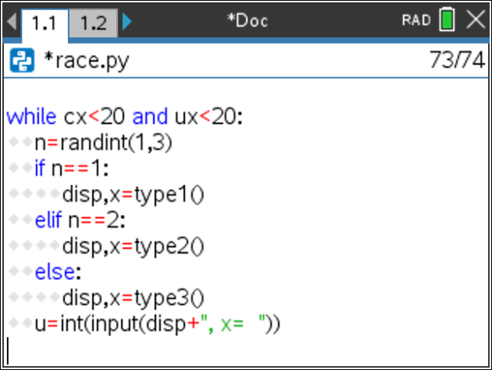
- If the user’s u matches the x value, move the player forward 2 or 3 spaces, otherwise move forward 0 or 1 spaces.  if u == x:  ux += randint(2,3)  else:  ux += randint(0,1)  **Check this carefully. Make sure you used u and ux correctly. |  | 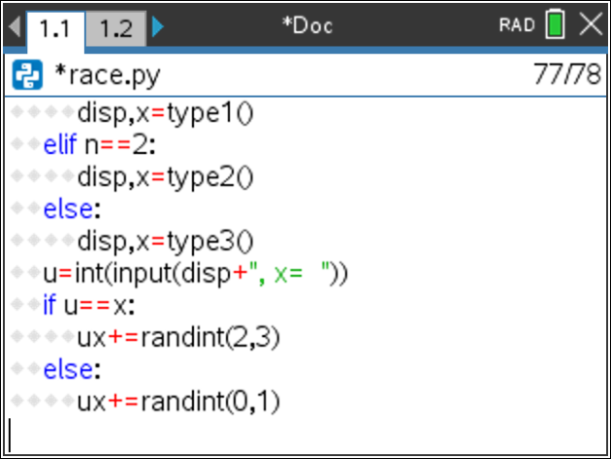
- Add between 1 and 3 steps for the computer.  cx += randint(1,3) |  | 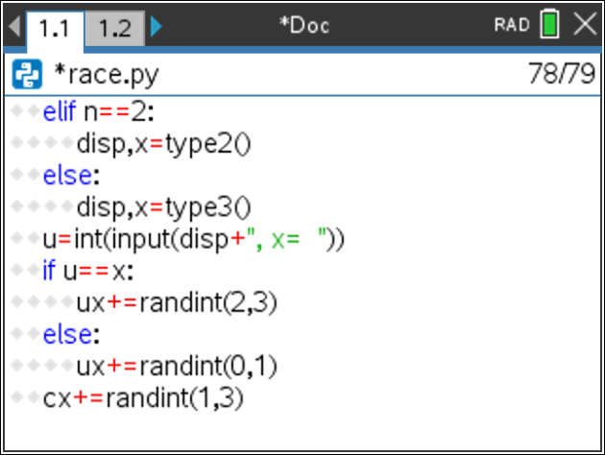
- Add ux to uxlist and cx to cxlist.  uxlist.append(ux)  cxlist.append(cx)  Menu > Built-ins > Lists > append |  | 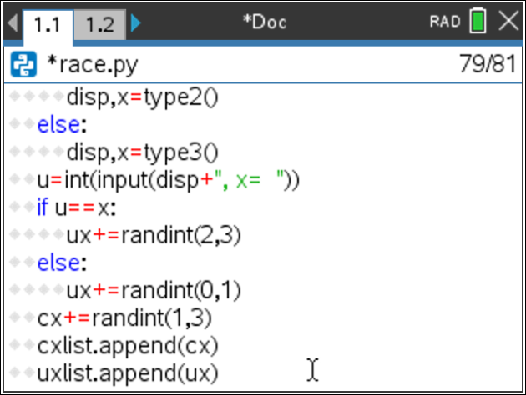
- After the loop, print the computer’s score and your score.  print(“computer”, cx)  print(“you”, ux)  Menu > Built-Ins > I/O > print |  | 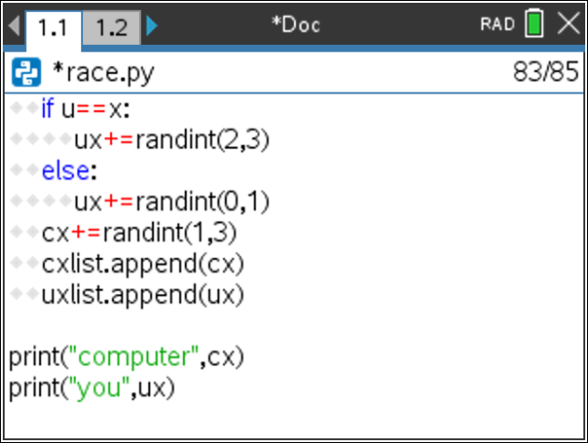
- Execute your program. [ctrl] [r]

Who won?
Run your program a few more times

- Now to add the graphics for the race. Add the ti_draw library.  Menu > More Modules > Draw |  | 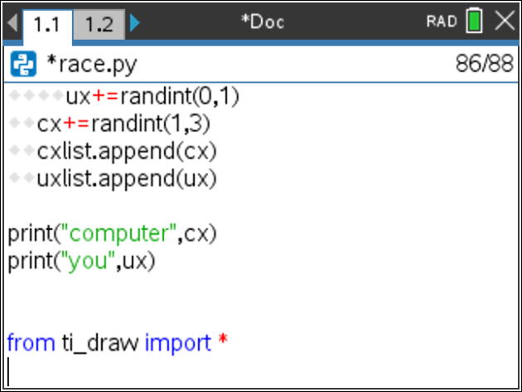
- Add the time library.  Menu > More Modules > Time |  | 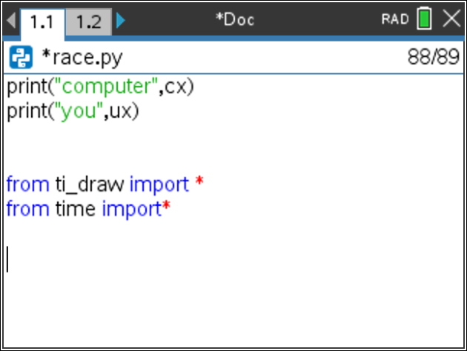
- For each item in the list we need to draw a circle to represent a step.  The number of items in the list can be found using len().  Add the line:  for i in range( len(cxlist) ):  Menu > Built-ins > Control > for  Menu > Built-ins > List > len |  | 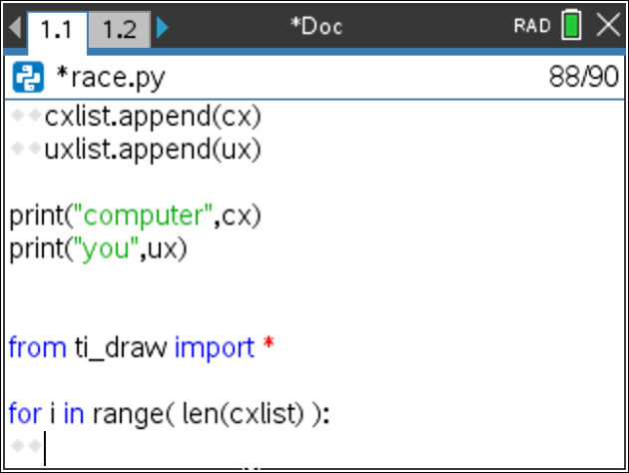
- Draw the computer’s circles using the values in the list.  Each item in the list can be accessed using the index with square brackets.  Set the computer y height to 30. Make the circles have a radius of 4.  draw_circle(cxlist[i]*12, 30, 4)  Menu > More Modules > TI-Draw > Shape > draw_circle |  | 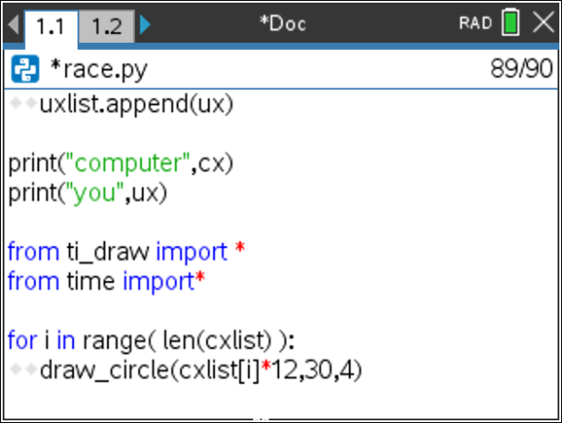
- Change the color for the user’s circles, draw the user’s circle, reset the color.  set_color(255,0,255)  draw_circle(uxlist[i]*12,60,4)  set_color(0,0,0)  Menu > More Modules > TI-Draw > Control > color |  | 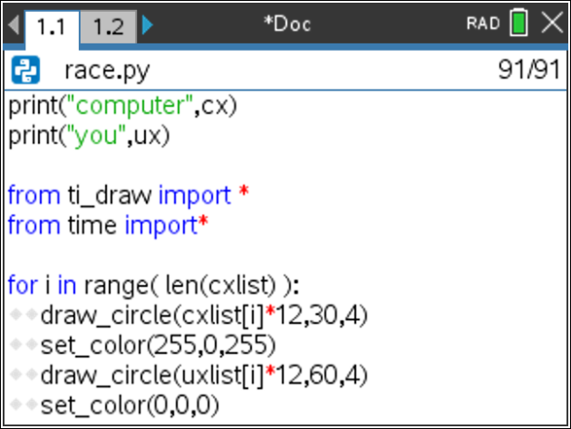
- Add a short sleep pause for 0.2 seconds.  sleep(0.2)  Menu > More Modules > Time > Sleep |  | 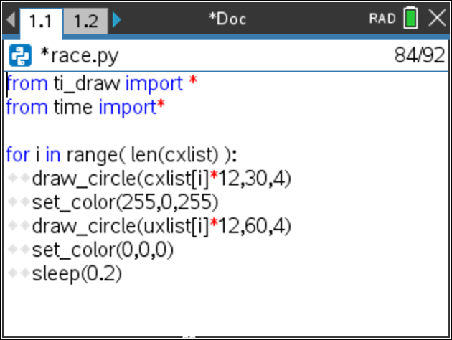
- Add an if statement that will print the winner.  if cx > ux:  draw_text(10,90,”computer win”)  else:  draw_text(10,90,”you win”) |  | 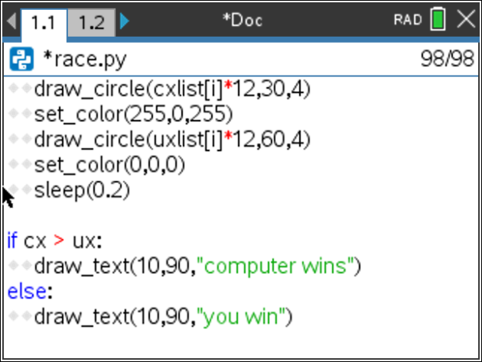
- Play your game several times. How often can you beat the computer?

- Challenge:
Currently, your code from step 42 declares you the winner if you tie.
Can you modify your code to say “tie”, if cx equals ux?

Teacher Notes: Challenge answer
if cx > ux:
draw_text(10,90,”computer win”)
elif cx == ux:
draw_text(10,90,”tie”)
else:
draw_text(10,90,”you win”)

Teacher Notes:
# Geometry Graphics
#================================
from ti_draw import *
#================================
from random import *

def ax_b():
a=randint(-10,10)
if a==0:
a=1
b=randint(-10,10)
x=randint(-10,10)
c=a*x+b
disp="x"
if a == -1:
disp="-x"
elif a != -1:
disp=str(a)+"x"
if b >0:
disp += "+" + str(b)
elif b<0:
disp += str(b)
return disp,x,c

def type1():
disp,x,c=ax_b()
disp+="="+str(c)
return disp,x

def type2():
disp,x,c=ax_b()
if randint(0,1) == 0:
d=randint(2,10)
else:
d=randint(-10,-2)
c = c*d
disp =str(d)+"("+disp+")="+str(c)
return disp,x

def type3():
disp,x,c=ax_b()
if randint(0,1) == 0:
d=randint(2,10)
else:
d=randint(-10,-2)
if randint(0,1) == 0:
e = randint(1,10)
else:
e = randint(-10,-1)
c = c*d+e
if e > 0:
disp =str(d)+"("+disp+")+"+str(e)+"="+str(c)
else:
disp =str(d)+"("+disp+")"+str(e)+"="+str(c)
return disp,x

cx=0
ux=0

cxlist = [0]
uxlist = [0]

while cx<20 and ux<20:
n=randint(1,3)
if n==1:
disp,x=type1()
elif n==2:
disp,x=type2()
else:
disp,x=type3()
u=int(input(disp+", x= "))
if u==x:
ux+=randint(2,3)
else:
ux+=randint(0,1)
cx+=randint(1,3)
cxlist.append(cx)
uxlist.append(ux)

print("computer",cx)
print("you",ux)

from ti_draw import *
from time import*

for i in range( len(cxlist) ):
draw_circle(cxlist[i]*12,30,4)
set_color(255,0,255)
draw_circle(uxlist[i]*12,60,4)
set_color(0,0,0)
sleep(0.2)

if cx > ux:
draw_text(10,90,"computer wins")
else:
draw_text(10,90,"you win")

