
CABRITM Jr. ACTIVITY:

Investigate the lengths of two tangents to a circle from the same exterior point.

ACTIVITY OVERVIEW:  In this activity we will  - Draw a circle  - Draw two tangent lines  - Find the point of intersection  - Measure the distances  - Animate one of the tangents | 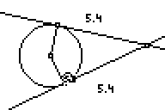
Press  and move down to the CabriJr APPLICATION then press. Press  for the F1 menu and select New. (If asked to Save changes? Press  to choose “No.”) | 
Press  for F2, move to Circle and press . Move to the location of the center and press . Move to a point the distance of your radius and press . Press  to exit the circle drawing tool. | 
Press for F2, move to Point. Press and move to Point on. Move the arrow close to the top part of the circle and press . Next move the arrow to the bottom of the circle and press . Press to exit the drawing tool. | 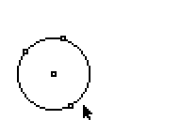
Press for F2, move to Segment. Move the arrow to the center point and press . Move the arrow to one of the point on the edge of the circle and press . This will create one radius. Repeat the process to draw the second radius. | 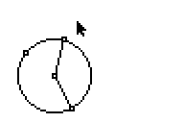
Press  for F3, move to Perp. Move the arrow to one of the radii so the radius is flashing. Press and move the arrow to the edge of the circle until the endpoint is flashing as well, then again press . This will create a tangent line to the circle through the point. Repeat the process to draw the second tangent line. Press to exit the drawing mode. | 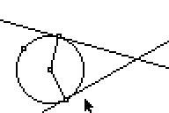
Press and move to Point then to select Intersection. Mover the arrow to where your two tangents are intersecting and press . Press to exit the drawing mode. | 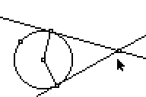
To measure the distances from the external point to the points of tangency, press  for F5. Move down to Measure and press . Select D. & Length and press . Position the arrow at the external point until it is flashing then press . Move the arrow to one of your points of tangency so that it is flashing as well then press . The moving hand should appear with the measurement of the distance. Move the distance to where you would like it and press . Repeat the process for the second line of tangency. Press to exit the drawing mode. | 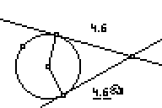
To Animate the drawing press for F1. Select Animate and . Move the arrow to the lower point of tangency so that the point is flashing and the symbol ↔ appears then press . | 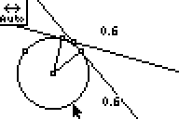  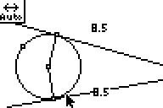
Exit the APP using the F1 and selecting Quit, or pressing  to Quit. | 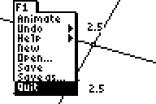

Question:
Describe any conditions where the two tangent lines will not intercept.

From this we can state the following Theorem:
If two segments from the same exterior point are tangent to a circle, then the segments are congruent.
If AT and HT are tangent to Circle B , then  AT HT. | 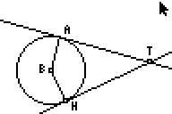

Construct a flow-proof for the Theorem:
If two segments from the same exterior point are tangent to a circle, then the segments are congruent.

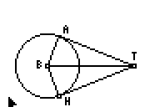
Given:
- AT is tangent to Circle B

- HT is tangent to Circle B

Prove:
- AT HT

Scrambled Statements (top) | Scrambled Reasons (bottom)
- AT HT  - AB HB  - TB TB  - TBA TBH  - AT and HT are tangent to Circle B.  - AT  AB and HT  HB | - Tangent and Radius are perpendicular  - Definition of Radius  - Corresponding Parts of Congruent Triangles are Congruent  - Given  - Reflexive Property  - Hypotenuse Leg Congruence Theorem

Teacher Answer Key:

Question:
The lines of tangency will not intercept when the two tangents lines are parallel. This results when the two points are the endpoints of a diameter.

Flow Proof:

AT and HT are tangent to Circle B.

Given

AB
HB

Def of Radius

AT  AB and HT  HB

Tangent and Radius are 

TB
TB

Reflexive Property

TBA
TBH

HL Theorem

AT
HT

CPCTC

