Personal Polynomials |  |  |  | Insert School Logo Here
Name: |  | Class:

Instructions:
- Sections in blue font are designed for teacher notes and instructions.
- Sections in red font represent answers, where applicable.
- There are two TI-Nspire files associated with this investigation:
  - Personal Polynomial – The included program generates the polynomial for a given name. This makes correcting student work much faster!
  - Three Letter Names – This document allows students to explore three letter names only, by dragging points to see how the function changes.
- Edit this document to suit the needs of your students / course and save it with all your questions / answers / notes. Then save a copy of this document adding STUDENT to the document name, then delete all the parts not intended for student use.
- Note: This version of Personal Polynomials is designed as an investigation, however Personal Polynomials is also available as a directed activity in three different formats.
  - Version 1 – Includes Programming – Activity includes instructions to help students write a program
  - Version 2 – Includes Programming – Activity includes an instructional video to help write a program.
  - Version 3 – No programming, just ‘mathematics’.
- A PowerPoint file is available for this version of Personal Polynomials (This version). The PowerPoint slides can be used to help introduce the investigation to students.

Introduction
Not everyone has a street named after them, but everyone can have a polynomial. What does your polynomial look like? In this activity you will change your name into a set of points and determine the polynomial that passes through these points, your personal polynomial. How does your polynomial compare and interact with others? How much can you tell about someone’s polynomial by just looking at their name?
The ‘ord()’ command on the calculator returns the ASCII code for the corresponding text.
ASCII code maps 128 characters, the more sophisticated UNICODE maps 2²¹ characters.

Technology Tip!

Explain what the ‘mid’ command does.
Answer: This command works the same as the equivalent Excel command. The ‘mid’ command returns any section of a text string where the first part of the command syntax is the text string; the second part determines the starting location and the third is the length of the string returned.
Examples: mid(“Maths”,2,1) = a. mid(“Maths”,1,3) = Mat.
In mathematics one function can be embedded inside another, these are referred to as composite functions. The output of one function feeds directly into the input of another. This may be expressed as: .  In this case, two programming commands “ord” and “mid” will be combined to produce a single result.  The output from the ‘mid’ command is fed into the input of the ‘ord’ command.  Type in the following combination:  ord(mid(“Maths”,2,1)) | 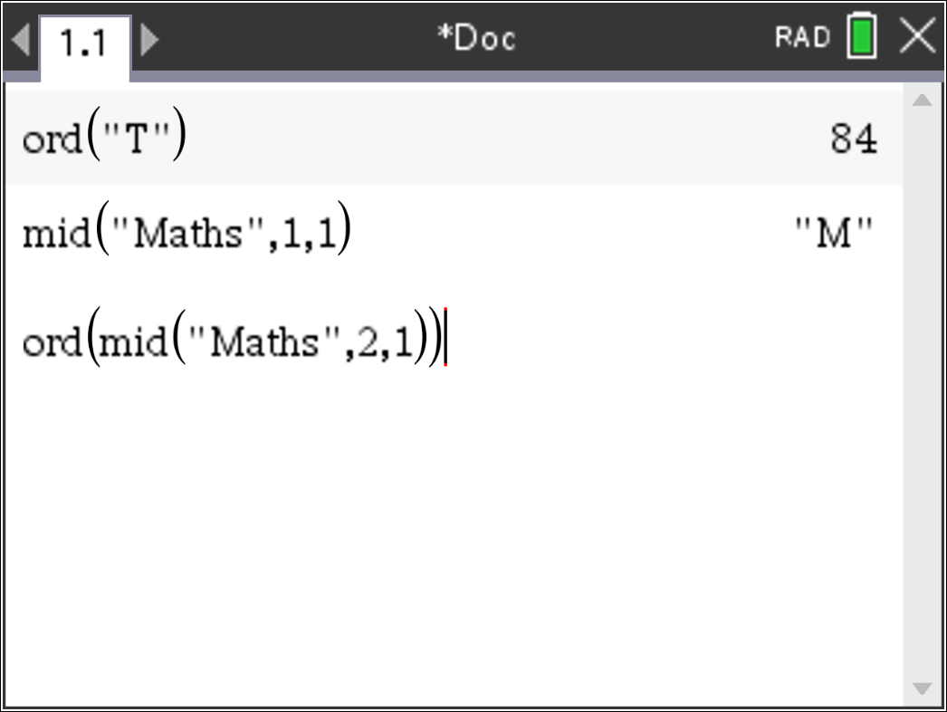

A short cut for entering the ord(mid(“Maths”,2,1)) combination is to start with ord( then arrow up through the history to select mid(“Maths”,2,1) and press Enter to paste it directly into the ord() command.

Technology Tip!

The last piece in this puzzle is the “dim” command.  Try the following:  dim(“Maths”) | 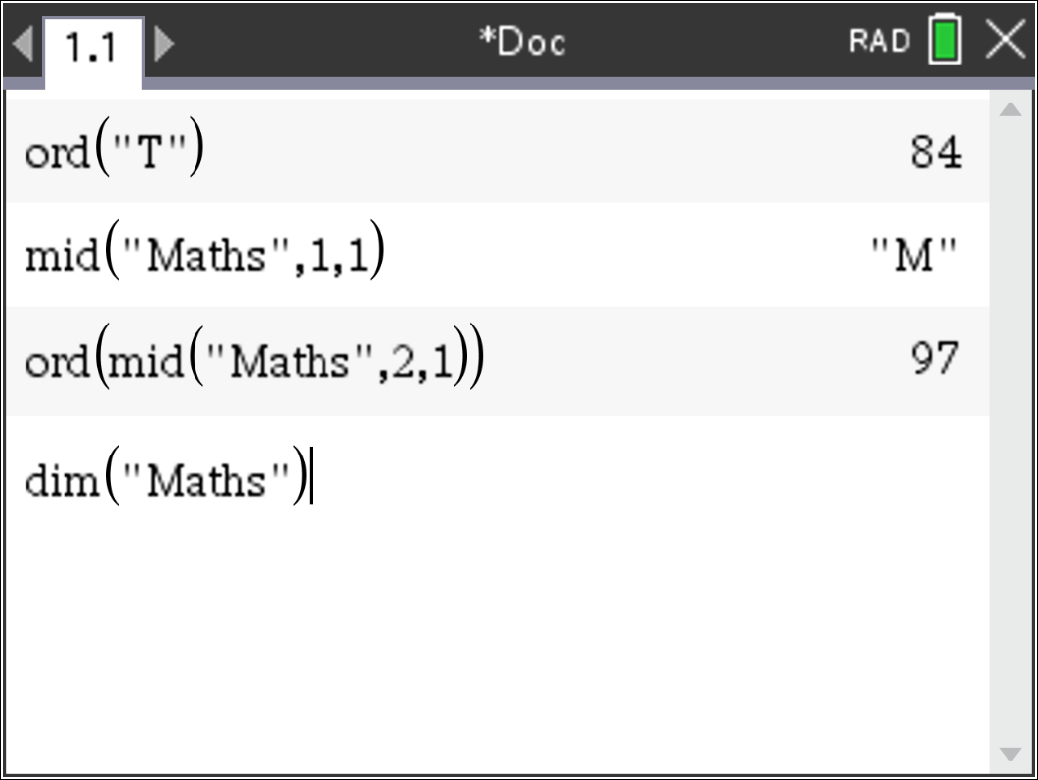

What does the dim() command do?
Answer: This determines the length of the string. dim(“Maths”) = 5. dim(“John”) = 4
You’re now ready to write a program!  From the menu select:  Functions & Programs > Program Editor > New  Enter the name for your program:  N2N (name to numbers)  The program application will appear in a split screen. Press Ctrl + 6 to ungroup the two pages. The program editor will be moved to Page 1.2. Navigate to Page 1.2 to start working on the program. | 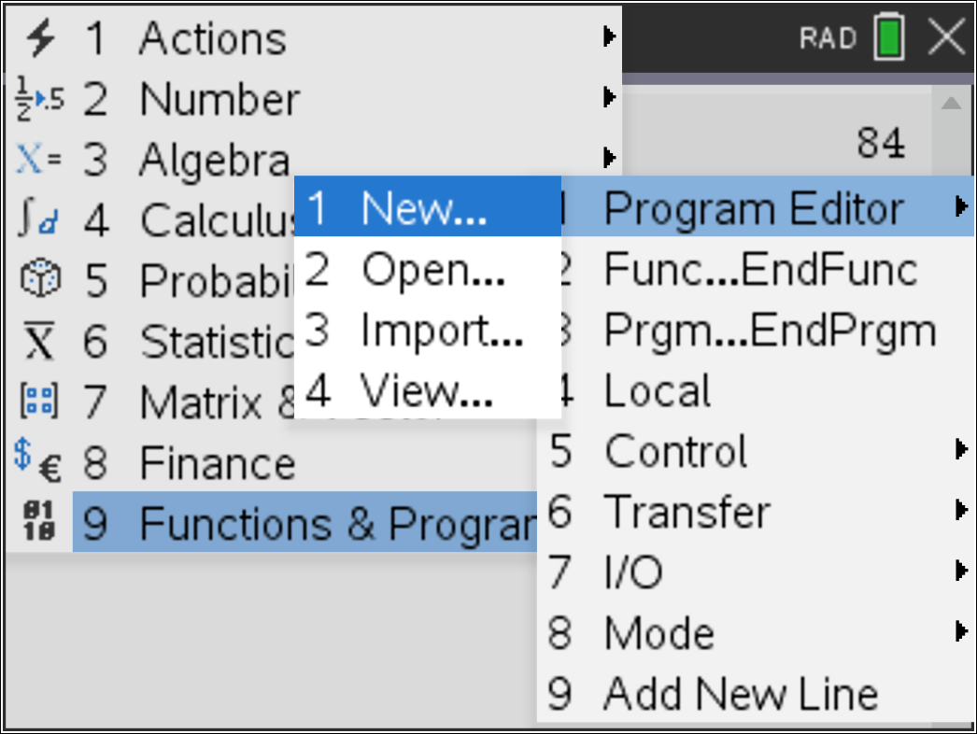
The first step in the program is to request the text to be converted into numbers. Text variables in programs are referred to as strings.  From the menu select  I/O > RequestStr  I/O = Input / Output  RequestStr = Request a string. | 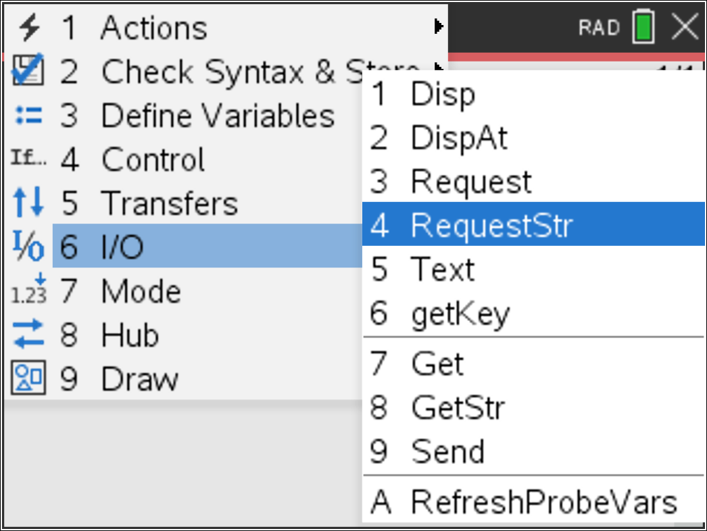
The Request-String command can include some prompting text relating to what is required.  Enter the following in the request command:  “Enter your name ”,name  This creates a text prompt “Enter your name” and creates a ‘string’ variable ‘name’ that will hold the text to be converted into numbers and ultimately become a polynomial. | 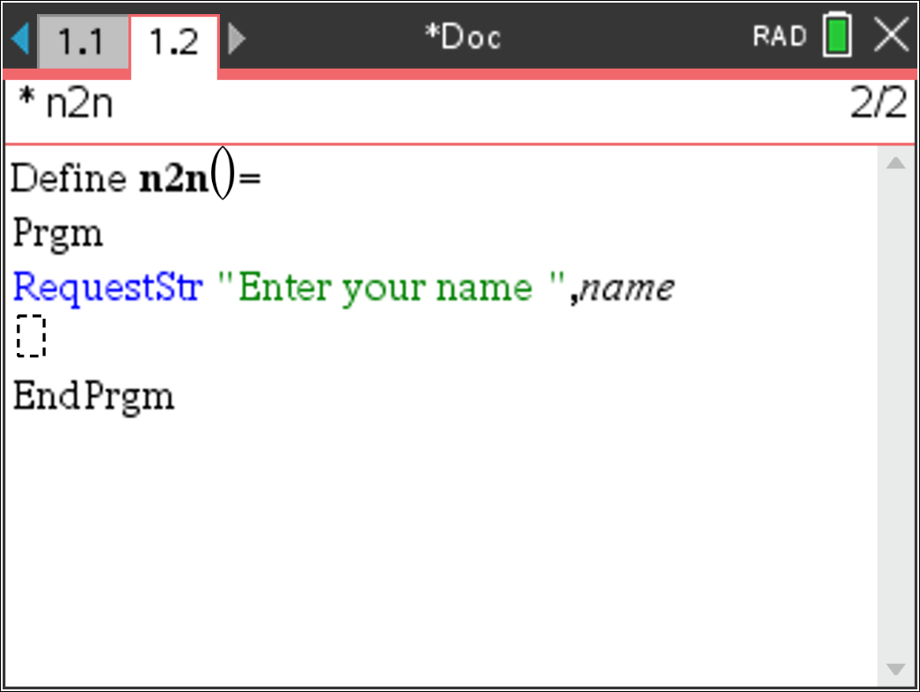
The value assigned to each letter will be determined character by character, a loop needs to be created to extract each letter using the commands explored earlier. The number of times the loop needs to be executed is determined by the number of letters in the ‘name’.  Type the following:  d:=dim(name)  A list also needs to be created to hold all the values.  n:=seq(0,x,1,d)  This creates a list filled with zeros, place holders for our final values. | 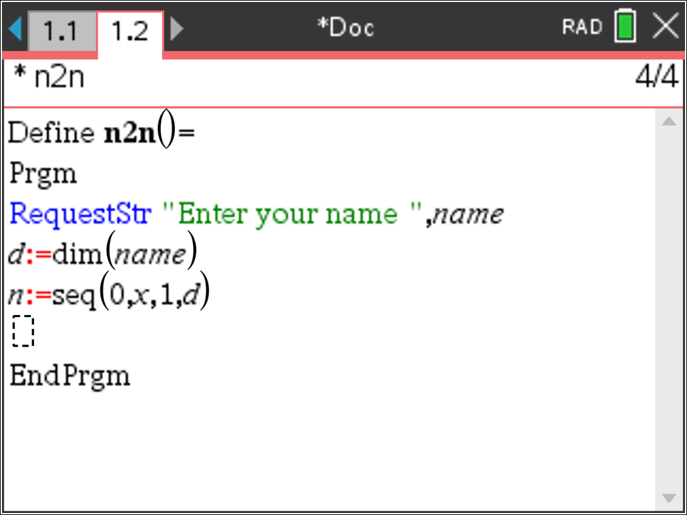
A “For” loop can be used to successively capture the value of each letter.  Use the menu and select:  Control > For…EndFor  Set the loop with a counter (i), starting at 1 and finishing at ‘d’.  See below right for more detail on the syntax of the For command. | 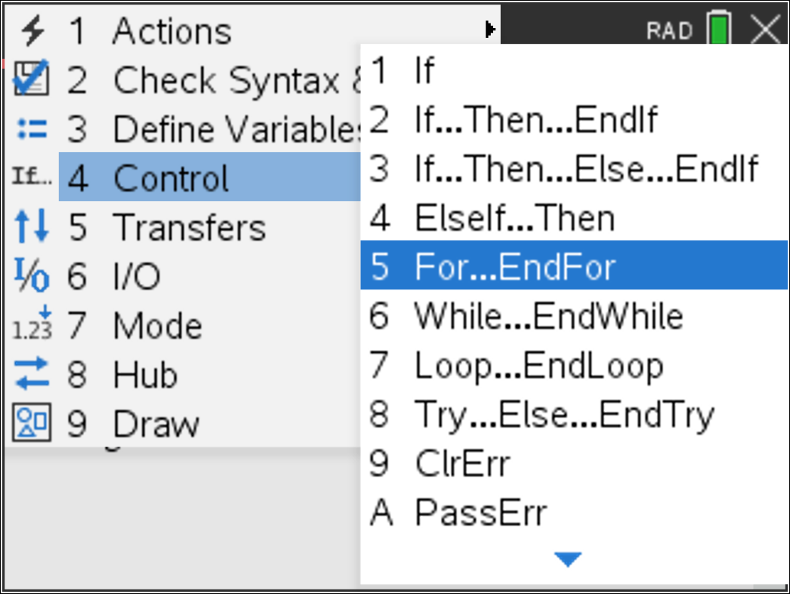
The first value in the list is equal to the numerical quantity aligned with the first letter of the ‘name’. To identify the first value in the list for ‘n’,  use [ ] brackets.  Type:  n[i]:=ord(mid(name,i,1))  Recall from the previous questions how the ‘ord’ and ‘mid’ commands work. | 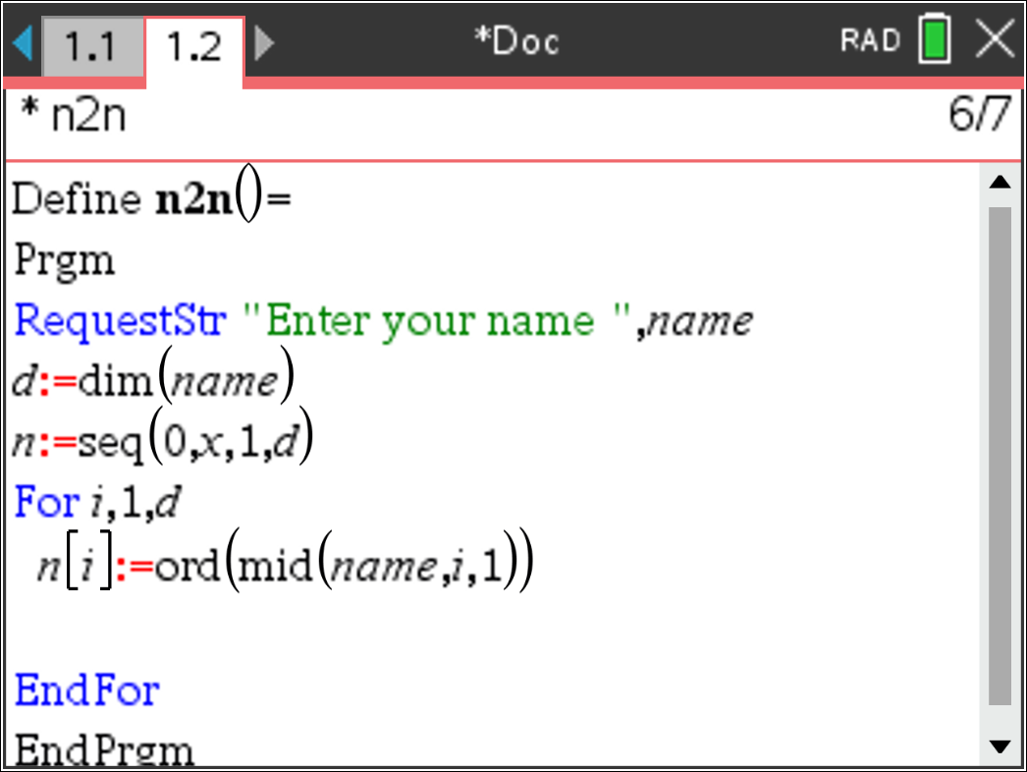
The final step in the program is to make the letter values range between 1 & 26. This can be done using an IF … THEN … ELSE statement.  If the letter value is greater than 96, then it is lower case. The ASCII code for ‘a’ is 97. The ASCII code for ‘b’ is 98 and so on, subtracting 96 will align these values to 1 to 26 for a to z respectively.  The ASCII codes for upper case letters such as “A” start at 65, so we need to subtract 64.  Notice how lower case letters were checked first! Why?  The program is now ready to run. Press Ctrl + R, then Enter to execute. | 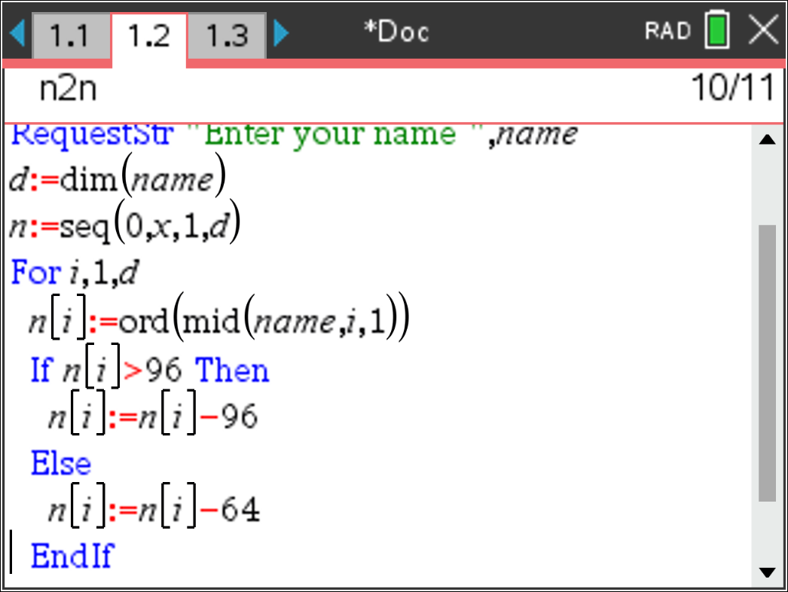
Write down your name as numbers from 1 to 26. [Note: On the calculator you can type: n]
Answer: Answers will vary. Use the program to check student’s answers. Note that students can simply type ‘n’ since it is a list created by the program.
Teacher Notes:
Teachers can encourage students to use a shorter (abbreviated) name where applicable. Names such as Alexander shortened to Alex but not Joseph shortened to Jo! If a student’s first name is not applicable, consider their middle name or surname.
The degree of the polynomial is typically one unit lower than the number of letters in the name. This does very a little depending on the name!

Write down the coordinates for the points that your polynomial must pass through: (1, #), (2, #) etc...
Answer: Answers will vary. Straight forward question designed purely to help students organise their information and align it with question 8 and later to help check their answer.

What is smallest degree polynomial that will pass through all of your points? What assumptions do you need to make?
Answer: Answers will vary. The polynomial will generally be one degree lower than the number of letters in the name being used. Students should however provide some justification for their answer. For example: Each letter generates another point for the function to pass through. For a linear function two points are required. For a quadratic, three points are required, however if the points are in a straight line a three letter name could be covered by a linear function.
Teacher Notes:
Example: John (4 letters) generates a polynomial of degree 3. Some names are relatively unique, for example: “Amy”. Whilst she has 3 letters in her name, suggesting a polynomial of degree 2, the letters are equally distributed in the alphabet resulting in a linear function. Palindromic names provide further challenges and restrictions as students will establish the further they progress through this guided exploration.

Define your polynomial as: according to the degree of your polynomial. Using your points from Question 6, write down the simultaneous equations that need to be solved in order to determine the equation for your polynomial.
If you used a program to help with changing your name from letters to numbers, you will need to delete the value stored in ‘d’: DelVar d

Technology Tip!
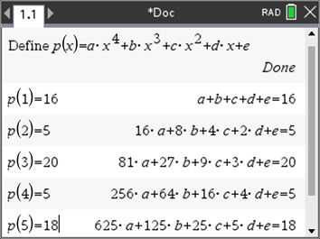
Answer: Answers will vary depending on the student’s name.
Example: Peter
This results in relatively straight forward equations:
Teacher Notes:
To check the coefficients for each equation, run the mypoly() program in the Personal Polynomial TI-Nspire file. Use the student’s name. A matrix “M” is created that contains the coefficients. Once the program has finished; type: M to see the coefficients.

Determine the solution to the simultaneous equations (Question 8) and hence write down the equation to your polynomial.
Answer: Answers will vary.
Teacher Notes:
Students can work through the equations by hand depending on the degree of the polynomial, however this can generate a disproportionate amount of work for Alexandria compared with Joe. Students may also use the ‘solve’ command or set up the equations as a matrix and use Row-Reduction-Echelon form.

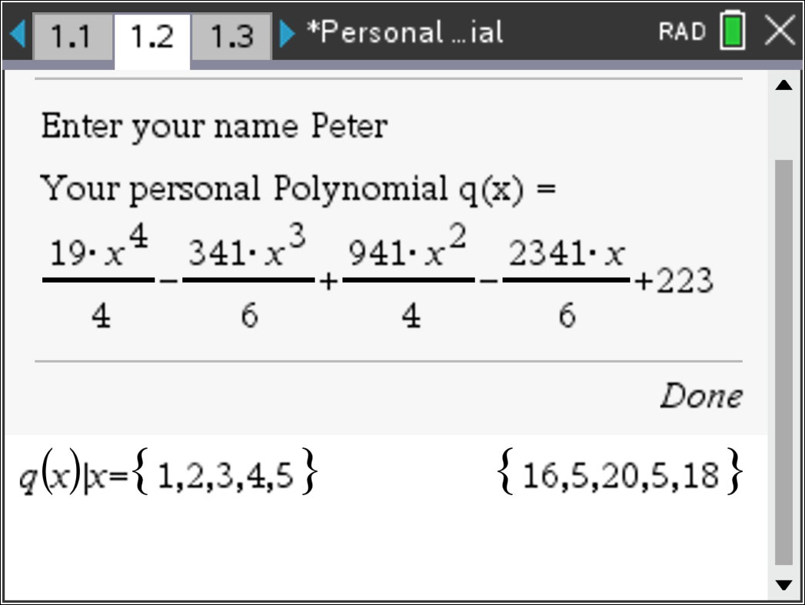
Generate a table of values to show that your polynomial passes through the appropriate points.
Answer: Answers will vary.
Teacher Notes:
The teacher TNS file stores the student equation in q(x). It is therefore quick and easy to perform a substitution as shown opposite.
Use the bisection method to determine the x-intercepts of your polynomial.
[Consult with your teacher if your personal polynomial does not have any x axis intercepts.]
You can write a program to perform the bisection method. Use the instructions below or scan the QR code to watch an explanation of the bisection method and instructions for writing the program.
Answer: Answers will vary. Students should generate a table of values that demonstrates how the location of point P generally toggles between the boundary conditions.
Teacher Notes:
The teacher TNS file includes the bisection program.
Where a student’s polynomial does not cross the x – axis, students can find where their polynomial intersects with the line: y = 10 (or similar). This means the student needs to translate their polynomial accordingly and the use the bisection method on the result.
Bisection Method
You can use the bisection method to find where your polynomial crosses the x axis. For the purposes of these instructions, it is assumed that the polynomial is stored in:
Insert a new program and call the program:
Bisection
Some variables may have already been used resolving your personal polynomial. It is therefore worthwhile defining some of the variables used in this program as ‘local’. Defining variables as local means they won’t interfere with variables of the same name outside the program.  From the menu select:  Define Variables > Local  Variables a, b, i, n are all local. [Use a comma to separate variables] | 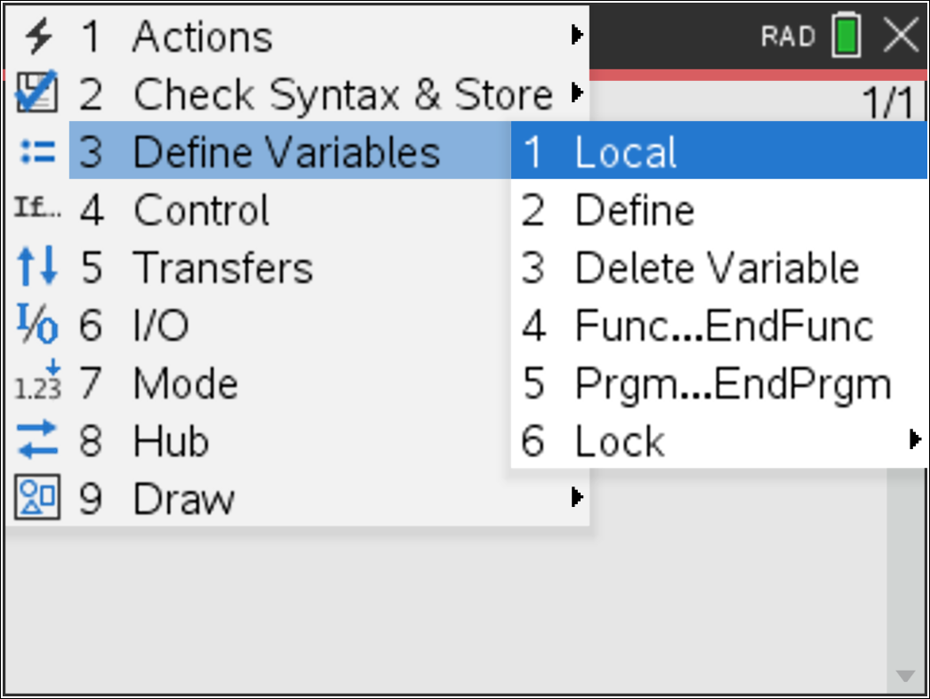
The program needs a left and right bound location between which to search for solutions. So the first step is to request these values.  From the menu select:  I/O > Request  Enter the text in quotation marks: “Left: ” followed by a comma and the variable ‘a’. When the program is running the prompt “Left” will appear and the value will be stored in ‘a’.  Repeat this process and request the “Right” boundary and store it in ‘b’ and also the number of “Iterations” to be stored in ‘n’. | 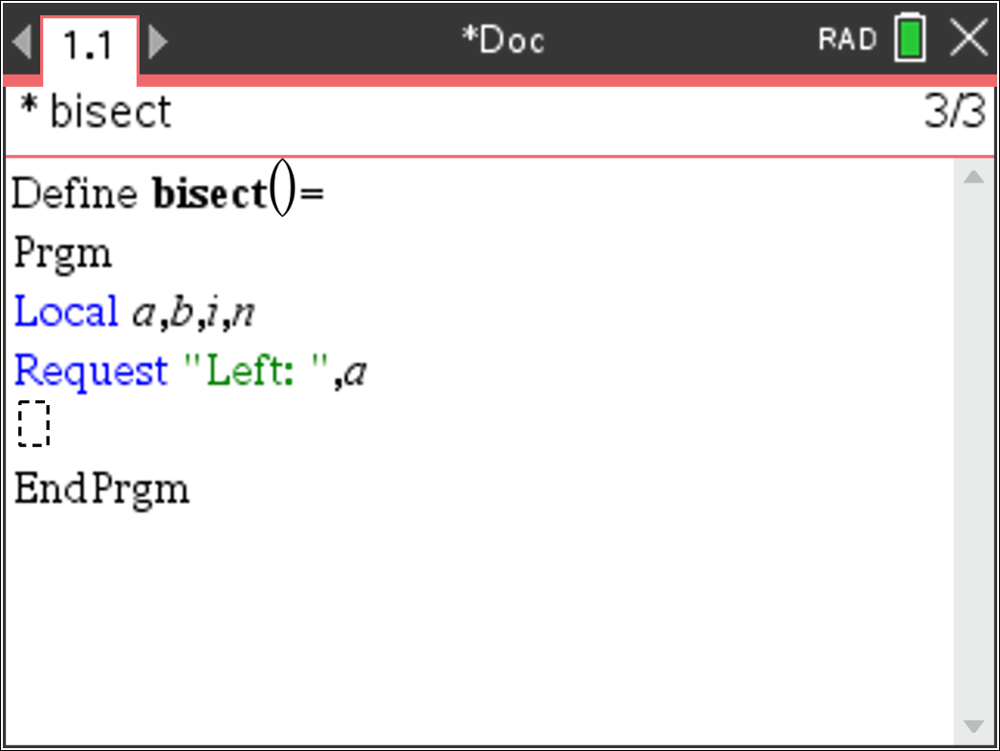
The bisection method is an iterative process which means it repeatedly follows a set of steps to get closer and closer to the solution. A range of loop options are available, for this program a FOR loop will be used.  From the menu select:  Control > For...EndFor  The accuracy of the result is reliant on how close a and b are to the axis intercept and also the number of iterations determined by the value of n. So the loop should be: For i, 1, n | 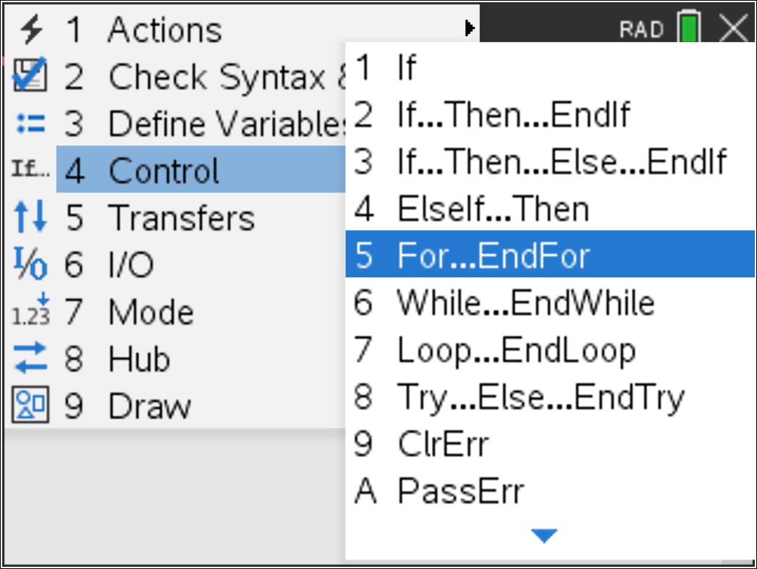
Point P is located half way between ‘a’ and ‘b’.  Assign the value of p such that: | 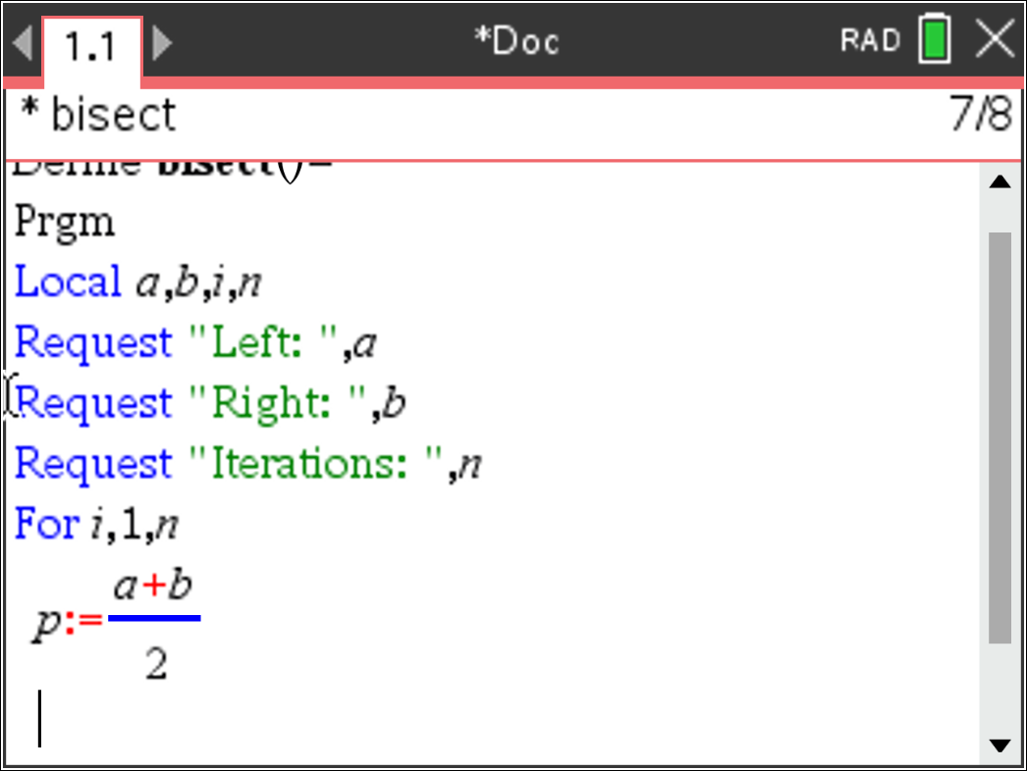
It is now decision time! The x axis intercept lies somewhere between  x = a and x = b. The bisection method checks the midpoint (p) using the product of the y coordinates. If is positive then points  a and p must be on the same side of the x axis. This means the x axis intercept lies somewhere between p and b , otherwise it lies between a and p.  The IF … THEN … ELSE command is located in the control menu. Match the conditions and outcomes shown opposite and detailed above. | 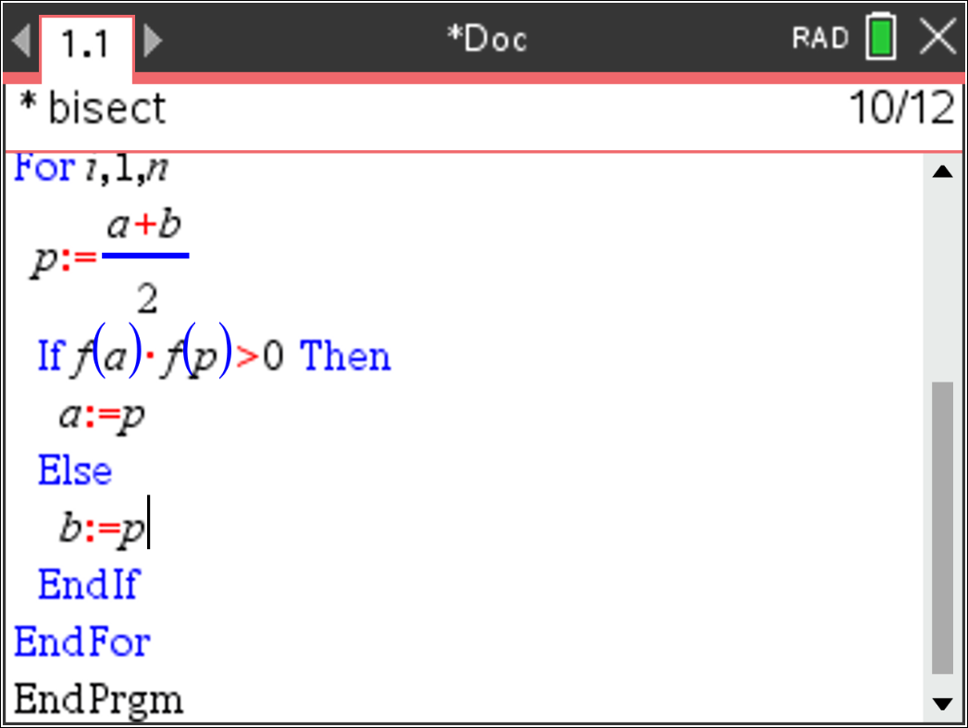
The program is now ready to run, however to see what is happening a couple of Display At (dispat) commands are useful.  From the menu select:  I/O > DispAt  Each time the loop is executed, display the following information on lines one through to three:  Current value of ‘a’, ‘b’ and ‘f (p)’.  It is also worthwhile adding a wait command to make it easier to watch what is happening. | 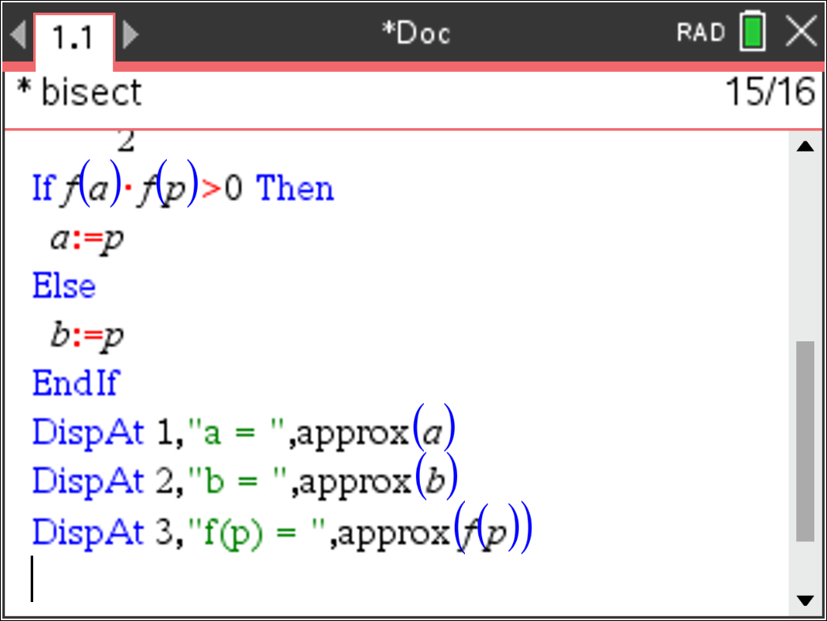

Exploring more Personal Polynomials

Hannah noticed that her polynomial had a smaller degree than she first thought. Explain why this is so.
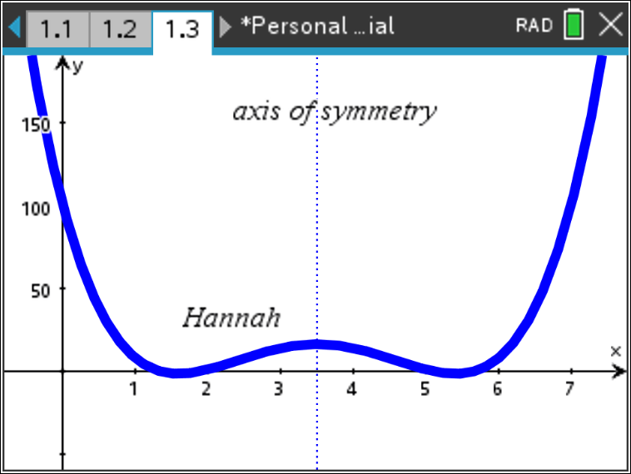
Answer: Hannah is a palindromic name so a polynomial that is symmetrical can pick up the additional points (letters) within her name without the need to increase the degree of the polynomial. This works specifically for Hannah since she has 6 letters in her name, typically generating a degree 5 polynomial. However, degree 5 polynomials do not have a vertical axis of symmetry but polynomials of degree 4 can.
Hannah’s Polynomial:

Arora and Mayam both noticed that Elle and Hannah’s polynomials had a smaller degree than expected, but their polynomials were ‘as expected’. Explain why this is the case.
Answer: Whilst Arora and Mayam have palindromic names there polynomials would normally be degree 4 since they have 5 letters in their name. The opportunity afforded through a palindromic name could normally reduce this to a degree 3 polynomial (cubic). The problem with an odd power polynomial is that it lacks the vertical symmetry required. Elle on the other hand would normally have a degree 3 polynomial, her name is palindromic so it can drop down to a degree 2 (quadratic).
Elle – Quadratic: | Arora and Mayam – Quartic functions
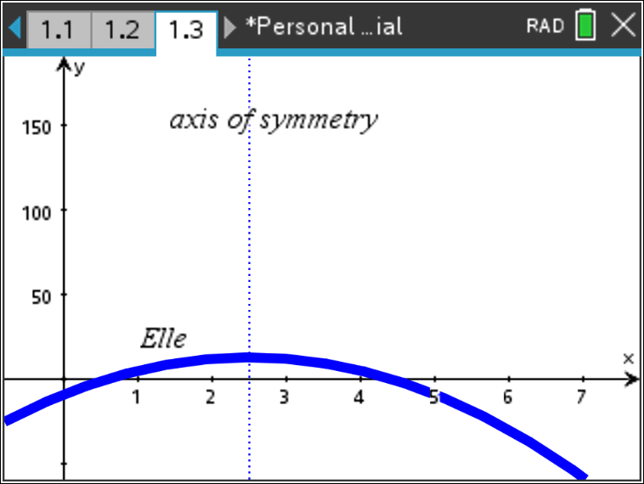 | 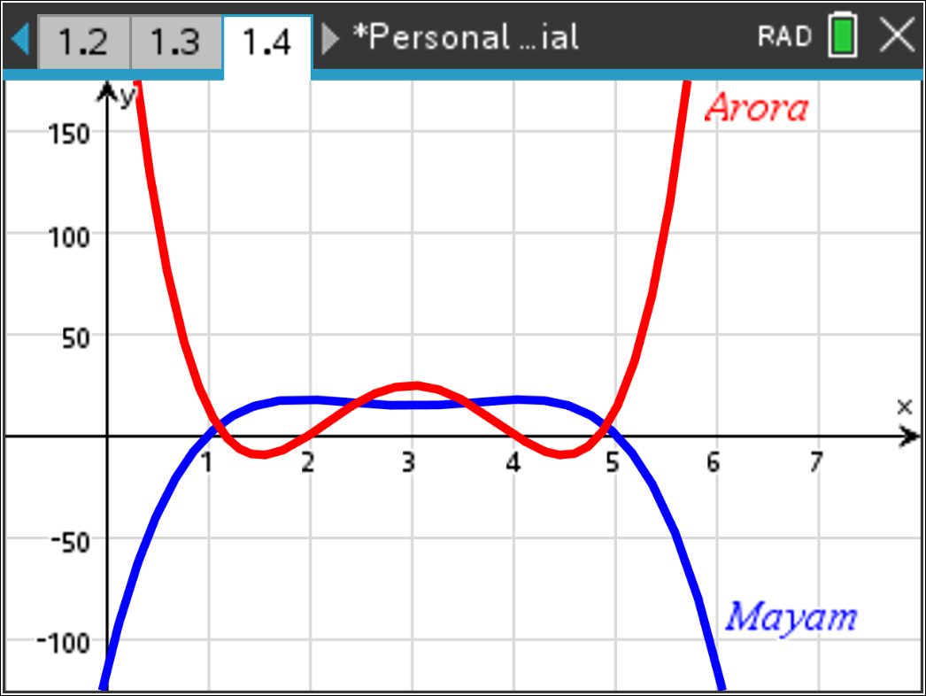

Amy joins the conversation and states that her name is unique. It too has a lower than expected degree, but for a different reason. Explain. Can you find another name that also has this property?
Answer: Amy’s name is not palindromic and is therefore not reliant on symmetry. However, ‘y’ naturally falls onto the function (linear) that would be generated by just the first two letters: A and M.
Other names: Ace, Fox (surname)
Other words: emu, din, jot. “ins” (plural of in, such as ‘ins and outs’)
There are no four letter words that produce a linear function although the plural of ‘din’ being ‘dins’ is linear. With the exception of slang, acronyms and palindromic words, void, dots, edit, hone, kilt, skim, swum and pops are all achievable with a quadratic function.
The famous Elon Musk, his first name only requires a polynomial of degree 2.

Which of the following names would provide polynomials p(x) such that p(x) = 0 has at least one solution:
- Daisy ii) Peter iii) Steven iv) Emma v)John

Answer: If p(x) = 0 must have at least one solution when the polynomial has an odd degree. John has four letters and is represented by a polynomial of degree 3, so he must have at least one solution to p(x) = 0. Steven has 6 letters so his default polynomial will be a degree 5, so he too must have at least one solution.
Daisy and Peter are all polynomials of degree 4, so they ‘may’ have zeros, but not ‘must’.
FYI - Daisy have two solutions, Peter has four.

Bindi notices that her polynomial p(x) has no solutions such that p(x) = 0. Find some other names that have no solutions to p(x) = 0. Explain how you searched and what criteria you used.
Answer: Bindi is a polynomial of degree 4. Whilst the turning points are very close to the x axis, the polynomial does not cross.
Other names – answers will vary with regards to names found. Search criteria should include:
- Name will have an odd quantity of letters so that the polynomial is of an even degree.
- If the name has an odd quantity of letters, the end letters are of greater value than second and second last letters. Riley for example, the value of “R” is greater than “I” and so too the value of “Y” greater than “E”.
- Given that a = 1, best to search for names that do not have letters such as a, b, c or d at the start or finish. Anika for example will most likely cross the x axis. Without determining the polynomial, it is most likely a polynomial of degree 4 (5 letters) and the value of A < n and a < k indicate that it will cross the x axis. On the other hand: “Rosey” is not likely to cross the x axis. The name has 5 letters meaning it will most likely be a polynomial of degree 4.
Answers for names that do not cross the x axis include:
Riley, Piper, Rosey, Henry, Leo,

According to their polynomials, where do Lilly and Lillian meet?
Answer: Without determining their equations, it is clear that they must meet at L, i, l and l which corresponds to (1, 12), (2, 9), (3, 12) and (4, 12). There are other points that students may not detect if they look just at the graph. Example: x ≈ 2.6429081. Beyond the typical window settings, students also need to consider that Lillian is a higher degree polynomial than Lilly. As lilly(4 + Δx) > Lillian(4 + Δx) then it follows that Lillian will eventually be greater than Lilly.

Victor and his friend Victoria want to explore all the places where there polynomials meet. Without determining their equations:
- Identify six points where their polynomials will intersect.
Answer: (1, 22); (2, 9); (3, 3); (4, 20); (5,15) and (6, 18).
- Explain why their polynomials have seven points of intersection.
Answer: Victor’s polynomial increases indefinitely beyond the point (6, 18). Victoria’s polynomial stays ‘low’ to pick up i: (7, 9) and (8, 1) however as her polynomial is of greater degree than Victor’s it will be steeper beyond the last point and eventually ‘catch up’ with Victor’s when x ≈ 10.8955224.
It should also be noted that Victor and Victoria are both odd degree polynomials.

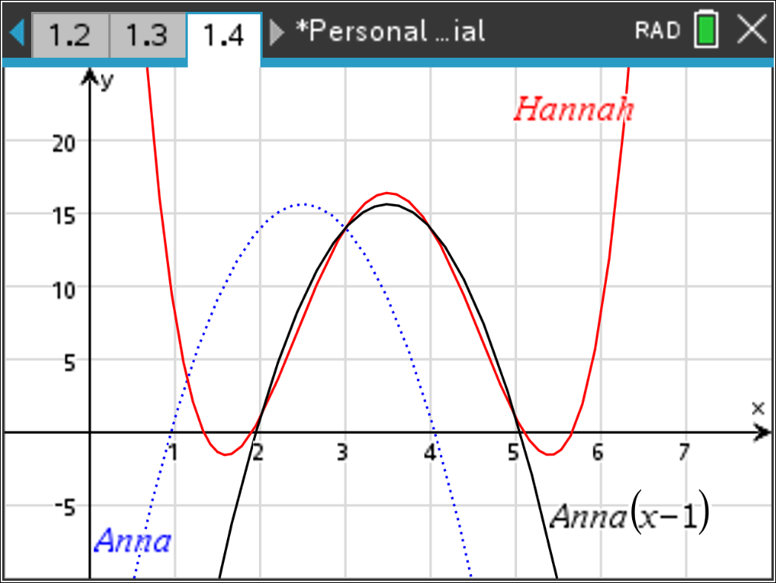
Anna and Hannah claim to have very similar polynomials. Apply an appropriate transformation and compare the two polynomials.
Answer: The middle four letters of the two names are the same. Suppose a(x) represents Anna and h(x) represents Hannah. Then a(x – 1) or h(x + 1) would merge the two polynomials together. They will not be exactly the same; however they are very similar over the four common letters.

Are there any two names that share the same polynomial? Explain your reasoning.
Answer: It is almost impossible for two names to share the same polynomial. The first part of the name would have to contain the same letters such as Jack and Jacky. The requirement is that the location of the ‘y’ would need to be a natural inclusion in the function such was the case with “Amy” forming a straight line.
Example: Jack and Jacky.
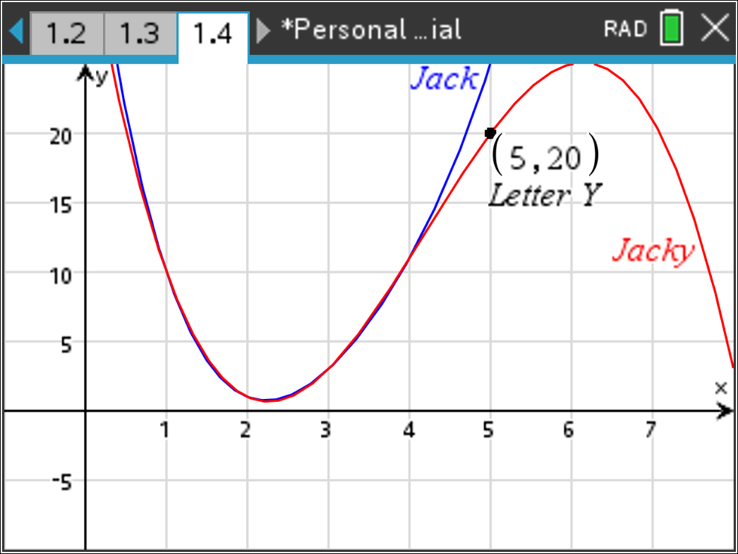
There is a good natural progression from the letters a, c and k, however Jack’s graph is still too steep to return a natural letter for x = 5 which is why the graph of Jacky has to ‘turn around’ to pick up this letter. (Point)
Similarly, a name like Zac produces a parabola, however
Zac(4) = 33 which is already beyond the letters of the alphabet if a fourth letter were to be included.
Carlo and Carlos don’t work since carlo(6) = 133, Justin and Justine don’t work either since Justin(7) = 180, nor do Paul and Paula as Paul(5) = -90.
The key elements to look for are as follows:
- Most likely a very short name so as to reduce the degree of the polynomial and volatility beyond the included letters.
- Letters in the name will be similar in value to reduce intermediate steepness.
- Letters at the end of the name must also be very similar
The last dot point can be explored through a name such as “Zac”. The last two letters are only 2 units apart, however the “Z” is a long way away.
For the second dot point, Simon and Simone are similar. The ‘e’ on the end of Simone is in the wrong direction, the similarity of the letters “m”, “o” and “n” really flatten the curve. Furthermore, simon(6) = 24 produces an integer value in the range 1 to 26. So Simon(x) and Simonx(x) would produce the polynomial. All we need now is for someone to call their child “Simonx”.
Another example is Conor. The letters “o”, “n”, “o” and “r” are all very close together producing a very ‘flat’ curve. Conor(6) = 8 leads to Conorh. Otto produces Otto(5) = 5 resulting in Ottoe and Apollo produces Apollo(7) = 20 resulting in Apollot, both of which are more hopeful than the Simonx or Conorh.
So there are examples of names that produce quite flat curves and integer values for the next ‘letter’, but the author of this exploration was not able to find any pair of names that would produce identical polynomials.

