Math Objectives  - Students will understand the role of the values of a and n in the equation $r=asin\left(nθ\right).$  - Students will be able to predict the number of petals and their length by examining the polar equation.  - Students will understand the relationship between the equation of a rose curve and the equation of a sinusoidal function.  Vocabulary  About the Lesson  - Students will investigate the effect of changing the values of a and n in the equation $r=asin\left(nθ\right).$  - Students will generalize the roles of a and n in the equation $r=asin\left(nθ\right)$.  - Students will compare the graphs of the sinusoidal function, $f\left(x\right)=asin\left(nx\right),$ and the rose curve, $r=asin\left(nθ\right)$ and make generalizations about the relationship between the graphs.  - Students will write equations of rose curves when given information about the petals of the curve.  Teacher Preparation and Notes.  - This activity is done with the use of the TI-84 family as an aid to the problems.  Activity Materials  - Compatible TI Technologies: TI-84 Plus*, TI-84 Plus Silver Edition*, TI-84 Plus C Silver Edition, TI-84 Plus CE  * with the latest operating system (2.55MP) featuring MathPrintTM _{functionality.} | 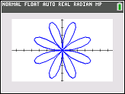  Tech Tips:  - This activity includes screen captures taken from the TI-84 Plus CE. It is also appropriate for use with the rest of the TI-84 Plus family. Slight variations to these directions may be required if using other calculator models.  - Watch for additional Tech Tips throughout the activity for the specific technology you are using.  - Access free tutorials at http://education.ti.com/calculators/pd/US/Online-Learning/Tutorials  Lesson Files:  Student Activity  Rose_Curve_84_Student.pdf  Rose_Curve_84_Student.doc
  - amplitude | - frequency
  - rose curve | - sinusoidal function
In this activity, you will investigate the effect of changing the values of a and n in the equation $r=asin\left(nθ\right).$ You will also explore the relationship between the polar rose curve $r=asin\left(nθ\right)$ and the sinusoidal function $f\left(x\right)=asin\left(nx\right).$

Discussion Points and Possible Answers
Tech Tip: The default setting for θstep for polar graphs is π/24 (0.1308996939). The value may need to be adjusted to π/48.

To set your calculator to Polar mode, press z and select POLAR as shown to the right. At this time, also set your graphing calculator to Radian mode by selecting RADIAN on this screen as well.  To graph a polar equation on your graphing calculator, press o  and enter your equation. . The „ key produces θ in your equation when you are in Polar mode. |  | 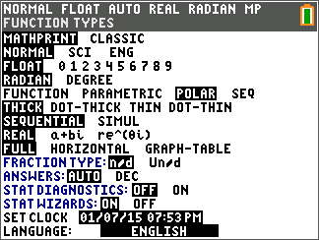
 | - Graph $r1=2sin\left(3θ\right).$ Press q and select 4: ZDecimal. A polar curve with an equation in the form of $r=asin\left(nθ\right)$ is called a polar rose. Why do you think this is so?  Answer: The graph of the polar equation $r=asin\left(nθ\right)$ forms a curve that looks like a flower. | 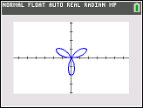
 | - Graph the following by editing $r1$ to observe each graph, then complete the table below.  $i) r1=2sin\left(θ\right)$ $ii) r1=2sin\left(2θ\right)$  $iii) r1=2sin\left(3θ\right)$ $iv) r1=2sin\left(4θ\right)$  $v) r1=2sin\left(5θ\right)$ $vi) r1=2sin\left(6θ\right)$  - What effect does the value of $n$ have on the graph of the curve?  Answer: The value of $n$ determines the number of petals on the rose curve.  - How many petals does the curve have when $n$ = 3? When $n$ = 4? Predict the number of petals when $n$ = 9 and when $n$ = 10.  Answer: When $n=3,$ there are 3 petals. When $n=4,$ there are 8 petals. When $n=9,$ there are 9 petals. When $n=10,$ there are 20 petals.  - Write a rule to determine the number of petals of a rose curve.  Answer: When $n$ is an even integer, there are $2n$ petals. When $n$ is an odd integer, there are $n$ petals |  | 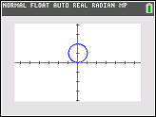  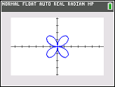  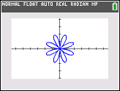  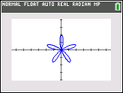  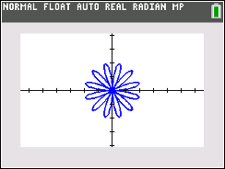
  Graph | $$n$$ | Number of petals
  $$i) r1=2sin\left(θ\right)$$ | 1 | 1
  $$i) r1=2sin\left(θ\right)$$ | 2 | 4
  $$iii) r1=2sin\left(3θ\right)$$ | 3 | 3
  $$iv) r1=2sin\left(4θ\right)$$ | 4 | 8
  $$v) r1=2sin\left(5θ\right)$$ | 5 | 5
  $$vi) r1=2sin\left(6θ\right)$$ | 6 | 12
 | - Graph the following.  $i) r1=2sin\left(3θ\right)$ $ii) r2=3sin\left(3θ\right)$  $iii) r3=4sin\left(3θ\right)$ $iv) r4=5sin\left(3θ\right)$  Explain the effect that the value of $a$ in the equation $r=asin\left(nθ\right)$ has on the graph.  Answer:  The value of $a$ determines the length of each of the petals, from the pole to the tip. As we increase the value of $a$, the length of the petals increases. |  | 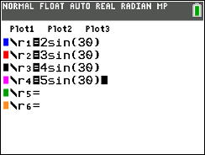  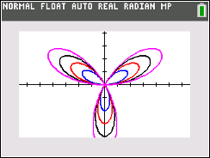
 | - The graph of the sinusoidal function $f\left(x\right)=3sin\left(2x\right)$ is shown below. The x-scale for the gridlines is π/4.  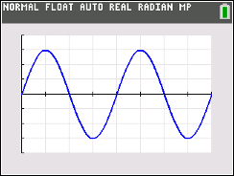  Graph the polar rose given by $r1=3sin\left(2θ\right)$. Press yq to access format. In the first row, use the right arrow to highlight PolarGC and press Í. Press r and then the right arrow to move your cursor. Observe the change in the r and θ values.  - When the r value is 3, your cursor will be at the tip of the first petal. Notice that the θ value is π/4 ≈ 0.7853982. On the interval from x = 0 to x = π/2, which point on the graph of the sinusoidal function would correspond to $\left(\frac{π}{4},3\right)?$ How is the value of $a$ in a sinusoidal function related to the graph of the polar rose?  Answer: The maximum of the sinusoidal function graph is located at the point $\left(\frac{π}{4},3\right)$ and this point corresponds to the tip of the polar rose. The amplitude of the sinusoidal function corresponds to the length of a rose petal; that is, the length of the petal from the pole to the tip.  - What part of the sinusoidal function graph corresponds to the first petal of the rose graph?  Answer: The first petal of the rose graph corresponds to the arch of the sinusoidal graph from x = 0 to x = π/2.  - From x = π/2 to x = π, the graph of the sinusoidal function has an arch that is below the x-axis. Continue to trace around the polar rose. In what quadrant is the second petal of the polar rose located? Why?  Answer: The petal is in quadrant 4 because the r values are negative.  - The graph of the sinusoidal function has two intervals where the graph is above the x-axis and two intervals where the graph is below the x-axis. How does this correspond to the graph of the polar rose?  Answer: The graph has two intervals where the sinusoidal function graph is above the x-axis and this corresponds to two petals. One is in quadrant 1 and the second one is in quadrant 3. The graph has two intervals where the sinusoidal function graph is below the x-axis and this also corresponds to two petals. One is in quadrant 4 and the second one is in quadrant 2. |  | 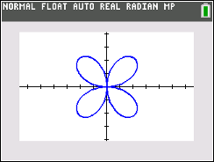  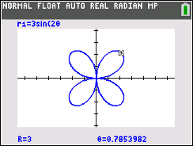
 | - The graph of the sinusoidal function $f\left(x\right)=3sin\left(3x\right)$ is shown below. The x-scale for the gridlines is π/6.  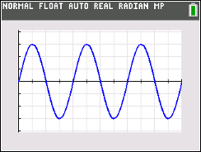  Graph the polar rose given by $r1=3sin\left(3θ\right)$. Press r and then the right arrow to move your cursor. Observe the change in the r and θ values. Explain why the polar curve $r=3sin\left(3θ\right)$ has only three petals, while the function $f\left(x\right)=3sin\left(3x\right)$ has six arches in the interval $0 ≤ θ ≤2 π.$  Answer: The three petals of the rose curve are sketched for values of θ in the interval $0 ≤ θ ≤ π.$ For the interval $π ≤ θ ≤2π$ the three petals are traced a second time. |  | 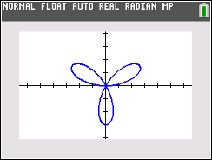
 | - What is the equation of a rose curve in the form of $r=asin\left(nθ\right)$ that has 12 petals, each of length 10? Check your answer by graphing your polar equation.  Answer: Since the length of each curve is 10, $a=10.$ To have 12 petals, we would need $n$ value of 6. The correct equation is $r=10sin\left(6θ\right).$ |  | 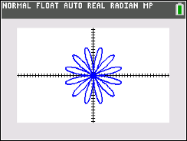
 | - What is the equation of a rose curve in the form of $r=asin\left(nθ\right)$ that has 5 petals, each of length 4? Check your answer by graphing your polar equation.  Answer: Since the length of each curve is 4, $a=4.$ To have 5 petals, we would need $n$ value of 5. The correct equation is $r=4sin\left(5θ\right).$ |  | 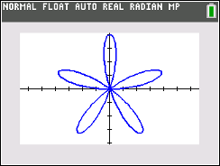
 | - Explain the similarities and differences you would expect if we replaced the sine graphs with cosine graphs. How does this affect the polar rose graph?  Answer: The cosine functions are horizontal translations of the sine functions. The polar rose would appear rotated. |  | 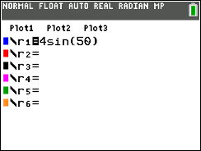  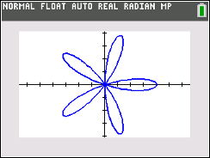
 | Teacher Tip: This might make a good extension question. You can develop this question into a part of your lesson, or omit it entirely.

Extensions
- Ask students to determine what happens to the rose curve when $n$ Is a non-positive integer.

Wrap Up
Upon completion of the lesson, the teacher should ensure that students are able to understand:
- The role of the values of a and n in the equation $r=asin\left(nθ\right).$
- How to predict the number of petals and their length by examining the polar equation.
- How the equation of a rose curve is related to the equation of a sinusoidal function.

