About the Lesson  When a ball is dropped, it does not rebound to the same height from which it is dropped. But how high does it bounce? In this activity, students will examine the relationship for maximum bounce height as a function of bounce number for a ball bouncing under a motion sensor. The equation that describes this height versus bounce number relationship is an exponential equation of form y = a(b)^{x}, where a is the initial drop height and b is the average rebound percentage. Students will:  - Collect motion data and graph scatter plots.  - Compute bounce ratios for sequential bounces and then compute the average bounce ratio.  - Use the average rebound percentage and the height of the first bounce to estimate the initial drop height.  - Determine the exponential equation that describes the relationship between bounce number and the maximum height of each bounce.  Vocabulary  - Rebound percentage  - Exponential function  Teacher Preparation and Notes  - Students should have worked with exponential functions.  - This activity provides an opportunity for math-science connections.  - This activity is best performed with at least three students: one to hold the CBR 2 and press the trigger, one to release the ball, and one to run the calculator.  Activity Materials  - CBR™ 2 motion sensor and USB CBR 2 to calculator cable  - Bouncing ball (Avoid using a soft or felt-covered ball such as a tennis ball.)  - TI-84 Plus CE or TI-84 Plus CE Python  - Vernier EasyData® App  - Recommended: TI-SmartView™ CE Emulator Software for the TI 84 Plus Family | 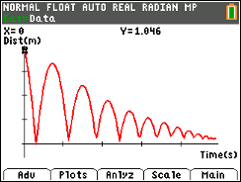  Tech Tips:  - This activity includes screen captures taken from the TI-84 Plus CE. It is also appropriate for use with the rest of the TI-84 Plus family. Slight variations to these directions may be required if using other calculator models.  - Access free tutorials at http://education.ti.com/calculators/pd/US/Online-Learning/Tutorials
Introduction
When you drop a basketball, it does not rebound to the same height from which you dropped it. But how high does it bounce? The rebound height of a basketball can be used to determine whether the ball is inflated to the correct pressure. You will sometimes see basketball referees drop the ball from a certain height to see if it rebounds correctly prior to officiating a game.
In this activity, you will determine the rebound percentage of a ball and how that percentage and the drop height relate to the height of a ball bounce as a function of bounce number.
Before collecting data, predict the graph of bounce height as a function of bounce number. Sketch your prediction to the right. Be sure to label the axes.  Write a sentence to explain why you think the graph will look like your prediction. |  | 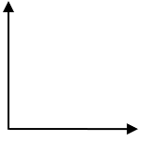
Set Up
- This activity is best performed with at least three students: one to hold the CBR™ 2 and press the trigger, one to release the ball, and one to run the calculator.  - Lift the pivot head on the CBR 2 and set the sensitivity on the CBR 2 to Normal. |  | 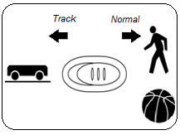
- Attach the CBR 2 to the calculator using the CBR 2 to calculator cable. The EasyData App launches automatically when you plug in the sensor.  Note: In the EasyData App, the tabs at the bottom of the screen indicate the menus that can be accessed by pressing the calculator keys directly below the tabs.  Note: The default unit of measurement for the CBR 2 in the EasyData App is meters. |  | 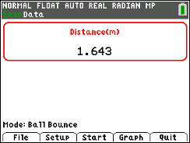
- Practice dropping the ball under the CBR 2. This is a practice run to determine if the ball is bouncing on a flat surface.  - Position the CBR 2 at least 15 centimeters (approximately 6 inches) above the ball.  - Hold the sensor directly over the ball and make sure that there is nothing in the Clear Zone.  - Hold the sides of the ball and then quickly move your hands outward to release the ball. Drop the ball (do not throw it). |  | 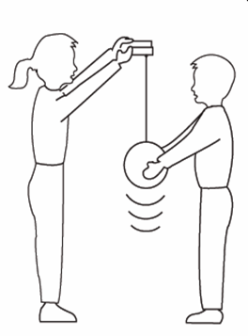
Data Collection
- You cannot place the CBR 2 on the floor and bounce the ball on it, but you can use the Ball Bounce Setup option to reverse the positions so that the data will appear as though it was collected with the floor as the zero height.  - Press o to select File from the Main screen, and then select New to reset the application. |  | 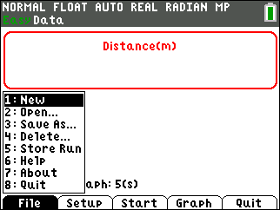
- Press p to select the Setup menu. Select Ball Bounce.  - After selecting Ball Bounce, press q to select Start.  - Follow the instructions displayed. |  | 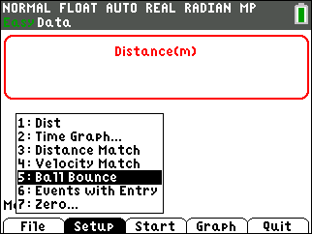
- One person holds the CBR 2 while another person holds the ball at least 15 centimeters beneath the CBR 2. Press q to select Next. |  | 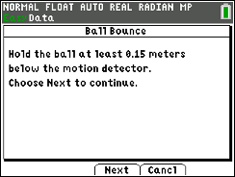
- Follow the on-screen directions. At this time, you may disconnect the CBR 2 from the calculator or you may leave it connected.  Important: Whether you leave the CBR 2 connected or not, you will need to press the TRIGGER on the CBR 2 to begin collecting data. (Do not press q to select Next yet.) |  | 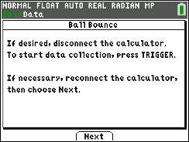
- Press the TRIGGER on the CBR 2 and when the CBR 2 begins clicking, release the ball, and then step back.
- Data will be collected every 0.05 seconds for 5 seconds.
- If the ball bounces to the side, move to keep the CBR 2 directly above the ball, but be careful not to change the height of the CBR 2.
- When the clicking stops, reconnect the CBR 2 to the calculator (if necessary) and press q to select Next.
- The collected data is transferred to the calculator. A screen displays a notice to wait as it is transferred.
- As soon as the data are sent, the calculator displays the distance versus time graph. Your distance versus time graph should contain a series of at least five parabolas. If it does not, try again. Show the graph to your teacher before proceeding to the next section of the activity.
- To repeat the sample, press s to return to the Main screen. Press q to select Start and repeat the data collection process.  - You will get a warning screen telling you the new data will overwrite any previous data. Press s to select OK.  - Follow the on-screen directions. |  | 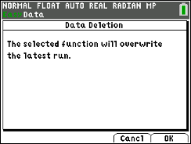
Data Analysis
- Use the arrow keys to determine the maximum height of the first bounce. Record it in the data table as the maximum height for Bounce Number 1. Then move the cursor to each successive maximum bounce height, and record the maximum heights of bounces 2 – 5 in the table below.
Record each maximum bounce height in meters, rounded to three decimal places.
Sample Data:
Bounce Number | Maximum Bounce Height (m) | Ratio of Bounce Heights
1 | H₁ = 0.900
2 | H₂ = 0.654 | 0.73
3 | H₃ = 0.487 | 0.74
4 | H₄ = 0.375 | 0.77
5 | H₅ = 0.295 | 0.79

- Examine the maximum bounce height data in the table. Is the relationship linear? How can you tell?

Answer: No. The bounce numbers increase by one unit, but the heights do not decrease by a constant amount.

- Is the relationship quadratic? How can you tell from the differences in heights?
Sample Answer: The relationship is not quadratic. If the data set were quadratic, the second differences would be constant. They are not constant.

Note: To answer questions 2 and 3, it might be helpful for students to compute and record the first and second differences of the height data.

- Divide each bounce height by the previous bounce height. For example, divide the height of Bounce 2 by the height of Bounce 1. Write each ratio as a decimal value, rounded to two decimal places, in the right column of the table.

- What do you notice about the bounce height ratios shown in the right column of the table?
Sample Answer: The ratios are similar.

- Find the average of the bounce height ratios. ____________________
Sample Answer: 0.76

- How could you use the average of the bounce height ratios and the height of the first bounce (H₁) to estimate the drop height of your ball? Show your work and record the drop height (in meters). Round your answer to two decimal places.
Estimated Drop Height = _______________
Sample Answer: 1.18 meters. Students should divide the height of their first bounce by the average of their bounce height ratios.

- If you didn’t know the height of the first bounce, H₁, you could use the average of the bounce ratios and the estimated drop height of your ball to predict that height.
H₁ = (drop height) * (average bounce ratio)

If you didn’t know the height of the second bounce, H₂, you could still use just the average of the bounce ratios and the estimated drop height of your ball to predict the height of the second bounce.
Since H₂ = (H₁) * (average bounce ratio), we know that
H₂ = ((drop height) * (average bounce ratio)) * (average bounce ratio)

How could you predict the height of Bounce 3 using only the estimated drop height and the average bounce ratio?
H₃ = ________________________________________________________________________

Answer: H₃ = ((drop height) * (average bounce ratio) * (average bounce ratio)) * (average bounce ratio)

- Using only your estimated drop height of your ball and the average of the bounce ratios, write an equation for each bounce height in the table below.

Sample Answer:

H₁ = (1.18 m) * (0.76)
H₂ = (1.18 m) * (0.76) * (0.76) or (1.18 m) * (0.76)²
H₃ = (1.18 m) * (0.76) * (0.76) * (0.76) or (1.18 m) * (0.76)³
H₄ = (1.18 m) * (0.76) * (0.76) * (0.76) * (0.76) or (1.18 m) * (0.76)⁴
H₅ = (1.18 m) * (0.76) * (0.76) * (0.76) * (0.76) * (0.76) or (1.18 m) * (0.76)⁵

- Exponential decay (this type of relationship) and exponential growth occur when an amount decreases or increases, respectively, at a rate proportional to the preceding amount. An exponential function has the form y = a(b)^{x}. In this example, b is the average rebound percentage written as a decimal. What does a represent?

Sample Answer: a is the drop height, 1.18 m in this sample data.

- Write the equation for the height of the ball at any bounce as a function of bounce number, x, for your set of data.

Sample Answer: y = 1.18 * (0.76)^{x}
- To check your equation, first create a graph of bounce height as a function of bounce number. Enter the bounce number and maximum height of each bounce into lists in your calculator.  - Press … Í to enter the data list edit.  Note: To delete any data in the lists, use the arrow keys to select the list heading (L1, L2, etc.), and then press ‘ Í.  - In List L1, enter bounce numbers 1 - 5.  - Enter the maximum heights of bounces 1 - 5 in list L2. |  | 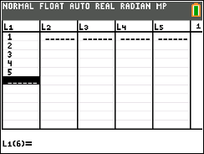
- To graph the maximum bounce height vs. bounce number, press y , to enter the Stat Plot menu.  Note: Make sure all the other plots or equations are turned off before plotting your data.  - Choose Plot 1 by pressing Í. On the resulting screen, turn on the plot by using the arrow keys and pressing Í when On is highlighted.  - On the Type row, choose a scatter plot by using the arrow keys and pressing Í on the first pictured graph type.  - Plot the bounce number on the x-axis by selecting L1 (press y d) for the Xlist. Plot the maximum height of each bounce on the y-axis by selecting L2 (press y e) for the Ylist. Press Í.  - To set the scaling values for the graph window, press q. Select ZoomStat to have the calculator automatically set the window scaling to your data. |  | 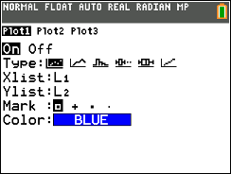  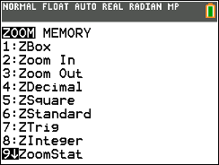
- Sketch the graph of your data at the right.  - How does it compare with the prediction that you made prior to data collection? |  | 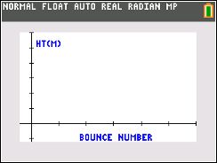
- Check to see how well the equation you found in Step 11 matches the data.
- Press o to enter your equation for the maximum bounce height as a function of the bounce number. You must use x for the bounce number in the equation.
- Press s.
- Is the equation you entered a good model the data? If not, make adjustments in the equation, and regraph. If any adjustments were made, record your new equation.

- Use your equation to predict the height of a tenth bounce. Show your work. Is your answer reasonable?

Sample Answer: H₁₀ = 1.18 * (0.76)¹⁰ or 0.08 meters.
- Jackie bounced a different type of ball and determined that it had an average rebound percentage of 71%. Her drop height was 1.45 meters.

- Write an equation for bounce height, y, as a function of bounce number, x.

Answer: y = 1.45 * (0.71)^{x}

- Predict the height of the ball’s 7th bounce.

Answer: 0.13 meters

- At what bounce number would the height of the bounce be approximately 0.5 meters?

Answer: Bounce 3

