Name: Date:

Birthday Simulation
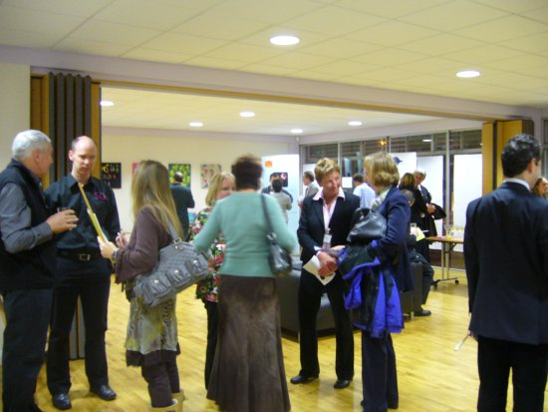
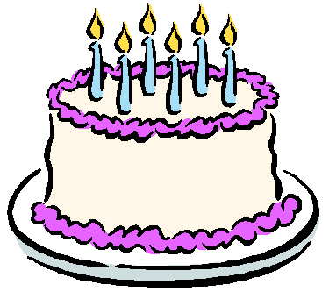
Suppose there are 30 people in the room.

Do you think that any two people will have the same birthday (d/m) ?

Record the results of your 25 trials in the table below.

Trial | Success | Failure |  | Trial | Success | Failure
1 |  |  |  | 14
2 |  |  |  | 15
3 |  |  |  | 16
4 |  |  |  | 17
5 |  |  |  | 18
6 |  |  |  | 19
7 |  |  |  | 20
8 |  |  |  | 21
9 |  |  |  | 22
10 |  |  |  | 23
11 |  |  |  | 24
12 |  |  |  | 25
13

Based on your simulation, what is the experimental probability that two out of thirty people in a room will have the same birthday?

Teacher Notes
Each student will have a different answer .

The theoretical probability of at least 2 people out of 30 having the same birthday is about 71%.

