Math Objectives  - Students will explore the validation of a model constructed from a data set.  - Students will be able to determine a regression equation.  - Students will understand that a pattern in the graph of the residuals indicates that the model is not appropriate for the data set.  - Students will look for and express regularity in repeated reasoning (CCSS Mathematical Practice).  - Students will look for and make use of structure (CCSS Mathematical Practice).  Vocabulary  About the Lesson  - This lesson includes modeling a data set using linear and exponential regressions.  - As a result students will:  - Observe a residual plot as well as a scatter plot of the data.  - Understand that a residual is the actual value of the data minus the predicted value from the regression equation.  - Conjecture and draw conclusions about the appropriateness of the model based on the residual plot.  Teacher Preparation and Notes.  - This activity is done with the use of the TI-84 family as an aid to the problems.  Activity Materials  - Compatible TI Technologies: TI-84 Plus*, TI-84 Plus Silver Edition*, TI-84 Plus C Silver Edition, TI-84 Plus CE  * with the latest operating system (2.55MP) featuring MathPrintTM _{functionality.} | 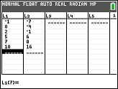  Tech Tips:  - This activity includes screen captures taken from the TI-84 Plus CE. It is also appropriate for use with the rest of the TI-84 Plus family. Slight variations to these directions may be required if using other calculator models.  - Watch for additional Tech Tips throughout the activity for the specific technology you are using.  - Access free tutorials at http://education.ti.com/calculators/pd/US/Online-Learning/Tutorials  Lesson Files:  Student Activity  Residuals_84_Student.pdf  Residuals_84_Student.doc
  - data set | - linear
  - residual | - exponential
In this activity, you will investigate a residual plot for a set of data after selecting a regression model. The residual plot is used to justify the choice of a function model based on an analysis of the residuals.

Discussion Points and Possible Answers
Tech Tip: If data exists in the lists of the Stats Editor, advise students to press the up arrow until L1 (or any other lists) is highlighted. Select ‘ and · to delete the data. An alternate method is given in Part 2.

Part 1
Use the following data set in Part 1.

$$x$$ | –1 | 0 | 2 | 5 | 7 | 10
$$y$$ | –7 | –4 | –1 | 6 | 8 | 16

- To enter the data, select … 1: Edit… Enter the x values in d and the y values in e.
Tech Tip: Students must press enter or the down arrow after the last value is entered. If the students gets a Dimension Mismatch error, they should check their data to make sure all the data has been entered.
To run a linear regression, select … and use the right arrow to highlight CALC.  Select 4: LinReg (ax + b). Make sure the Xlist: is set to L1 and the Ylist: is set to L2. Arrow down to Store RegEQ: and press ƒr to select 1: Y1. Arrow down to Calculate and press Í. The linear regression is calculated and is also stored in Y1.  What is your linear regression equation?  Answer: The linear regression equation is | 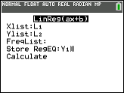  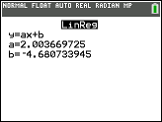
- To view the scatter plot, press yo to access STAT PLOTS. Select 1: Plot 1 and press Í. Use the arrow keys to change the settings to match the screen to the right.  Select q 9: ZoomStat.  Note: To hide the graph of the linear regression equation, select o, use the left arrow key to place it on the = sign and press enter. Select s to view the scatter plot. | 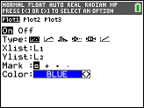
 | 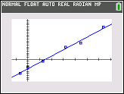
The residual is the actual value minus the predicated value. A regression model is justified as appropriate for a data set if the residuals of a regression, the residual plot, appear without pattern. To view the residual plot, press yo and edit the settings of Plot 1 to match the screen to the right. Note: Resid is found by pressing y…. Select q 9: ZoomStat.  Does your residual plot have a pattern? Would a linear regression be appropriate for this data set?  Answer: The residual plot does not have a pattern. A linear regression is appropriate for this data set. | 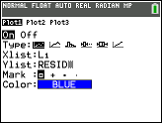  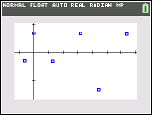
3. To evaluate the predicted values, press ƒr to select 1: Y1. Calculate Y1(–1) and then calculate the residual when x is –1. Calculate Y1(0) and then calculate the residual when x is 0. Notice that one residual value is negative and one is positive. What does this tell us about the predicted value as being an underestimate or an overestimate?  Answer:  Y1(–1) = –6.68440367; Residual = –0.31559633  Y1(0) = –4.680733945; Residual = 0.680733945  If the residual is positive, the predicted value is an underestimate.  If the residual is negative, the predicted value is an overestimate.  Note: To view the residual list for all of the data points, select … 1: Edit… . Arrow to the right until you get to L6. Press the Up arrow and then the right arrow. Open the List Editor by selecting y…. Select 7: RESID and press Í. | 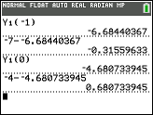  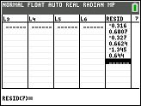
Teacher Note: The graph of the scatter plot with the regression equation may be helpful to visualize the overestimate or underestimate.
Part 2
Use the following data set in Part 2.

$$x$$ | –1 | 0 | 1 | 2 | 4 | 5
$$y$$ | 0.2 | 0.6 | 0.9 | 2.1 | 7.9 | 16.2

Tech Tip: To clear the data and residuals from the previous problem, select … and 4: ClrList, then add L1, L2, LRESID separated by commas.

4. Follow the steps in Part 1. Enter the data in L1 and L2. Compute a linear regression, view the scatter plot, and view the residual plot. Does your residual plot have a pattern? Would a linear regression be appropriate for this data set?  Answer: The residual plot appears to have a pattern. A linear regression is not appropriate for this data set. | 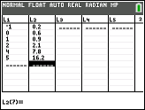  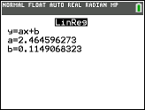  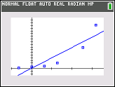  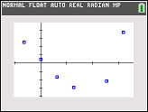
5. Now compute an exponential regression which is 0: ExpReg in the Stats Calc menu. View the scatter plot, and the residual plot. Does your residual plot have a pattern? Would an exponential regression be appropriate for this data set?  Answer: The residual plot does not appear to have a pattern. An exponential regression is appropriate for this data set. | 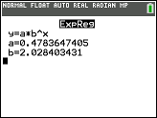  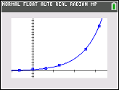  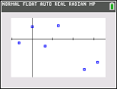

Extensions
- Find a data set that models a quadratic and ask the students to follow the steps for a quadratic regression. Observe the scatter plot and the residual plot.

Wrap Up
Upon completion of the lesson, the teacher should ensure that students are able to understand:
- How to input data in the Stats Editor.
- How to compute linear, quadratic, and exponential regressions.
- How to plot residuals and determine if the residual plot has a pattern.

