Topic 3.14 Polar Function Graphs | Rose Curves

Practice Problem 1
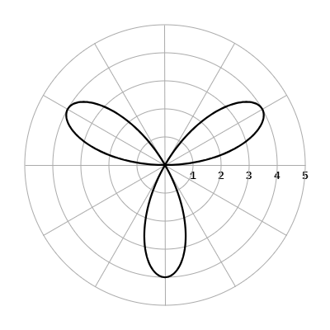

The figure shows the graph of a polar function $r=f\left(θ\right),$ for $0 ≤ θ ≤π.$ Which of the following could be an expression for $f\left(θ\right)?$
A. $f\left(θ\right)=4sin\left(3ϑ\right)$
B. $f\left(θ\right)=4sin\left(6ϑ\right)$
C. $f\left(θ\right)=4cos\left(3ϑ\right)$
D. $f\left(θ\right)=4cos\left(6ϑ\right)$

Practice Problem 2

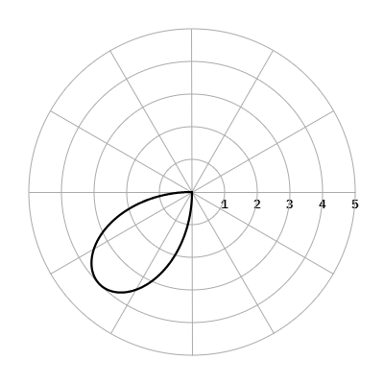

A portion of the graph of the polar function $r=f\left(θ\right),$ where $f\left(θ\right)=4sin\left(2θ\right),$ is shown in the polar coordinate system for $a ≤ θ ≤b.$ If $0 ≤a<b ≤2π,$ which of the following could be the values of $a$ and $b?$
A. $a=\frac{π}{2}$ and $b=π$
B. $a=\frac{π}{4}$ and $b=\frac{3π}{4}$
C. $a=\frac{π}{2}$ and $b=\frac{3π}{2}$
D. $a=π$ and $b=\frac{3π}{2}$

Solutions:
Practice Problem 1 Solution:
- $f\left(θ\right)=4sin\left(3ϑ\right)$
This is the graph of a polar rose in the form of $f\left(θ\right)=asin\left(nϑ\right)$. The length from the pole to the tip of a petal is 4 units so $a=4.$ There are an odd number of petals so $n$ represents the number of petals and $n=3$.

Practice Problem 2 Solution:
D. $a=π$ and $b=\frac{3π}{2}$
The graph of the sinusoidal function $f\left(θx\right)=4sin\left(2x\right)$ shown to the right is positive on the interval $\left[π, \frac{3π}{2}\right]$. On the interval $\left[π, \frac{3π}{2}\right]$ the polar rose has values of $r$ which are positive so the points of the polar rose would be graphed in quadrant 3. | 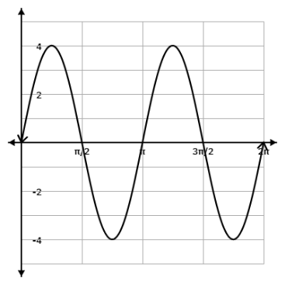

This is the graph corresponding to choice A. | This is the graph corresponding to choice B. | This is the graph corresponding to choice C.
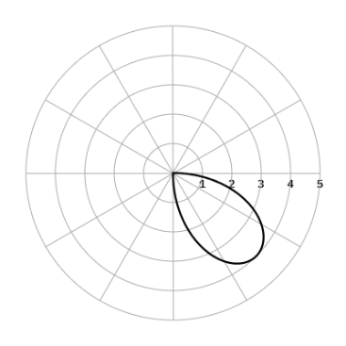 | 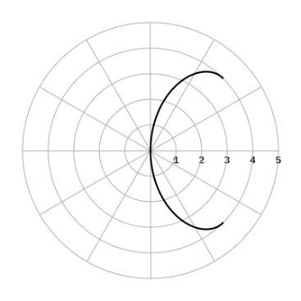 | 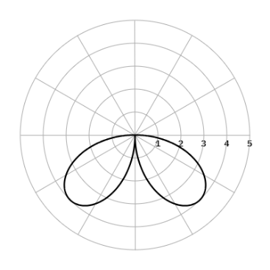

**Note: This activity has been developed independently by Texas Instruments. AP is a registered trademark of the College Board, which was not involved in the production of, and does not endorse, this product. Policies subject to change. Visit www.collegeboard.org.

