Part 1 – Plotting Coordinates & Exploring Polar Graphs
The coordinates of a polar curve are given as (θ, r).
1. Plot and label the following points on the graph below: A(15°, 4), B(270°, 5), C and D.
2. If r(θ) = cos(θ), what is r ?

3. Graph r(θ) = 2 – 2cos(θ). What is the shape of the graph?

4. Using your graphing calculator, explore polar graphs by changing your equation. Try to generate the graphs listed below. Which of the graphs were you able to make? Write the equation next to the graph shape.
- circle
- rose with even number of petals
- rose with odd number of petals
- limaçon with an inner loop

Part 2 – Slopes of Polar Graphs
5. How do you find the slope of a line tangent to a polar graph?

6. Recall the polar graph from Problem 1. When r and θ are known, how can you find the x- and y-coordinates?

7. a. What are the criteria that determine when a horizontal tangent will occur?  b. How many horizontal tangents occur on the polar rose to the right?  c. Find the angle θ of the point where the horizontal tangent is shown to the right. | 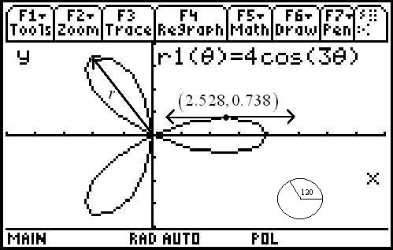
d. Consider that solve(d(r1(θ)*sin(θ),θ)=0,θ)|0<θ<π can be used to solve for all θ between 0 and π for the horizontal tangents of r1(θ) = 4cos(3θ). Use this information to find the angles for the horizontal tangents and to similarly find the angles for the vertical tangents. Show the setup and answers. (Note: make sure to use derivative for the d in the above command, not just the letter d.)

8. Find when θ = for r1(θ) = 4cos(3θ). Show your work. Do not use a calculator to solve this problem. (Hint: Use your answer to Problem 6 to help you.)

Part 3 – Area of Polar Graphs
The equation for the area inside a polar curve is where θ₁ and θ₂ are the “first” two times r = 0.
9. What are the limits of integration to find the area of one petal of r1(θ) = 4sin(3θ)?

10. Use your calculator to find the area of the first petal of r1(θ) = 4sin(3θ).

