Problem 1 – Exploring Vertex Form
To get the Transformational Graphing Application started, press Œ and select Transfrm.  Now press o and enter (X–B)²+C to match the screen to the right. | 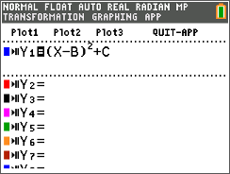
Press q and select ZStandard to view the graph displayed in a normal window. Notice that the variables B and C are listed to the left along with the equation. | 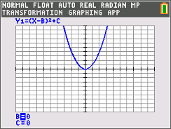
Change the values for B and C by using the } and † keys to select the variable to change and the
| and ~ keys to change the value. Make changes to B and C so that the graph of the parabola’s vertex will be in Quadrant I and write down the resulting equation in the table below. Find three other parabola equations whose vertices are also located in Quadrant I and record their equations in the table as well. Repeat this for the remaining three quadrants.

Quadrant I | Quadrant II | Quadrant III | Quadrant IV

Use the vertex form of the equations to answer the questions below.
1. In which quadrants is the value of B positive?

2. In which quadrants is the value of C positive?

Problem 2 – Happy and Sad Parabolas
“Happy” parabola  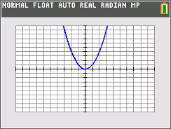 | “Sad” parabola  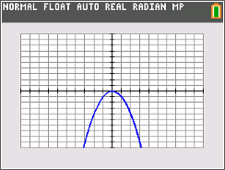
Press o and enter AX² to match the screen to the right. Then press s.  Make the “happy” parabola wider, narrower, and “sad” by changing the value of A.  Record four “happy” and four “sad” parabolas. |  | 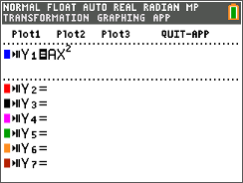
“Happy” Parabolas | “Sad” Parabolas

3. How does the equation change when the parabola is wider or narrower?

4. For what values of A is the parabola “happy” (opens up) or “sad” (opens down)?

5. Is f(x) = 3.5(x – 2)² + 5 a “happy” or “sad” parabola? How do you know?

6. Determine whether the following parabolas open up or down.
a(x) = 2.5x² – 5 c(x) = –(x – 2)² – 5
b(x) = 6 + 3(x – 3)² d(x) = 7(x + 1)² – 1

Extension – Parabola Hunt
Enter the following data points into lists L1 and L2 of the graphing calculator by pressing … Í.  (–6, 4), (–2, –2), (4, –1), (6, 5) |  | 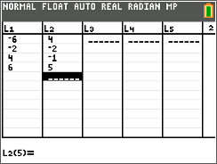
Now, set the calculator to graph these data points by pressing y o [stat plot], selecting Plot1 and matching the screen to the right. |  | 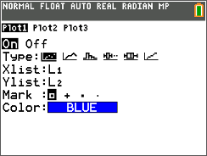
Now press o and enter A(X–B)²+C next to Y1.  View the finished screen by pressing q and selecting ZoomStat. |  | 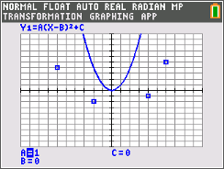
For each of the points given on the graph, find an equation of a “happy” parabola so that the vertex of the parabola is located at the given point. Then, find an equation of a “sad” parabola at each vertex point. Check your answer using your graphing calculator and values for A B, and C.
Point 1 | Point 2 | Point 3 | Point 4

Compare your equations with a classmate. Using all of your equations listed above, rank the parabolas from widest to narrowest.

Bonus Problem
Find the equation of a parabola that passes through any two of the labeled points on the graph.

