Math Objectives  - Students will learn review the concepts of a normal distribution and its characteristics, including but not limited to percentiles and area under a normal curve.  - Students will practice how to use the handheld commands Normal Cdf and Inverse Normal.  - Students will try to make a connection with how to understand these topics in IB Mathematics courses and on their final assessments.  Vocabulary  - Percentile • Normal Distribution • Empirical Rule  - Probability • Standard Deviation • Mean  About the Lesson  - This lesson is aligning with the curriculum of IB Mathematics Applications and Interpretations SL/HL and IB Mathematics Approaches and Analysis SL/HL  - This falls under the IB Mathematics Core Content in Topic 4 Statistics and Probability:  4.2: (b) Histograms  (c) Percentiles  4.3: (a) Measures of central tendency (mean)  (c) Measures of dispersion (standard deviation and  variance)  4.9: (a) The normal distribution and curve  (b) Properties of the normal distribution  (c) Diagrammatic representation, Normal probability  calculations, Inverse normal calculations  As a result, students will:  - Apply this information to real world situations.  Teacher Preparation and Notes.  - This activity is done with the use of the TI-84 family as an aid to the problems.  Activity Materials  - Compatible TI Technologies: TI-84 Plus*, TI-84 Plus Silver Edition*, TI-84 Plus C Silver Edition, TI-84 Plus CE  * with the latest operating system (2.55MP) featuring MathPrintTM _{functionality.} | 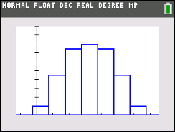  Tech Tips:  - This activity includes screen captures taken from the TI-84 Plus CE. It is also appropriate for use with the rest of the TI-84 Plus family. Slight variations to these directions may be required if using other calculator models.  - Watch for additional Tech Tips throughout the activity for the specific technology you are using.  - Access free tutorials at http://education.ti.com/calculators/pd/US/Online-Learning/Tutorials  Lesson Files:  Percentiles-Student-84CE.pdf  Percentiles-Student-84CE.doc
The goal of this activity is for students to use the area to the left of a value in a normal distribution to find its percentile. The process will then be reversed to find the value for a given percentile. In doing so, students will learn how to use the Normal CDF and Inverse Normal commands on the handheld.

Teacher Tip: This activity is one where entering the data in problem one is key to fully understanding how the TI-84 Plus CE handheld can help students answer normal distributions both graphically (with histograms) and through the Normal commands mentioned above. Please take a moment to help the students enter the data and demonstrate how to create the histogram along with refreshing their memories on the sequence of entering values into the two Normal commands.

For this activity, students should be familiar with the normal distribution and its characteristics, specifically the empirical rule (68-95-99.7 rule). Percentiles divide data into 100 equal parts. For the sake of simplicity, round all percentiles to the nearest whole percent.

Problem 1 – Find the Percentile Given the Score

A sample of 68 scores from a standardized test are listed below. Input the scores into L₁ on your handheld.

34, 23, 21, 26, 20, 31, 9, 7, 32, 11, 15, 52, 20, 9, 28, 13, 14, 14, 13, 28, 26, 8, 25, 4, 15, 29, 12, 32, 17, 15, 9, 24, 44, 28, 33, 31, 44, 36, 33, 49, 22, 22, 28, 38, 19, 24, 17, 37, 30, 45, 17, 21, 15, 19, 37, 26, 39, 43, 23, 4, 31, 38, 36, 39, 41, 29, 36, 35

(a) Calculate the mean and standard deviation using the 1-Variable Statistics command from the stat,
Calc menu.
Solution: $\overline{x}=25.66178…$ and $sx=11.52623…$
(Since this is a sample we use $sx$ and not $σx$)

(b) Create a histogram on your handheld. Describe the distribution. Use the following window settings:
Xmin = -10, Xmax = 60, Xscl = 8, Ymin = 0, Ymax = 20, Yscl = 2

Possible Description: Approximately normal.

(c) Sketch your graph below.

Teacher Tip: Although students need to draw this histogram by hand, now would be a good time to demonstrate how to attain one on the handheld. Pressing 2nd, y = (stat plot), enter (Plot1), and select the histogram. Go to the window settings and change the values as stated above.

(d) Without calculating, and assuming the scores are normally distributed, find the percentile of the
score if it is…
(note that pressing trace and moving your cursor left and right will give you how many scores are in
each bin. Divide this number by the total number of scores, 68, to find the percentage in each bin)
(i) the mean.

Solution: 50%

(ii) one standard deviation above the mean.

Solution: 84%

(iii) one standard deviation below the mean.

Solution: 16%

(e) Using the histogram and what you know about normal distributions, fill in the following table with
your guess of the percentile for each score and the actual percentile for each score. Use the
2nd, vars (distr), normalcdf( command to find the actual percentile for the scores in the table.

 | 33 | 50 | 26 | 12
Guesses | 75% | 95% | 50% | 10%
Actual | 74% | 98% | 51% | 12%
Solution: Answers for the guesses will vary, but a sample is given in the table above.

Teacher Tip: This would be a good time to define and discuss percentile. Stress that the percentile gives the proportion of the scores to the left of that score. Also, review the characteristics of a normal distribution and the empirical rule. Students are to determine what they think are the percentile scores from the table above. Discuss with the students how they determined their answers.

Problem 1 Practice

(a) Assuming that the scores for the class were normally distributed and given that a student scored a 610 on a test with $\overline{x}=550$ and $σ=28$, find the percentile.

Solution: 98th percentile

(b) Assuming that the scores for the class were normally distributed and given that a student scored a 17 on a test with $\overline{x}=20$ and $σ=2.5$, find the percentile.

Solution: 11th percentile

Problem 2 – Finding the Score Given the Percentile
The scores on a test are normally distributed with a mean of 120 and a standard deviation of 12, or using the notation $N(120, {12}^{2})$. To reverse the process and find a score given its percentile, use the invNorm( command from the 2nd, vars (distr) menu. When the input screen appears, enter:

area, mean, standard deviation, LEFT
The area on the input screen refers to the area to the left of the given score, marked by the percentile.
**Remember that the normal distribution notation is $N\left(μ, σ^{2}\right)$, where $σ^{2}$ represents the variance.

(a) Estimate what you think the lowest score a student needs to be at least the 60th percentile. Explain your answer.

Solution: Answers will vary. The actual answer is 123.04.

(b) Verify your estimate from part (a) using the invNorm( command. Also use this command to help find the scores for the following percentiles:

 | 60th | 30th | 70th | 90th
Guesses
Actual | 123.04 | 113.707 | 126.293 | 135.379

Solution: Answers will vary for the guesses.

Problem 3 – Practice

(a) Helen took a test where $N(380, {42}^{2})$ and scored 465. Juan took a test where $N(65, {10}^{2})$ and scored
88. Determine which student is at the higher percentile.

Solution: Using the normcdf( command,
Helen’s percentile was 0.9785… or the 97.9th percentile
Juan’s percentile was 0.989276… or the 98.9th percentile
Juan was in the higher percentile.

(b) Ty scored lower than 14% of the rest of the students on a test with $N(200,{ 35}^{2})$. Estimate Ty’s
score.
Solution: Using the invNorm( command,
Ty’s score was about 237.811…, or 237
(c) Find the score Shuang must get to be in the top 5% of the students taking a test with $N(325,{ 35}^{2})$.

Solution: Again, using the invNorm( command,
Shuang’s score is about 382.57…, or she had to get a score of at least 382

Further IB Applications

It is known through the company website that 43% of gecko heat lamp bulbs have a life of less than 60 hours and 89% have a life less than 65 hours. It can be assumed that heat lamp bulb life is modelled by the normal distribution $N\left(μ, σ^{2}\right)$.

(a) Find the value of $μ$ and the value of $σ$.

Solution: Using the idea of the area under a normal distribution curve is equal to the total
probability in the normally distributed gecko hear lamp bulb scenario, first find the z-scores with
the given percentages above:
$P<60 hours$ : InvNorm(0.43, 0, 1) = -0.176
$P<65 hours$ : InvNorm(0.89, 0, 1) = 1.23
Then, set up two equations using the z-score formula: $z= \frac{x- μ}{σ}$
$-0.176= \frac{60- μ}{σ}$ and $1.23= \frac{65- μ}{σ}$
Solve the system of equations for $μ$ and $σ$.
$μ=60.6286$ and $σ=3.56404$

(b) Find the probability that a randomly selected bulb will have a life of at least 55 hours.

Solution: $P ≥55$, using the Normal Cdf command:

= 0.943
Having a visual representation of the normal distribution curve is helpful:

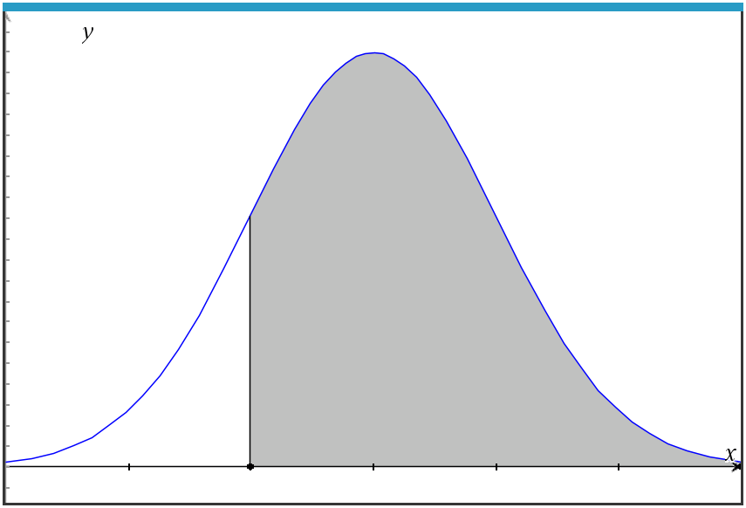

(c) Find the percentile for the bulb with 58 hours of life.

Solution: $P<58$, normCdf(-9E99, 60.6286, 3.56404) = 0.2303988…
= 23rd percentile

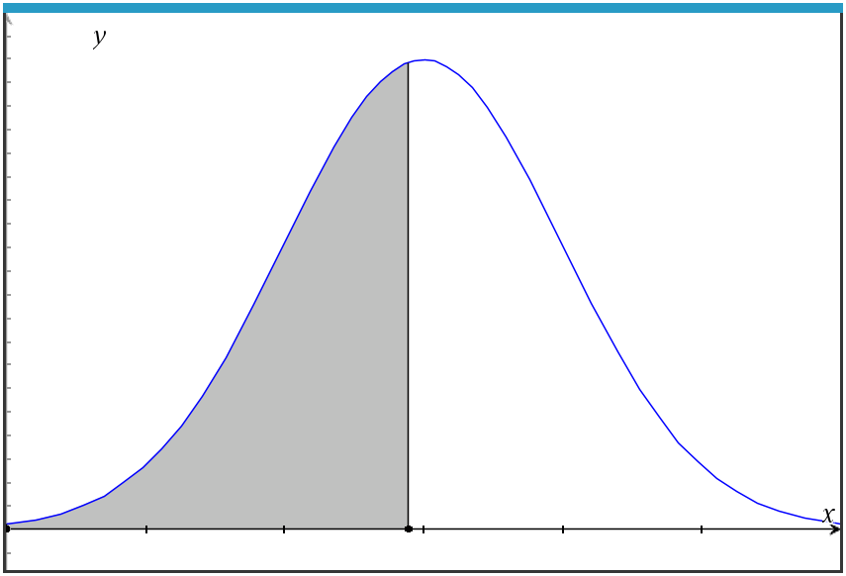

Teacher Tip: Please know that in this activity there is a lot of time dedicated to students talking with one another and sharing their thoughts with the class. The goal here is to not only review transformations of functions, but also to generate discussion.

**Note: This activity has been developed independently by Texas Instruments and aligned with the IB Mathematics curriculum, but is not endorsed by IB™. IB is a registered trademark owned by the International Baccalaureate Organization.

