Exit Stage Left |  |  |  | Insert School Logo Here
Name: |  | Class:
Instructions:
- Sections in blue font are designed for teacher notes and instructions.
- Sections in red font represent answers, where applicable.
- The Spreadsheet includes all the relevant data, so too the TNS file.
- Edit this document to suit the needs of your students / course and save it with all your questions / answers / notes. Then save a copy of this document adding STUDENT to the document name, then delete all the parts not intended for student use.
Teacher Notes:
This investigation requires students to dig into the data to see if there is a gender bias in the media, go beyond the rhetoric and find the evidence. One form of evidence is the age at which males and females win one of the most prestigious acting awards: The Academy Awards™. This data is available in the spreadsheet, along with the year in which the actors/actresses won their award(s).
The first part of the investigation is for students to compare the ages of male and female award winners. The second part is to see if this discrepancy has changed over time for either the females, the males or perhaps both. This can incorporate median smoothing, there are some decades that stand out amongst the others. Finally, students should detail their own investigation. Options include:
- Australian Logie Award winners
Don’t expect any surprises here. In 1968 there was no award presented for “Most Popular Female in Television”. According to the host (Bert Newton), “it appears no one was deemed worthy enough to receive it"

- AACTA Award winners
These results fall between the Academy Awards and the Logies. The contrast being offered here is that the Logies are essentially a “People’s Choice” award where as the AACTA awards are determined only by members of the industry.

- Television Commercials
Students could categorise stereo-typical roles and then identify whether males / females are still predominantly shown in those roles within the commercial television network. YouTube is a great way to locate Television commercials from the past, however viewer discretion is advised! Some television commercials from the 1970’s through to the 1980’s would certainly NOT pass today’s standards. The challenge here for students is to provide some sort of quantitative analysis rather than opinion based.

- Miss Representation [missrepresentation.org]
Perhaps 50% of the student population will not need any ‘introduction’ to help immerse themselves in this investigation, the website and perhaps even the movie trailer should speak volumes.

Introduction
The term “exit stage left” refers to an uneventful departure, making way for more interesting events. If you’re female and working in the Hollywood, you might be mistaken for thinking the definition said “youthful” rather than “interesting”. When a 28 year old actress is knocked back because she is too old to play the love interest of a 39 year old actor, and a 37 year old actress too old for the 55 year old actor, something is clearly wrong. Could all of this be mumurs and rumblings from a small gendered group of disgruntled celebrities or is there data to support these claims?
In 2004 Geena Davis founded the “Geena Davis Institute on Gender in Media”, the organisation has been busy collecting data. Now it’s your turn, is this a case of “Entrapment” (1999) or “Somethings Gotta Give” (2003). The data source used for this investigation comes from the pinacle of the movie industry: the Academy Awards®. These awards commenced in May 1928. Since 1935, Pricewaterhouse has managed the awards and initiated the secrecy of the result by placing the winner’s name in a sealed envelope, coining the phrase: “The envelope please”. Past award winners include Jodie Foster (29), Gwyneth Paltrow (26), Julia Roberts (33), Will Smith (52), Jack Nicholson (60) and Anthony Hopkins (82).

Data Analysis

Using the Academy Award™ data, identify the following ages for both males and females:
- Mean Answer: 35.6 (F) & 43.3 (M)
- Median Answer: 32.0 (F) & 41.5 (M)
- Minimum (Q₀) Answer: 20.0 (F) & 28 (M)
- Maximum (Q₄) Answer: 79.0 (F) & 82 (M)
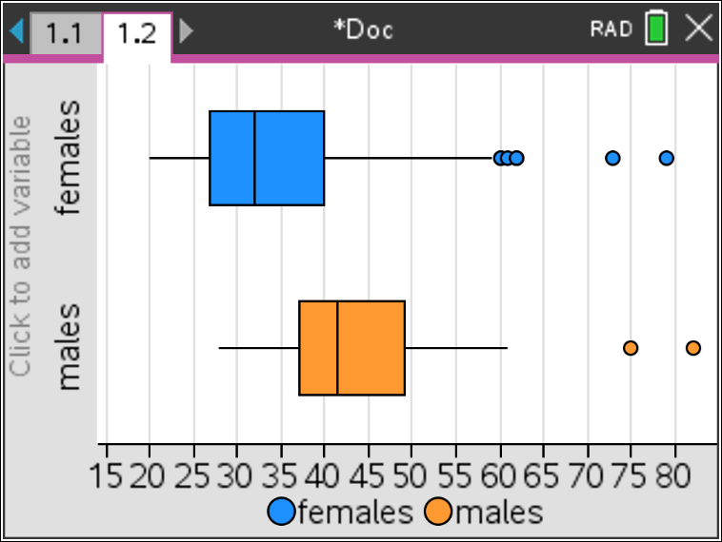
- First Quartile (Q₁) Answer: 27.3 (F) & 37 (M)
- Third Quartile (Q₃) Answer:40.0 (F) & 48.8 (M)

Represent the data graphically and comment on the result, including references to applicable outliers.
Answer: The boxplots really emphasis the difference in the data sets. Q₁ for males lies between Q₂ and Q₃ for females.
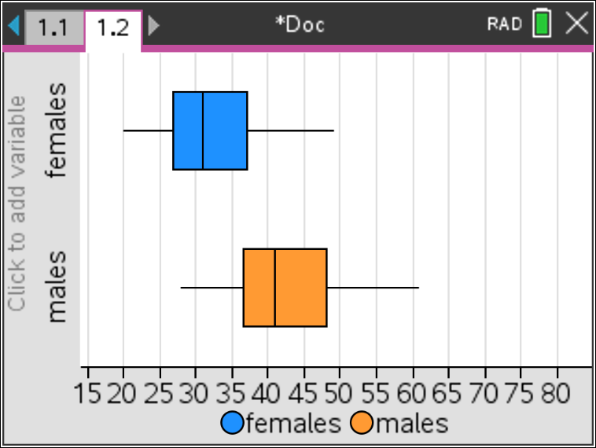
Removing the outliers for men and women (below right) only makes the comparison worse as Q₁ for males aligns almost precisely with Q₃ for females!

Miss Representation
The boxplots may be misrepresenting the data, they don’t show trends over time. Has there been any change over the past 18+ years since Geena Davis founded her institute?

Determine a least squares regression equation for the male data since the inception of the awards and comment on whether there is any trend in the data.
Answer: Equation: y = 0.070x – 95.14. Pearson’s correlation coefficient: r² = 0.040, indicates there is effectively no correlation in the data. ie: No trend. Even if there were a correlation, the gradient of the function shows no sign of any downward trend for males. Furthermore, isolating the data since 2004 doesn’t provide any evidence of more recent change.

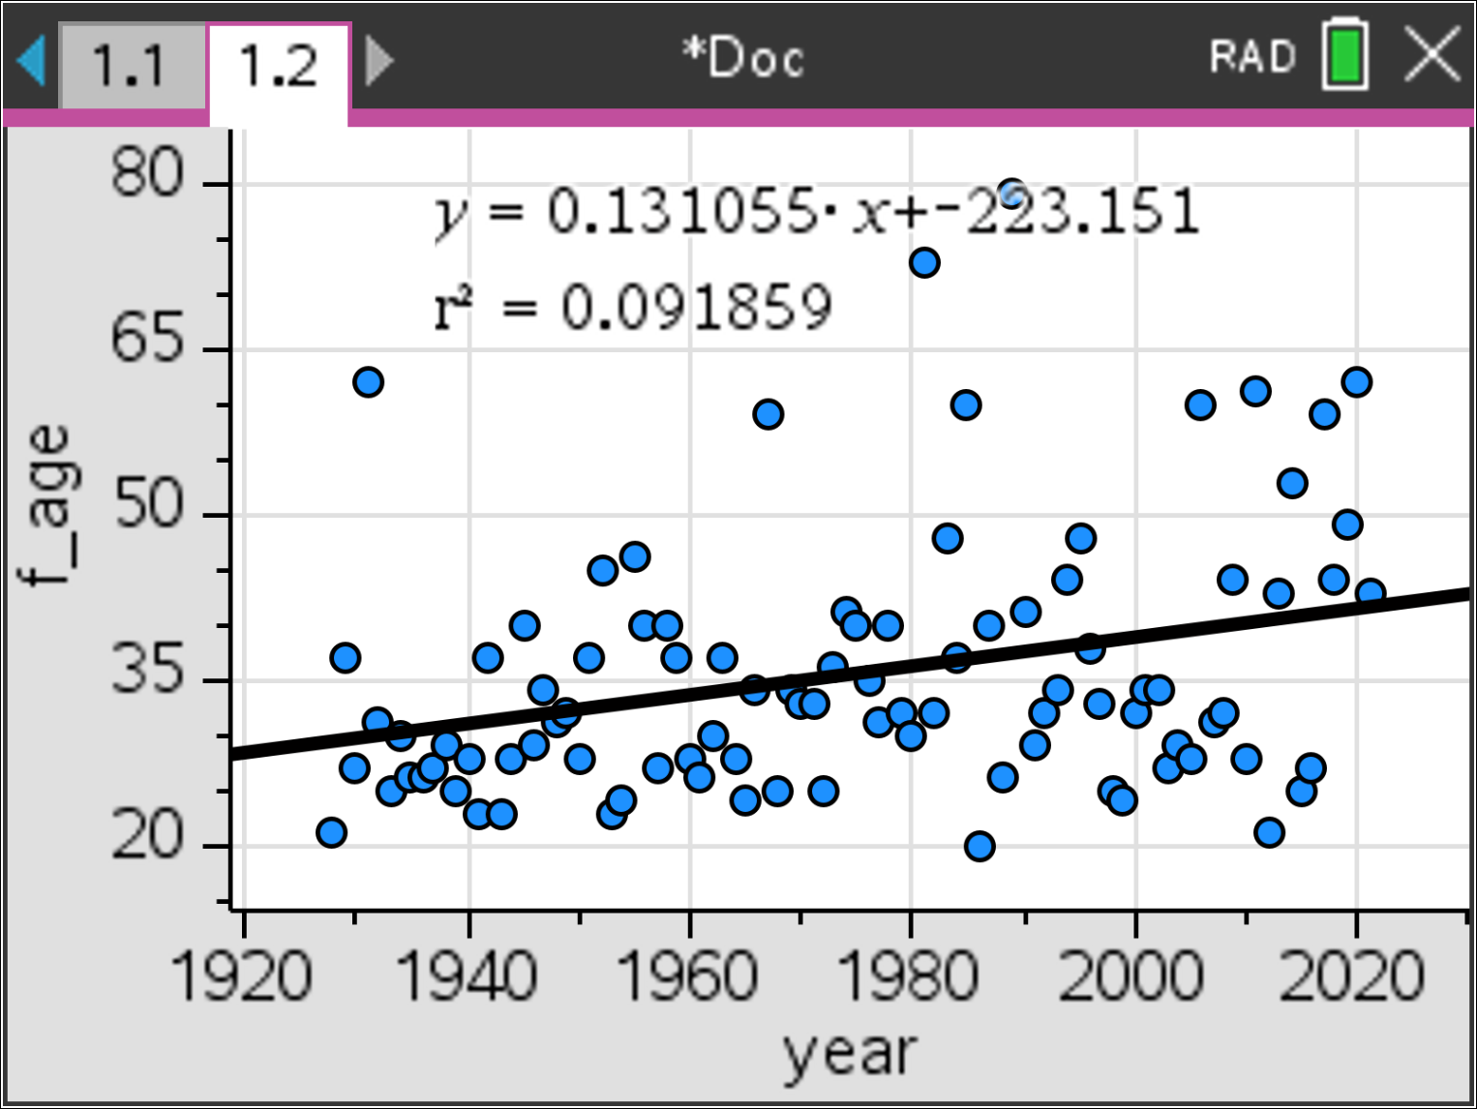
Determine a least squares regression equation for the female data since the inception of the awards and comment on whether there is any trend in the data.
Answer: Equation: y = 0.131x – 223. Pearson’s correlation coefficient: r² = 0.092, indicates there is effectively no correlation in the data. ie: No trend. However, unlike the data for the males, the visual representation (scatterplot) does show some interesting points since the year 2000.
Since 2004, the average (mean) age of female Academy Award™ winners has been almost 42, almost identical to the male data!

TV – Week Logie Awards™
The TV-Week Logie Awards™ have been running for many years. Since 1977 an award for most popular male actor and most popular female actress have been presented. These awards are determined by the general public, the original voting slips were obtained from the TV-Week magazine, now the awards are voted for on via an online form, so these awards are very much a ‘people’s award’.
- Is there any gender bias in these awards?
- How do they compare to the Academy Awards™?
- Comment on any issues pertaining to the data.
TV Week Logie Awards – Summary Results
There is much less evidence for gender bias in the Logie awards. The minimum and first quartile for both sets of data align quite well. The mean and median age however for females is still lower than that for males.
Just like the Academy Awards data, there is virtually no evidence of any trends for male or female data with regards to addressing the age/gender bias.
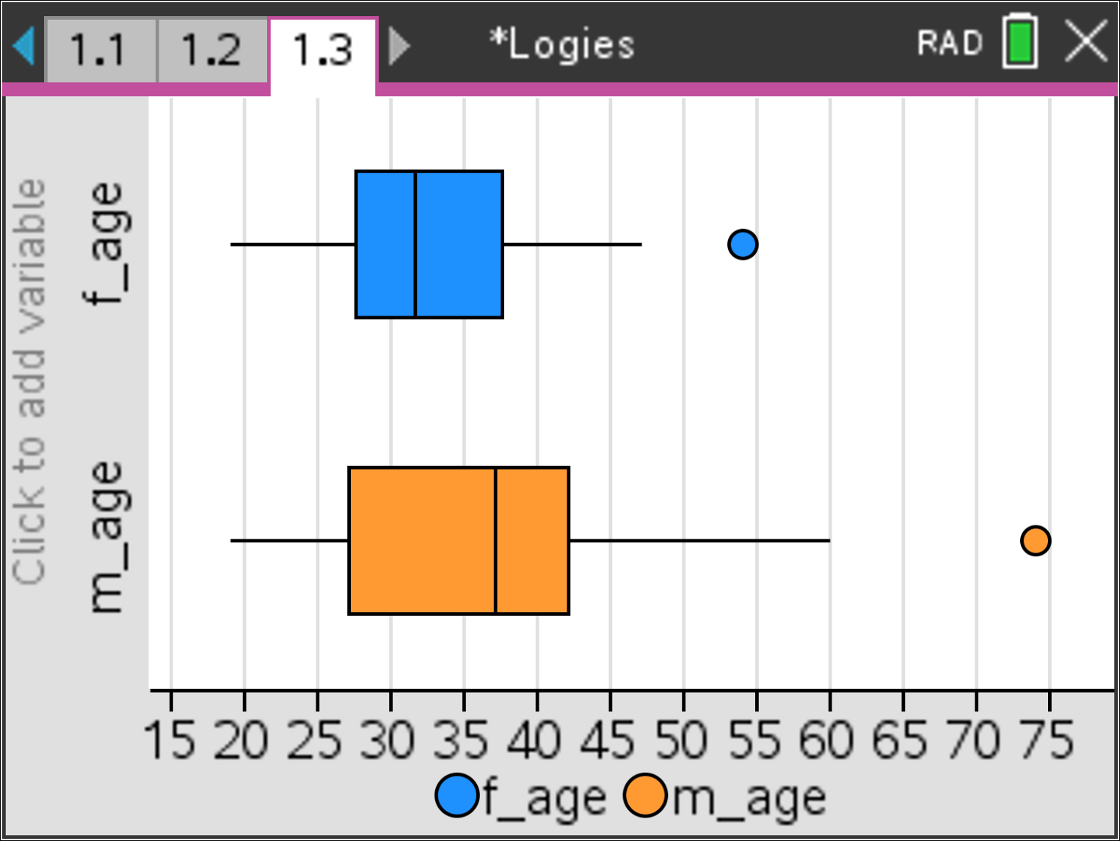  Q₀ and Q₁ align nicely, however the female data is left skewed the male right skewed. Interestingly the outliers for both male and female award winners were both awarded recently! | 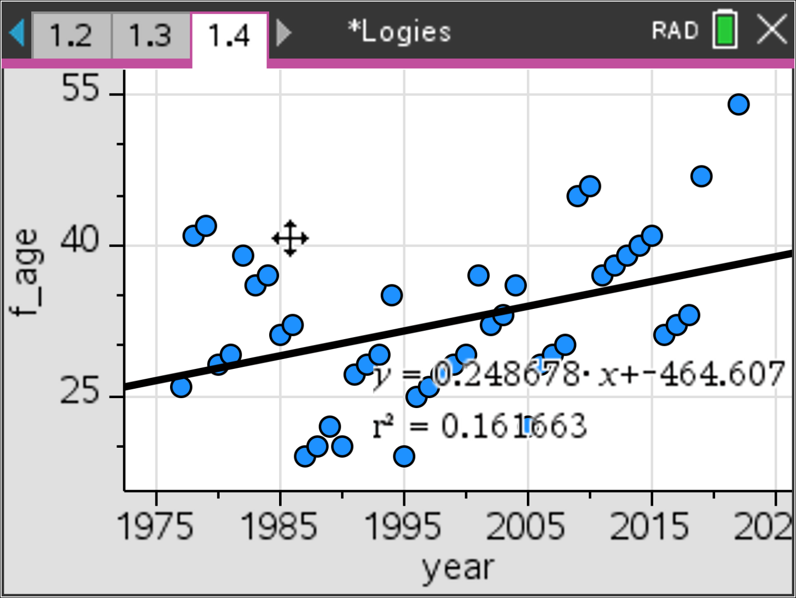  R² = 0.16 does not provide sufficient evidence of correlation. Consecutive wins by the same actress on multiple occasions create an interesting impression when trying to identify patterns. | 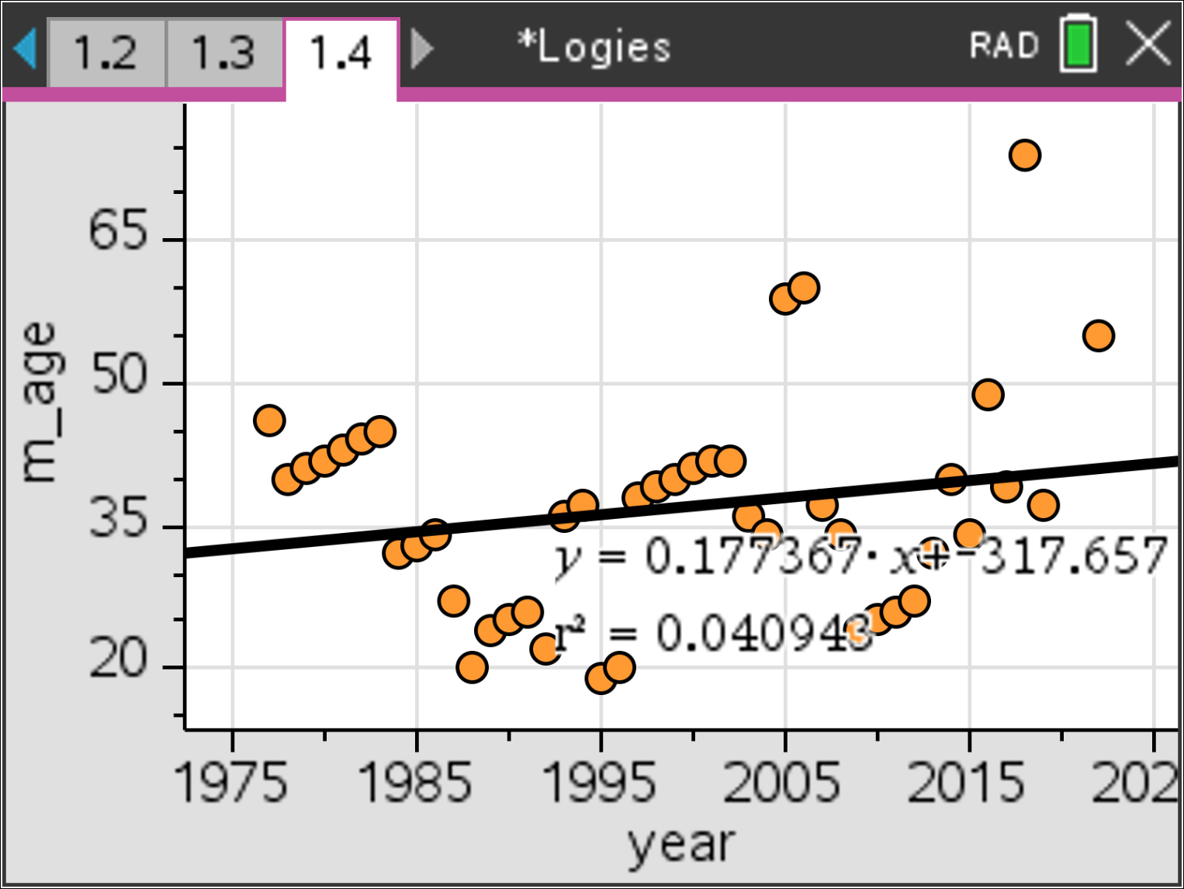  R² = 0.04 provides no evidence of any change over time.
The Most Popular Logie award is selected ‘by the people’ (viewing audience). There are many occasions where an actor / actress receives the award several years in a row. For example: Asher Keddie won “Most Popular Female” award for five consecutive years, similarly, Lisa McCune won the same award for five consecutive years!

AACTA Awards
The Australian Academy of Cinema and Television Arts commenced in 1972 as the Australian Film Industry awards. Whilst specific awards have changed over time, the best actor or actress has always been a part of the line up in some form. Voting for the AACTA awards is done only via AACTA members, in that sense they are an ‘industry’ award.
- Is there any gender bias in these awards?
- How do they compare to the Academy Awards™?
- Comment on any issues pertaining to the data.
AACTA Awards – Summary Results
There AACTA awards gender and age bias lies between the Academy Awards and the Logies. The minimums align quite well, however the long tail on the male data has Q₁ (males) aligning with Q₂ (females).
Just like the Academy Awards data, there is virtually no evidence of any trends for male or female data with regards to addressing the age/gender bias.
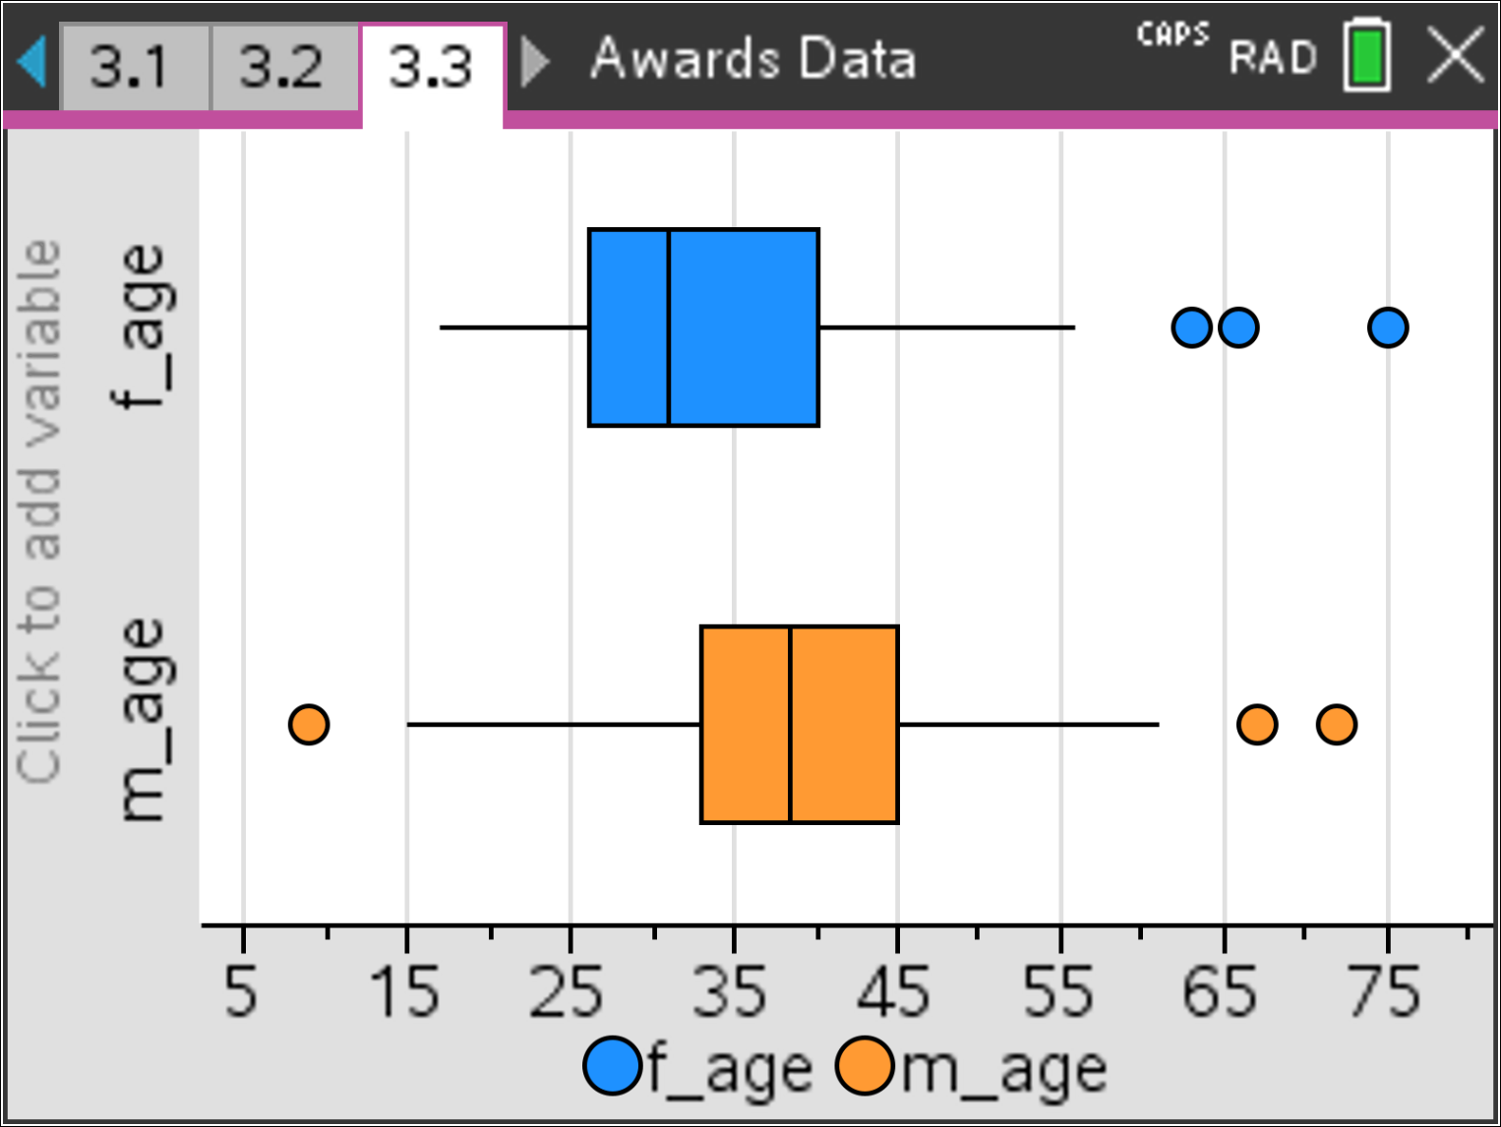  Q₀ and Q₁ align nicely, however the female data is left skewed the male right skewed. Interestingly the outliers for both male and female award winners were both awarded recently! | 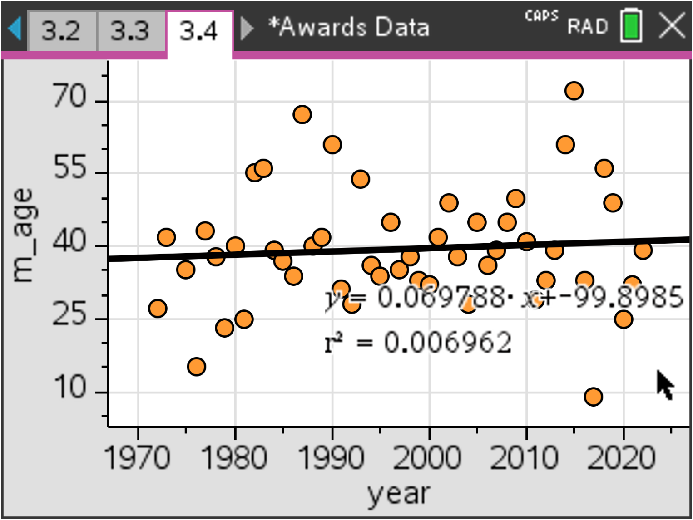  R² = 0.007 does not provide any evidence of correlation for males. There also appears to be a period from the mid 1990’s through to 2010 where almost the winners were between 30 and 45 years of age. | 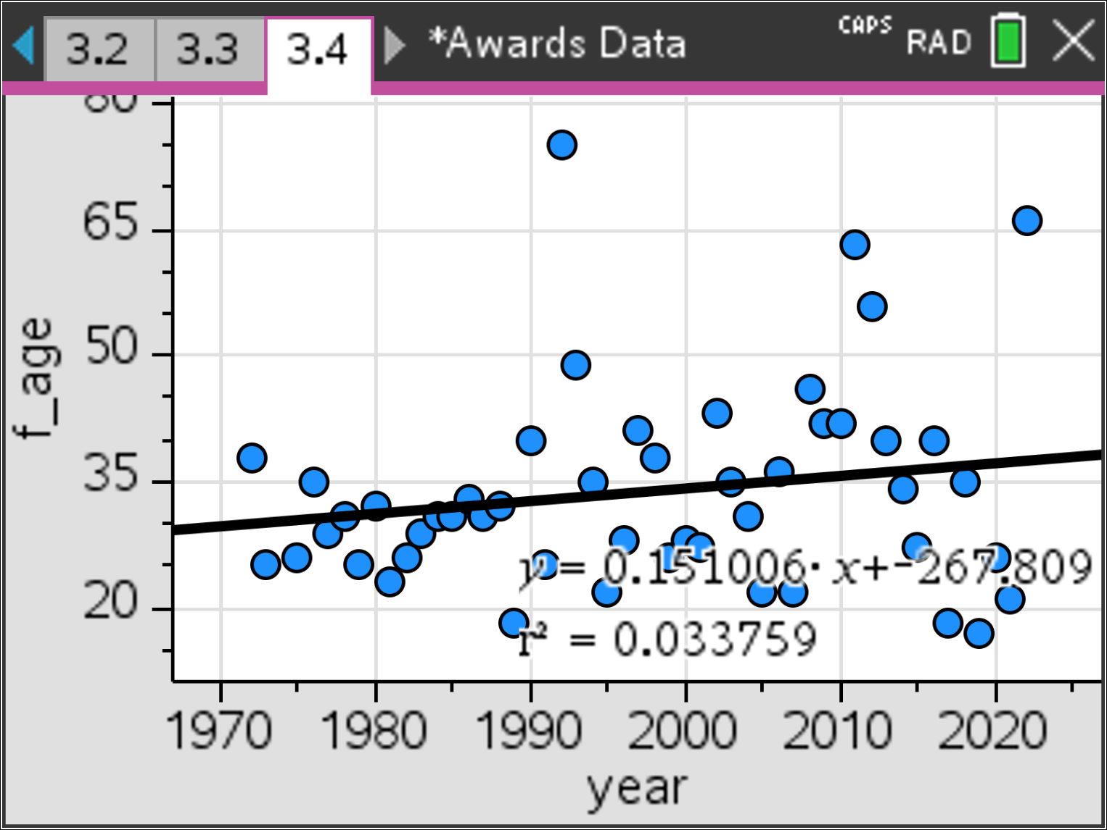  R² = 0.03 provides no evidence of any change over time for females. There does however seem to be a much greater range of ages since the 1990’s

Gender Bias in Australian Television Commercials
There is no doubt that sexism has occurred in Television commercials for many years. Take a look back at Australian Television commercials from the 1970’s, many of these advertisements included blatant objectification of women. Has there been any positive improvements over time?
Unlike the Awards data, this investigation requires quantification of observations. It is not sufficient to say “Yes” or “No” to improvements over time, these judgements require numerical evidence. Aligning numerical evidence means quantifying observations.

