Open the TI-Nspire document Exploring_Energy_Transfer.tns.  Have you ever put an ice cube into a warm drink to cool it down? How exactly does this temperature change occur? The temperature change of a substance is related to how much energy it gains or loses. If a substance gets warmer, it gains energy. Conversely, if a substance gets cooler, it loses energy. Whenever two objects of different temperatures come in contact with one another, thermal energy will flow from the warmer object to the cooler one until both are the same temperature. Once the objects are at the same temperature, they are at thermal equilibrium. In this activity you will explore how energy is transferred when a warm block of metal is placed in a beaker of room temperature water. |  |  | 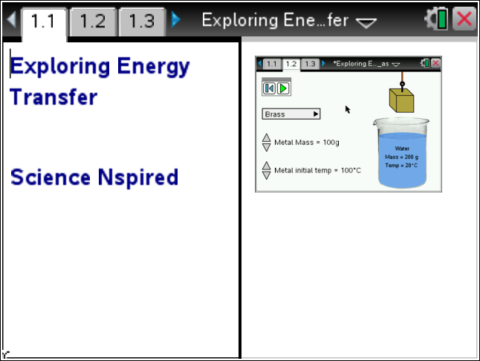
 | Move to Pages 1.2 - 1.4.
 | Read the instructions for the simulation.  1. Use the drop down menu to select any metal of your choice. Use the up and down arrows to adjust the metal cube so that it has a mass of 10 g and a temperature of 100°C. Record the type of metal and the initial temperatures of the metal cube and water in the table.  2. Select the Play button . Observe the change in temperature of the metal block and the water. Once the block and water have come to thermal equilibrium, observe the spreadsheet and graph on pages 1.3 and 1.4.  3. Record the final temperatures of the water and metal in the table. Also record the time it took for both objects to come to thermal equilibrium.  4. Return to Page 1.2 and repeat steps 1 - 3 for the different masses listed in the table. Be sure to use same metal each time and keep the initial temperature set to 100°C. |  | 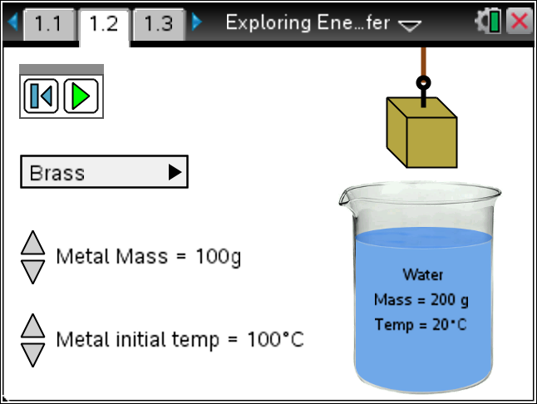
 | Tech Tip: To access the Directions again, select b or Document Tools () > Exploring Energy Transfer > Directions.
 | Tech Tip: To access the Directions again, select > Exploring Energy Transfer > Directions.
 | Metal: __________________
Initial Metal Mass (g) | Initial Metal Temp  (°C) | Final Metal Temp  (°C) | Metal  Change in Temp (°C) | Initial Water Temp  (°C) | Final Water Temp  (°C) | Water  Change in Temp (°C) | Time to reach equilibrium (s)
10
20
30
40
50
60
70
80
90
100

Move to Pages 1.5 - 1.6.
Answer questions 1 and 2 below and/or in your .tns file.

Q1. How does the mass of the metal cube affect the time it takes for the metal and water to reach thermal equilibrium?

A. As the mass of the cube increases, the time it takes to reach equilibrium increases.
B. As the mass of the cube increases, the time it takes to reach equilibrium decreases.
C. The mass of the cube is unrelated to the time it takes to reach equilibrium.

Q2. Calculate the change in temperature of the metal and water for each mass in the table. How does the change in temperature of the water compare with the change in temperature of the metal? (Note that a negative temperature change means that the object decreased in temperature.)

 | Move to Pages 2.1 - 2.2.  5. Read the information on pages 2.1 and 2.2. The heat energy gained or lost by an object is given by the following equation:  ΔQ = mass * Specific Heat * ΔT  where ΔQ is heat energy gained or lost by the object and ΔT is the change in temperature of the object.  6. Calculate the heat energy gained or lost by the brass cube and water masses given in the table. (You will need to use some of the data from the first table you completed earlier.) |  | 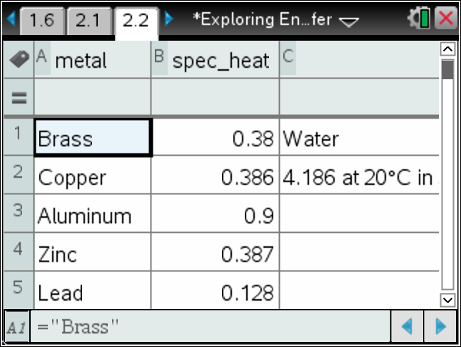
Metal: __________________

Metal Mass (g) | Specific Heat of Metal (J/g°C) | Metal  Change in Temp (°C) = ΔT | ΔQ for Metal (J) | Water Mass (g) | Specific Heat of Water (J/g°C) | Water  Change in Temp (°C) = ΔT | ΔQ for Water (J)
10 |  |  |  | 200
40 |  |  |  | 200
70 |  |  |  | 200
100 |  |  |  | 200

Move to Pages 2.3 - 2.7.
Answer the questions 3 - 7 below and/or in your .tns file.

Q3. Compare the calculated values of “ΔQ for Metal” and “ΔQ for Water” in your table. What do you notice about these quantities?

Q4. Based on the results of your calculations, which of the following can you conclude?

A. The temperature increase of the metal is equal to the temperature loss of the water.
B. The heat energy gained by the water is equal to the heat energy lost by the metal.
C. The mass gained by the metal is equal to the mass lost by the water.

Q5. 10 g of water and 10 g of copper are placed under a heat lamp. Each object absorbs an equal amount of heat energy. Which object will increase most in temperature?

A. water
B. copper

Q6. 10 g of zinc and 10 g of alluminum are placed under a heat lamp. Each object absorbs an equal amount of heat energy. Which object will increase most in temperature?

A. zinc
B. alluminum

Q7. If the two objects in questions 5 and 6 absorb the same amount of heat energy, why is it that the temperature of one object increases more than the other?

