Index of Refraction:
Treasure at the Bottom of the Sea
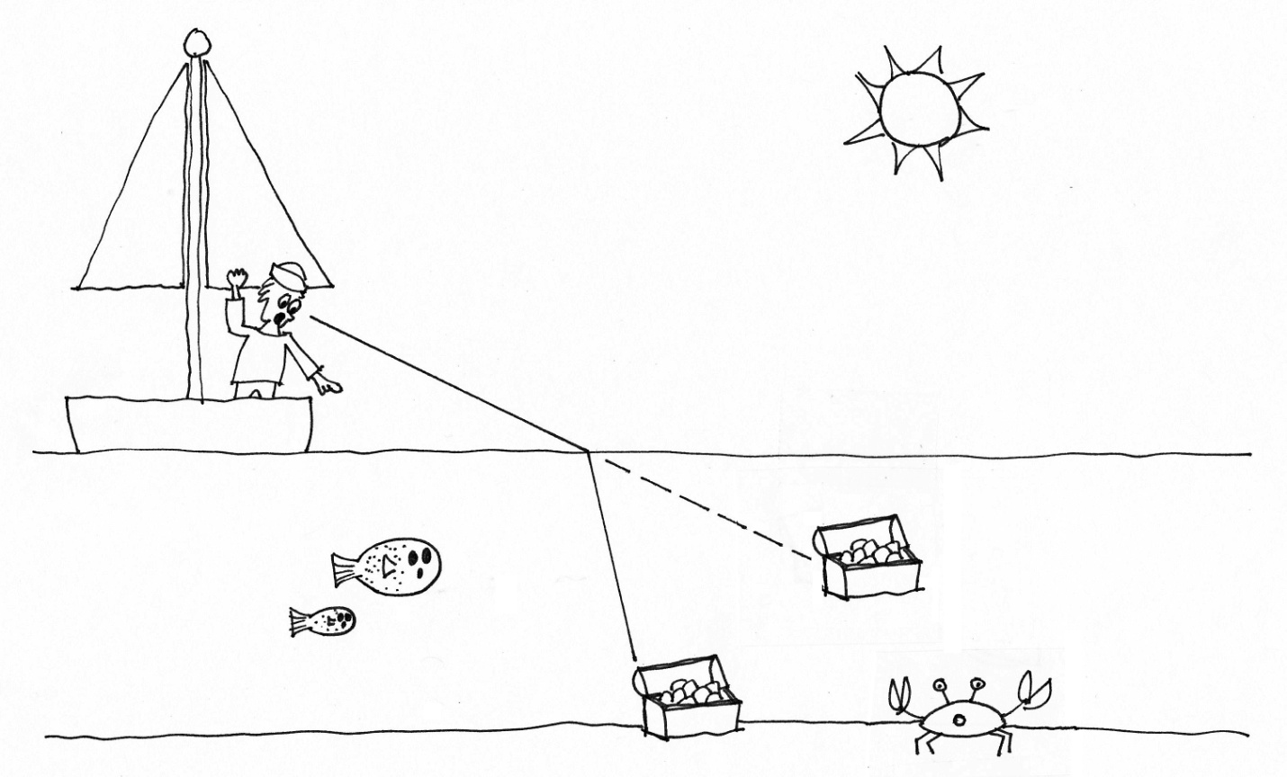
Artwork by Shelly Lynn Johnson

When light moves from one material to another, the speed of the light changes. Refraction is the bending of a light ray when it moves from one medium (like air) to another (like glass or water). The amount of bending depends on the difference in speed of the light in the two different media. Snell’s Law describes this relationship.

The refractive index of a material is an important optical property and is used to calculate the focusing power of lenses and the dispersive power of prisms. Refractive index is an important physical property of a substance that can be used for identification, purity determination or measurement of concentration.

This activity is designed for the Nspire handheld and intends to help students understand the refraction of light as it moves from one medium to another. Students will discover Snell’s Law using an interactive diagram.

Introduction  - Open the IRefracS.tns file.  - Read the first three pages of the document. | 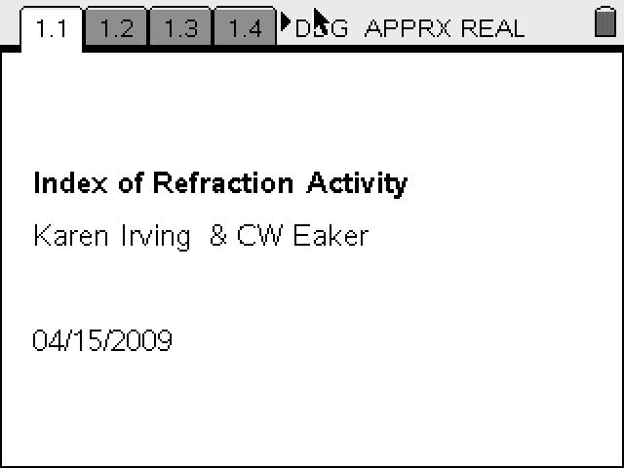
1.2 Reflection and refraction describe the behavior of waves. Compare and contrast these behaviors by answering the following questions.  Q1. How are they similar?  Q2. How are they different?  Q3. With a partner, write at least 2 statements describing reflection and refraction. | 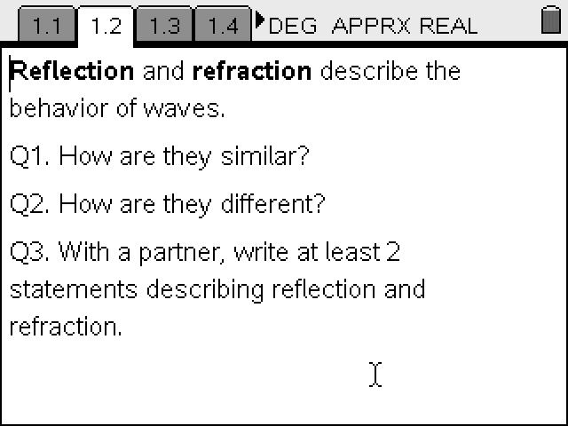
1.3 This activity is intended to help you understand how light behaves as it moves from one medium to another.  Q4. What is an optical medium? | 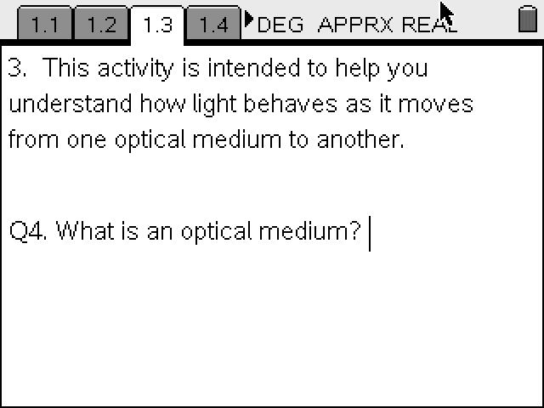
1.4  Q5. What word describes objects that allow light to pass through? Give an example of this type of medium.  Q6. What word describes objects that allow only some light to pass through?  Given an example of this type of medium.  Q7. What word describes objects that do not allow light to pass through? Give an example of this type of medium. | 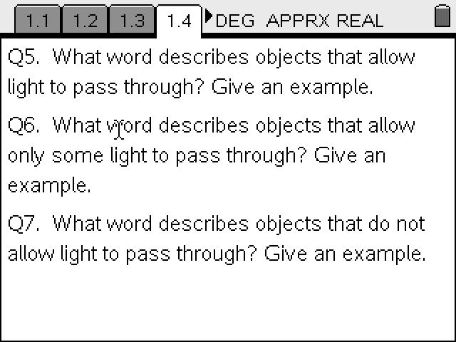
1.5 In the diagram, an observer (or sailor) at point A is looking into water.  - When a light source is present (like the sun), the observer can see an object under the water - perhaps a treasure chest.  - The object at the "actual location" is perceived by the sailor to be at the "apparent location." | 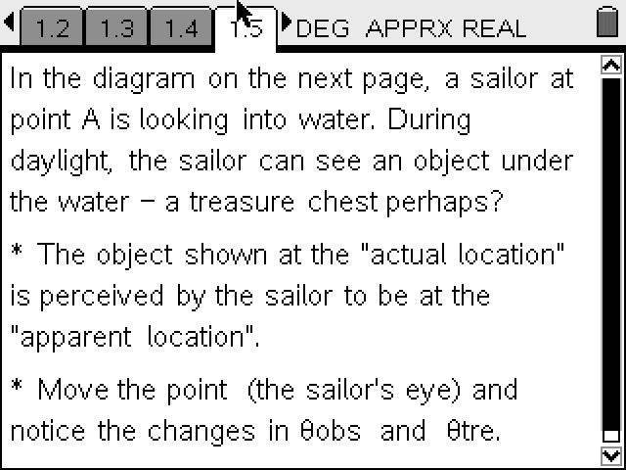
1.6 Move point A and notice the changes in θ_{obs} and θ_{obj}.  Use the NavPad to move close to the point at the end of the line, labeled sailor’s eye. When an open hand appears ÷, press the / key followed by the x to grab the point. Notice that the hand closes. You will be able to move point A. Notice that the values of θ_{obs} and θ_{obj} change as you change the position of point A. | 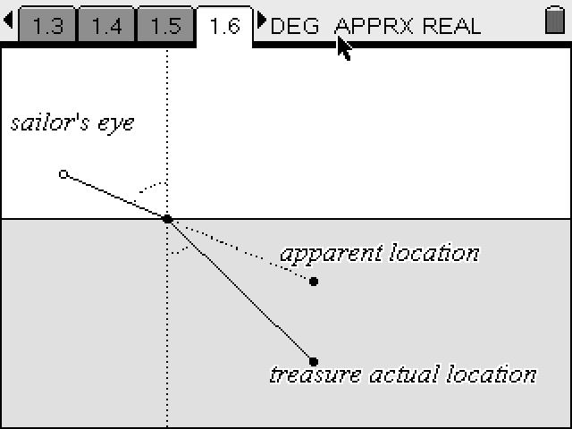
1.7a  Q8. Describe the path of the light from the actual location to the observer's eye at point A.  Use /e to move between the two sections (notes at the top versus interactive diagram at the bottom) of the screen.  After selecting the top text box, use the up and down arrows to reveal questions 9, 10, and 11. | 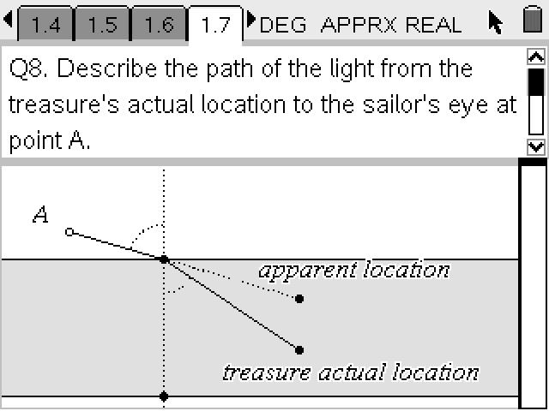
1.7 b  Q9. Describe the path of the light from the apparent location to the observer's eye at point A.  Use /e to move between the two sections (notes at the top versus interactive diagram at the bottom) of the screen. | 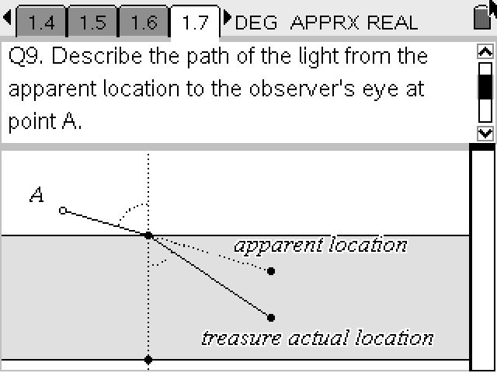
1.7c  Q10 Will the treasure be where the sailor sees it in the water? | 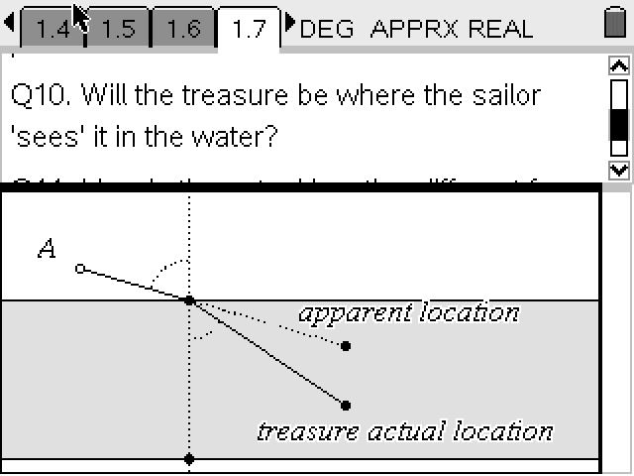
1.7d  Q11 How is the actual location different from what the sailor sees? | 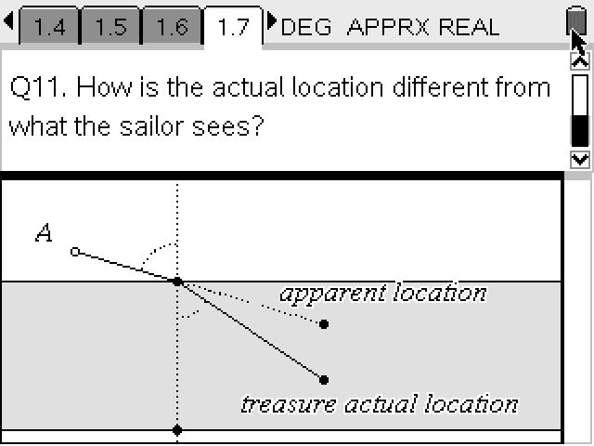
1.8 Notice the dotted line that is drawn perpendicular to the boundary between the two media (air & water). This line is called the normal line. Label the line on the diagram.  To add a text box: Select b Actions Text ·. . You will see a box. Type in normal. Press · again. Move the cursor away. You can select the text box and move it with the hand tool.  Consider the magnitude of these angles.  Q12. Are they ever the same size?  Q13. As θ_{obs} increases, what happens to θ_{tre}? | 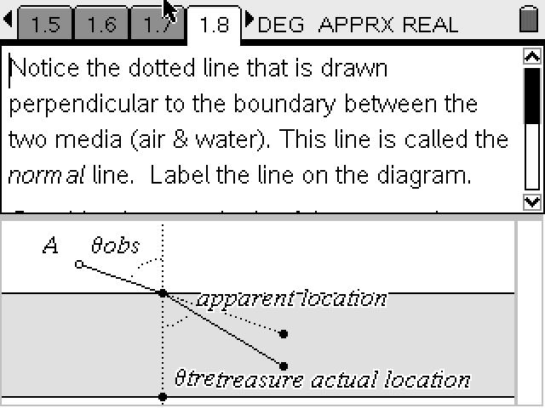
1.9 Use the lists and tables function to create a table of θ_{obs} and θ_{tre}.  See if you can discover a relationship between the angles.  Remember that in a right triangle,  sin θ = Opposite/Hypotenuse.  cos θ = Adjacent/Hypotenuse | 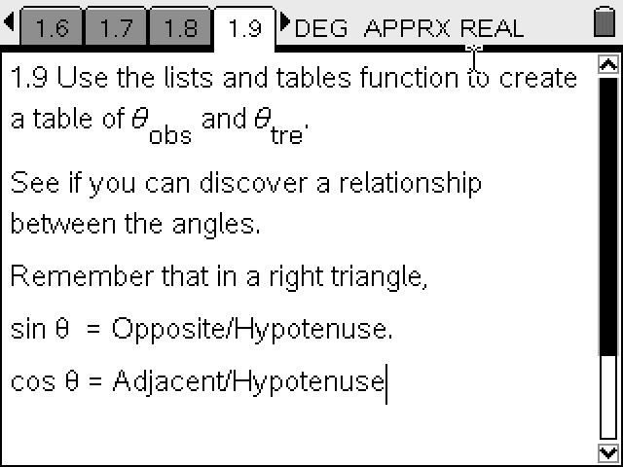
1.10 Select 5 different of θ_{obs} angles. Measure the θ_{tre} for each of the selected θ_{obs} angles. Record your data in the list on the next screen.  Use the NavPad to move close to the point at the end of the line. When an open hand appears ÷, press the / key followed by the x to grab the point. Notice that the hand closes. You will be able to move point A. Record the values of θ_{obs} and θ_{obj} as you change the position of point A to collect 5 different sets of angle values. | 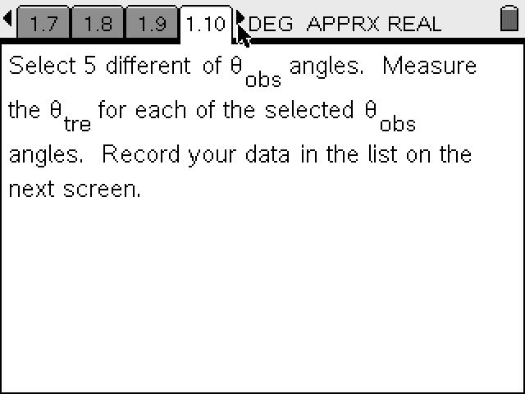
1.11 Record your data in the table. Each student will create their own unique data set. Be sure to include the digit after the decimal point as part of your data. | 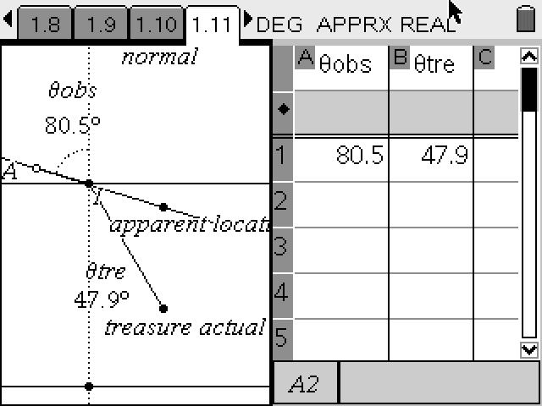

1.12  Q15 Which trigonometric function would best measure the magnitude of the angles formed by the ray from the treasure to the surface (refracted ray) and from the surface to the sailor's eye?  Sin or Cos? Why | 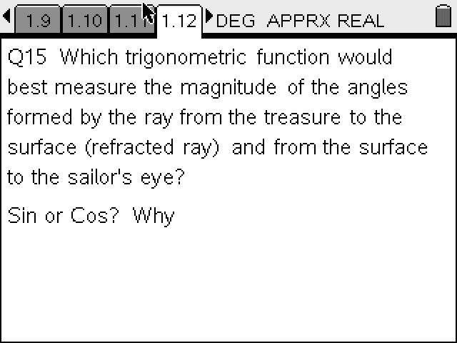
1.13 Snell selected the sin θ value for the index of refraction. Calculate the sin of each angle. | 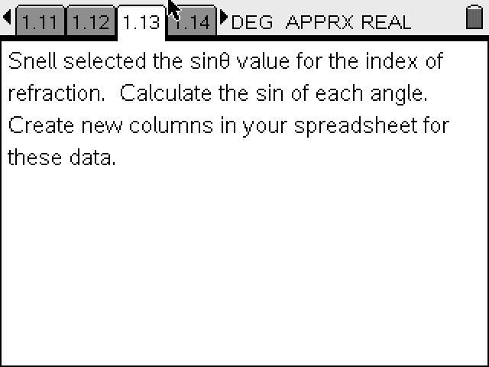
1.14 Create two new columns in your table, one for sin θ_{obs} and the other for sin θ_{tre}.  The θ symbol can be found in the catalog located by selecting /k (the symbol that looks like an open book with Greek symbols above). Select the symbol you want | 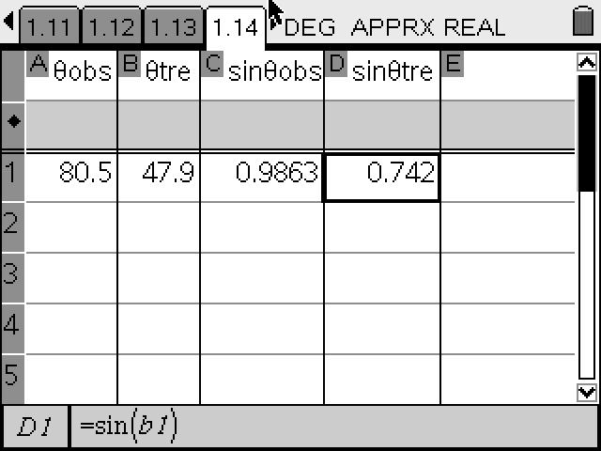
1.15 Experiment with the ratio of sin angles. Check out both possibilities for each of your five sets of angles. | 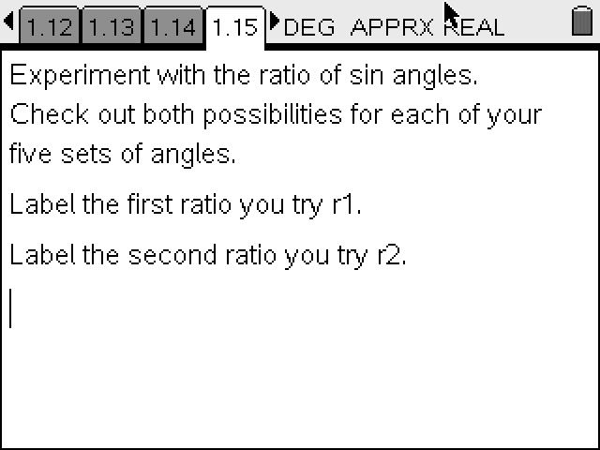
1.16. Try the opposite ratio too. | 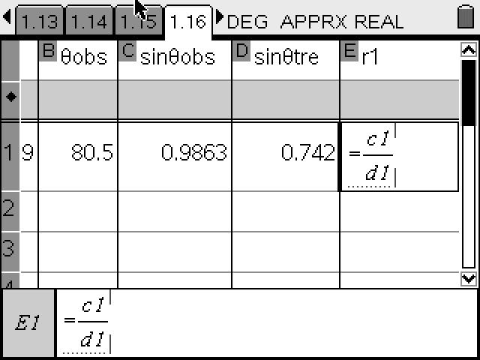
 | 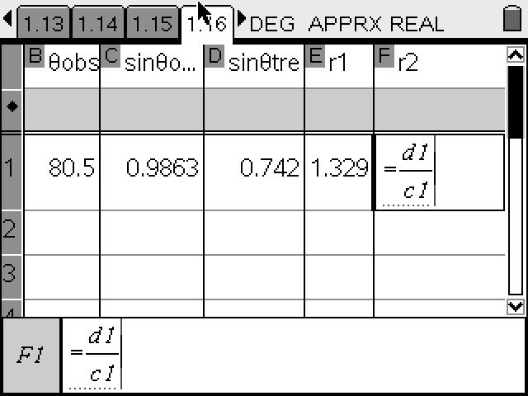
1.17 Study the values you have produced in the spreadsheet.  Q16. Which calculation produces a constant value for all 5 of your measurements?  Q17. Which calculation produces a constant value greater than 1? | 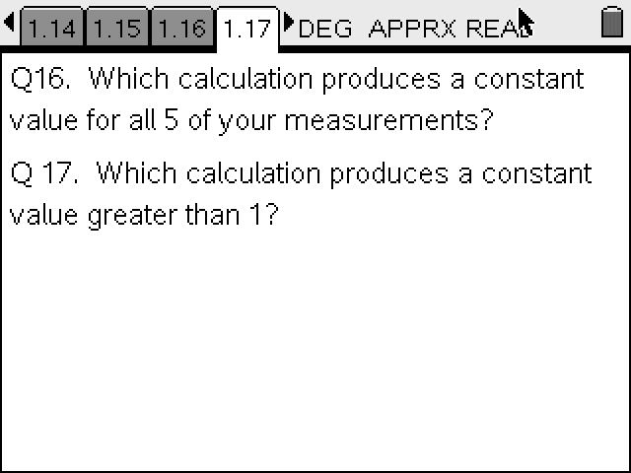
1.18 The index of refraction is a number (usually greater than 1.0) that measures how much the speed of light (or other waves such as sound waves) is reduced inside the medium.  Q18. Write a mathematical expression for the Index of Refraction. | 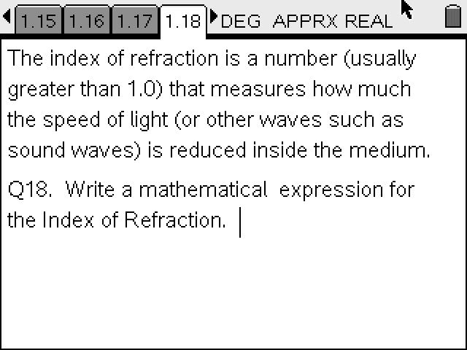
1.19  Q19. Use a reference book or web site to find the Index of Refraction for these substances:  1. diamond  2. water  3. air  4. salt (NaCl) | 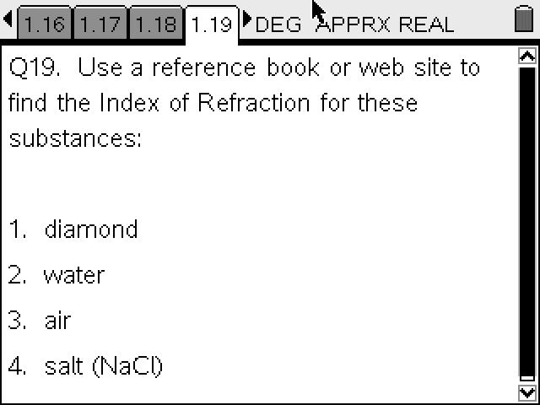
Q20. Which of these media will refract light the most?  Q 21. Which of these materials will refract light the least?  Q 22. What media have an index of refraction around 1.5? | 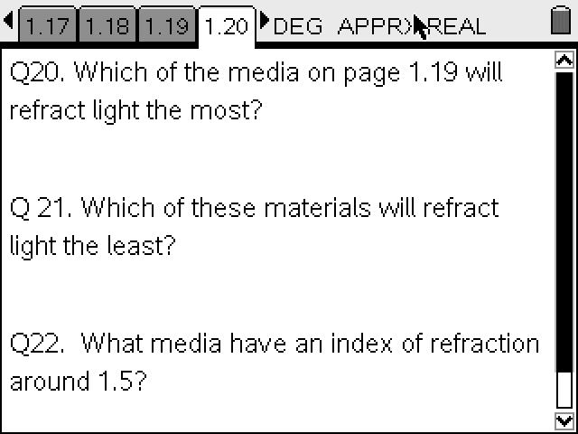

Indices of Refraction
Material | Index
Vacuum | 1.00000
Air at STP | 1.00029
Ice | 1.31
Water at 20 C | 1.33
Fluorite | 1.433
Fused quartz | 1.46
Typical crown glass | 1.52
Crown glasses | 1.52-1.62
Spectacle crown, C-1 | 1.523
Sodium chloride | 1.54
Polystyrene | 1.55-1.59
Flint glasses | 1.57-1.75
Heavy flint glass | 1.65
Extra dense flint, EDF-3 | 1.7200
Sapphire | 1.77
Arsenic trisulfide glass | 2.04
Diamond | 2.417
Index of refraction source:
http://hyperphysics.phy-astr.gsu.edu/Hbase/tables/indrf.html#c1

Emergent ray
Incident ray
Interior ray
A
B
C
D
Normal line 1
Normal line 2
Angle 1
Angle 2
Angle 3
Angle 4

