Activity Overview  In this activity, you will create a new document with a Graphs & Geometry application to explore transformations of an absolute value function. You will use the table feature to examine the effect the transformation has on the coordinates.  Activity Materials  - Technology needed (TI-Nspire™ handheld, computer software) | 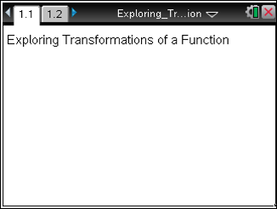
Steps

Step 1: Preparing the Document  - Open a new document by clicking c > New Document > Add Notes.  - Using this Notes page as a title page, give it an appropriate title, such as Exploring Transformations of a Function.  Note: To type capital letters, press the g key, then the letter.  - Press ~ > File > Save As…  Type: Exploring_Transformations_of_a_Function.  Note: To obtain the underscore, press / _.  Tab to ¾, and press ·.  4. To add a new Graphs page, press / ~ > Add Graphs. | 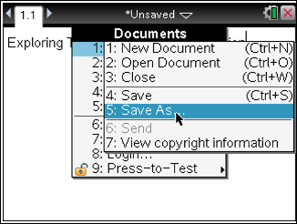  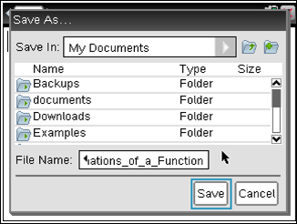  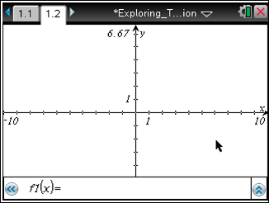
Step 2: Enter the function into f1(x).  1. The cursor should be in the function entry line at the bottom of the screen.  2. To graph f1(x) = , type: A B S (X) · .  Note: You can also access the absolute value template by pressing the t key. | 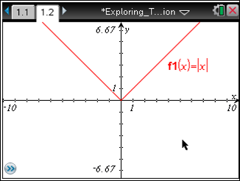
Step 3: Change the attributes of the graph to create a dashed line.  - To change the attributes, move the cursor near the graph until the cursor becomes a pointed finger (ø) and the graph turns bold.  2. Press / b > Attributes. A drop-down menu appears. Select the third line style in the second row of attributes by pressing ¤ ¢ ¢ so that “(3/3) Line style is dashed” appears. Press ·. Move the cursor away from the graph. | 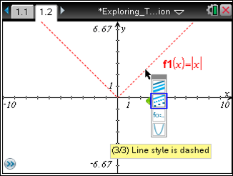
Step 4: Enter a second function into f2(x).  1. Press e to move the cursor to the function entry line for f2(x).  Note: You may also click the chevron () or press / G to display and/or hide the function entry line.  2. To graph f2(x) = 3, type 3 A B S (X) ·.  3. To move the function labels, move the cursor until it hovers over one of the labels. The word “label” appears and the cursor turns into an open hand (÷). Press / x to close the hand ({). Move the function label to an open space near the bottom left of the screen and press x. Repeat for the other function label.  Note: An alternate method of selecting an object is to press and hold x when the cursor is an open hand ÷. | 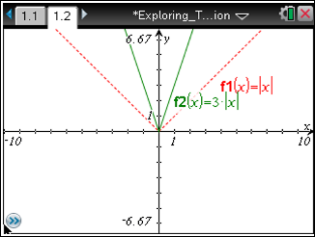  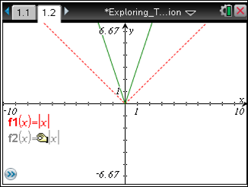
Step 5: Insert a table into a split screen layout.  1. To insert a table, press / T.  2. Notice that we cannot see the values of f2(x) in the second column. To view these values, in the next step we will adjust the widths of the two parts of the split screen. | 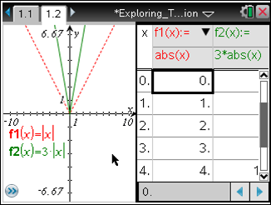
Step 6: Adjust the widths of the split screen.  1. Press ~ > Page Layout > Custom Split.  2. The message “Use + or – to choose a layout” appears for a moment, which allows you to toggle between a horizontal or vertical split. You may test this feature now if you wish, but a vertical split is the preferred view for this lesson.  3. To change the widths of the two parts of the screen, press ¡ or ¢. In this case, press ¡ a few times until you can read the values in the f2(x) column.  4. Press ·. | 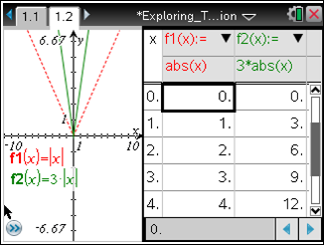
Step 7: Edit the function in f2 and observe the graph and table.  1. Use the e key to highlight the top of the table. Then use the ¤ ¢ keys to select the cell containing 3abs(x).  Note: You can also use the touchpad mouse to click on that cell.  2. To edit the expression, select Menu > Table > Edit Expression, or you may double-click the cell. Redefine f2(x) as .  3. This action will be repeated again by the students to redefine f2(x) as each of the following: , , and . | 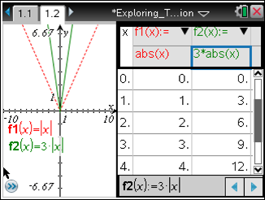  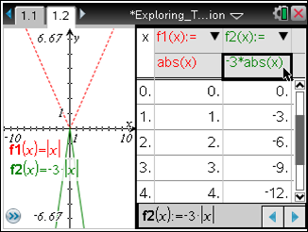
Step 8: Save the document  1. Redefine f2(x) back to its original definition, f2(x) = .  2. Press / S to save the document. | 