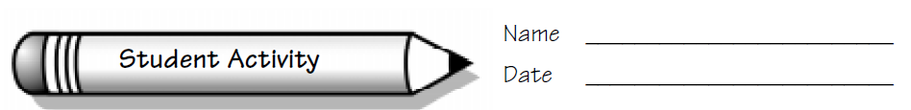
Focus: Use estimation to measure.
No More Peas, Please!

Collecting and Analyzing Data
Materials we will need:

To find out how many peas it will take to fill this room, we will:

Analyzing Data and Drawing Conclusions
The method we chose will work because:

Questions we thought of while we were doing this activity:

