In this activity, you will examine several power and polynomial functions to determine their similarities and differences and the characteristics of their end behavior. You will then make connections between these power functions and polynomial functions and write their end behaviors using limit notation. | 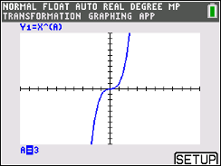

You will use the Transfrm App on the TI-84 CE. Press apps, scroll to the bottom, press Transfrm, and press any key.

1. Press y=, and type the function y = x^{A} into Y1. Press graph. Click the right and left arrows to see the graphs of various power functions in the form y = x^{A}. Remember that A is a positive integer.

a. As you scroll through the functions, describe the similarities and differences that you see.

b. As you look at the various graphs of the power functions, answer the following.
i. What happens to the value of the function as x increases without bound (x → ∞)?

ii. Give a mathematical explanation to describe the behavior of the graph.

iii. Write your explanation using limit notation.

c. Again, look at the various graphs, and as x decreases without bound (x → –∞), answer the following.
i. What happens to the y-values?

ii. Explain this behavior mathematically.

iii. Write your explanation using limit notation.
Press y=, and type the function y = -x^{A} into Y1. Press graph. Click the right and left arrows to see the graphs of various power functions in the form y = -x^{A}. Remember that A is a positive integer.

2. Click the left and right arrows to see the graphs of additional power functions.
a. How do these power functions differ from the functions with a positive coefficient from question
1?

b. As x increases without bound (x → ∞), what happens to the y-values?

c. As x decreases without bound (x → –∞), what happens to the y-values?

3. Using limit notation, write a general statement about the end behavior of power functions.

You will now type in several polynomial functions and discuss their similarities to the power functions.

4. A polynomial function is a sum of power functions whose exponents are non-negative integers. Go to y=, quit the Transfrm app (top right corner), and type the following function into Y1.
$Y1=2x^{3}+5x^{2}-x-5$. For this graph, what parent power function, with the same end behavior, do you expect this polynomial function to resemble? Why?

5. a. If you zoom out, what do you predict will happen to the shape of the graph? Was your prediction
correct?

b. Discuss the similarities and differences between the polynomial function and the power function.

6. Graph the following graphs into Y1.
$$Y1=x^{3}-0.5x^{4}+2x^{2}$$
$$Y1=3x^{4}-5x^{2}-2$$
$$Y1=3+x^{2}+6x^{3}-4x^{4}-2x^{5}$$
$$Y1=x^{6}-0.5x^{5}-4x^{4}+0.6x^{3}+4x^{2}-0.12x-0.75$$
Zoom out each of the graphs. By looking at the equation of a polynomial function, how do you determine which power function the graph will resemble? Explain your reasoning.

7. Does the end behavior of each graph follow the limit notation general statements written in number
three? Explain your answer.

8. The graph of a polynomial function is shown.  a. Write a possible equation that models the function. | 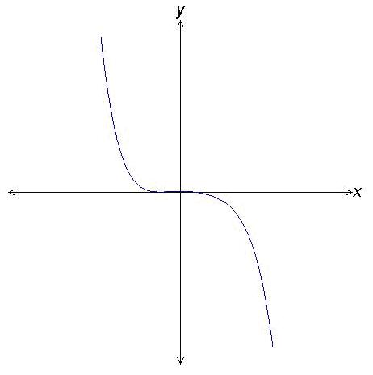
b. Explain your reasoning.

9. For a polynomial function $f$, $\lim_{x→-∞}{f\left(x\right)= -∞}$ and $\lim_{x→∞}{f\left(x\right)= -∞}$. Describe the degree and
leading coefficient of $f(x)$.

