In this activity, you will use the data in the file FindThatSine.tns, which contains the temperatures and hours of sunlight in Kansas City, and the heights of tides in the Bay of Fundy. You will find the equations of Sine curves that model the given data and answer several questions about what you have found.  **Note: Make sure that your handheld is in Radian mode. | 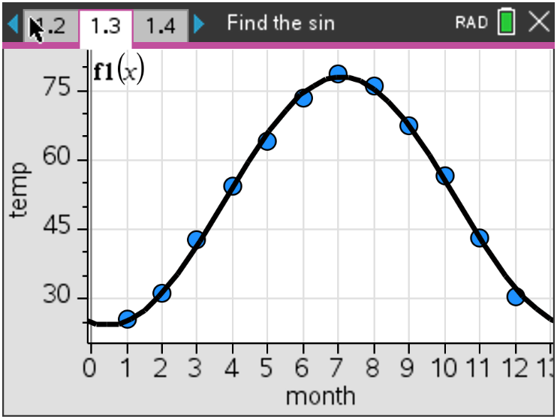

Problem 1 – Temperature

In this problem, you will graph data and find a sinusoidal function.

The temperature in Kansas City fluctuates from cold in the winter to hot in the summer. The average, monthly temperature (°F) has been entered into the list and spreadsheet on page 1.3. After your teacher has transferred the file to your handheld, open the file and read through pages 1.1 and 1.2.
Find the equation that models the data. Place the cursor on cell c1 and select Sinusoidal Regression from the Stat Calculations menu.

On page 1.4, create a scatter plot for this data (Menu, 3 Graph Entry/Edit, 6 Scatter Plot)

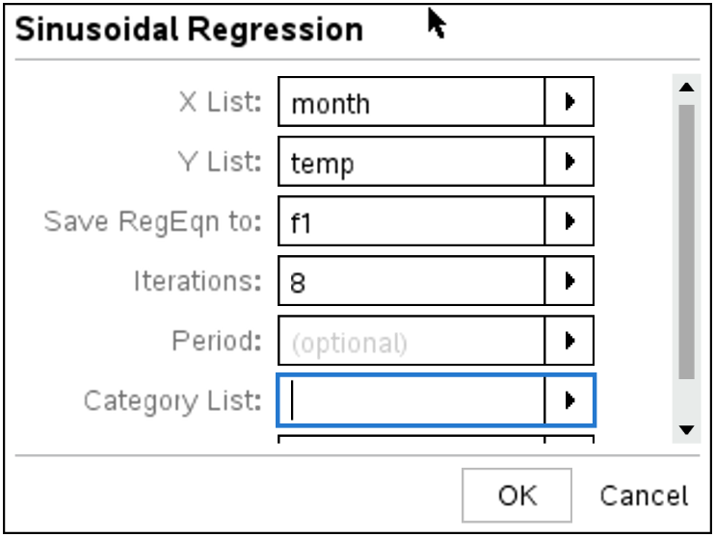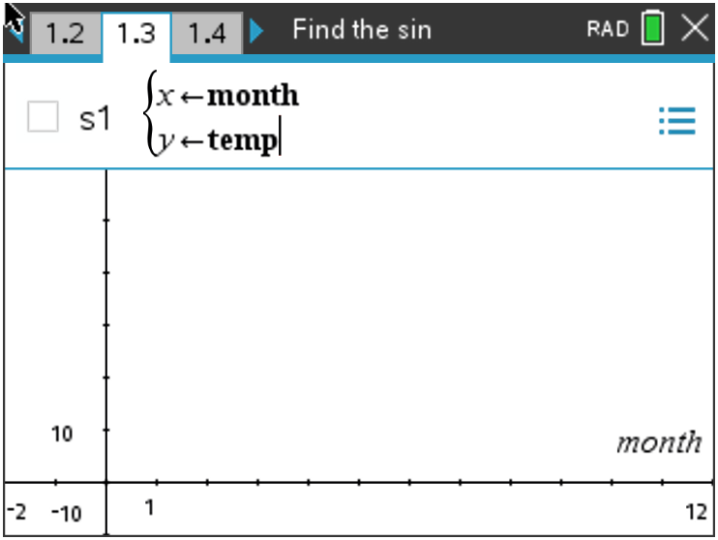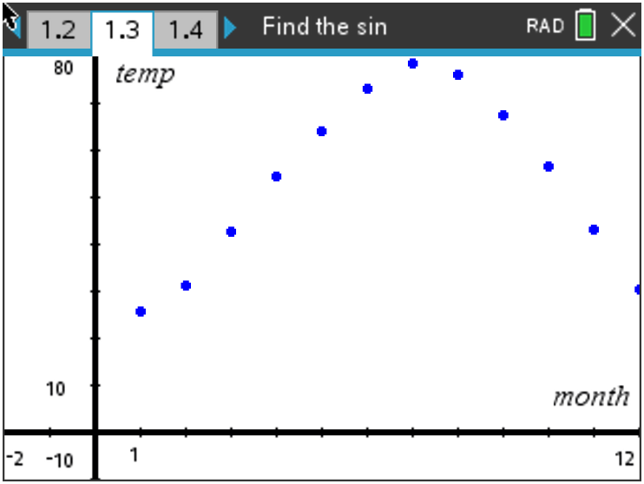

(a) Write the sine equation that models the data in the form $y=a ∙\sin\left[bx+c\right]+d$.

On page 1.4, press tab, the up arrow and then enter to see the sine regression stored in f1(x)
from the temp data. Move to page 1.5.
(b) Discuss with a classmate how well the sine curve of regression models the data. Share your
thoughts with the class.

(c) Move to page 1.6. Find the approximate temperature in Kansas City on March 15. Explain if this
is a reliable temperature you found.

(d) Using your sine curve of regression, estimate when your temperature will reach 85° in Kansas
City and give an explanation of your results.

Problem 2 – Hours of Sunlight

Move to page 2.1, then 2.2. The amount of light a location on the Earth receives from the Sun changes each day depending upon the time of year and latitude of that location. The amount of daily sunshine Kansas City experiences has been recorded in the lists on page 2.3 where the calendar day is in day, and the hours of sunlight is light.
Move to page 2.4 and create the scatter plot and sine equation that models the data as outlined in Problem 1. To create the scatter plot, make sure to change the X List to day and the Y List to light.
In early cultures, certain days of the year had significant importance because of the planting cycle. These days were the winter and summer solstices, and the spring and fall equinoxes. The equinoxes are the days with equal amounts of light and dark. The summer solstice has the greatest amount of sunlight, while the winter solstice has the fewest amount of sunlight.

(a) Rounding to the nearest hundredth, write down the sine equation.

(b) Discuss with a classmate how well the sine curve of regression models the data. Share your
thoughts with the class.

(c) Move to 2.5. Find the equinox dates using your sine curve of regression.

Fall Equinox ____________________ Spring Equinox ___________________

(d) Move to 2.6. Find the date of the summer solstice (day with the greatest amount of sunlight).

Summer Solstice ____________________

(e) Move to 2.7. Find the date of the winter solstice (day with the fewest amount sunlight).

Winter Solstice ____________________

Problem 3 – Tides

Move to page 3.1. The Bay of Fundy has the highest tides in the world. If a tape measure were attached at the water line of a peer, and the water level height were recorded over a period of eighteen hours, data like that in the list and spreadsheet on page 3.2 would be generated.
Create the scatter plot and sine equation that models the data as outlined in Problems 1 and 2. To create the scatter plot, make sure to change the X List to time and the Y List to height.

(a) Rounding to the nearest hundredth, write down the sine equation.

(b) Discuss with a classmate how well the sine curve of regression models the data. Share your
thoughts with the class.

(c) Using the sine curve of regression for the data, predict the water level when the time is 49 hours
after the readings were started. Share one or more ways you can attain this answer by using
your TI-Nspire CX II handheld.

Further IB Applications

The height of the tides off the coast of Fripp Island, SC is modelled by the function
$H\left(t\right)=a sin\left(b\left(t-c\right)\right)+d$, where t is the number of hours after midnight, and a, b, c, and d are constants, where a > 0, b > 0, and c > 0. The following graph shows the water for 15 hours, starting at midnight.

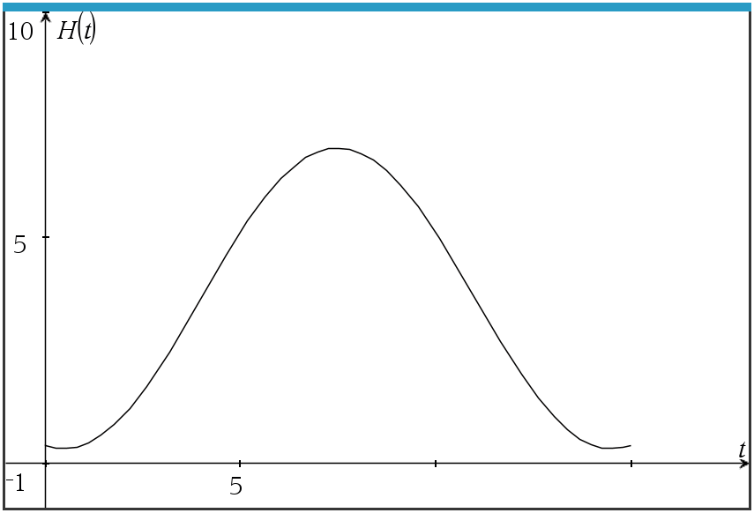

The first high tide occurs at 7:10 am and the next occurs 12 hours later. Throughout the day, the height of the water fluctuates between 6.9 ft. and 0.4 ft. All heights are given correct to one decimal place.

(a) Show that $b= \frac{π}{6}$.

(b) Find the value of a.

(c) Find the value of d.

(d) Find the smallest possible value for c.

(e) Find the height of the tide at 12:00 pm.

(f) Determine the number of hours, over a 24 hour period, that the tide is over 4 ft.

