Discriminating Against the Zero  TI-Nspire™ CX Family | Time Required  30 minutes

Activity Overview
In this introductory activity, students explore when a graph has two zeros, one zero, and no zeros. They will also determine when a graph has real, rational, irrational, or imaginary roots. The teacher should then follow up with a formal discussion on the discriminant.

Topic: Polynomial Functions
- Real and imaginary roots
- Zeros of a quadratic function
- Quadratic formula
- Discriminant

Teacher Preparation and Notes
- You may need to remind students that a solution to the equation f(x) = 0 is called a zero, or a root, of f(x). If x = a is a real solution of f(x) = 0, then the point (a, 0) is an x-intercept of the graph y= f(x).
- If time is short, Problems 1 and 2 can be done in class as a 15–20 minute activity.
- Notes for using the TI-Nspire™ Navigator™ System are included throughout the activity. The use of the Navigator System is not necessary for completion of this activity.

Associated Materials
- DiscriminatingAgainstTheZero_Student.doc
- DiscriminatingAgainstTheZero.tns
- DiscriminatingAgainstTheZero_Soln.tns

Problem 1 – Exploring Values of b and c
On page 1.3, students are to change the values of b and c for f(x) = x² + bx +c. The value of a (coefficient of x²) is set to 1 and cannot be changed for this part of the activity.  As students change the values, they are looking for when the graph has 2 zeros, 1 zero, and no zeros. They will also be looking for when the zeros are rational and irrational. Specific attention should be paid to the number under the square root of the quadratic formula (the discriminant) as they find the zeros.  If students have trouble finding functions with rational zeros or functions with just one zero, give them the following values of b and c to get them going in the right direction.  2 rational roots: b = –5, c = 6  1 rational double root: b = 2, c = 1  2 Irrational roots: b= -6, c=7  Explain to students that when a function only has one root, it is called a double or repeated root. Students should also understand that there can be 1 irrational double root, but that it cannot be achieved in this activity.  Students should see that when the graph is completely above the x-axis, the page will say no real zeros and the solutions will be imaginary.  Ask students how they would write the functions with rational roots in factored form. | 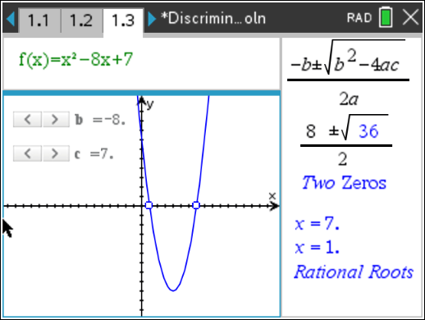  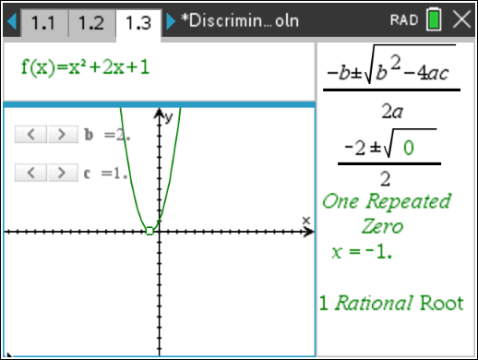  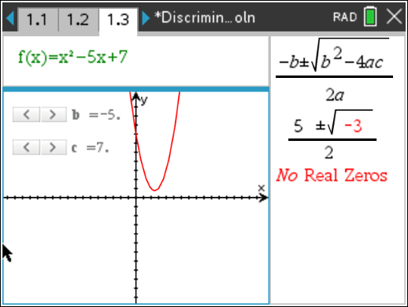  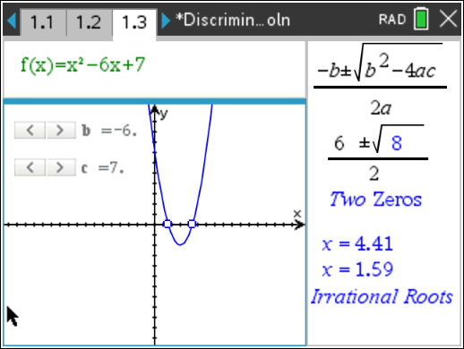
TI-Nspire Navigator Opportunity: Quick Poll
See Note 1 at the end of this lesson.

Problem 2 – The Quadratic Formula
Students will use the quadratic formula by hand to find the exact roots of two different functions. The first function has irrational roots and the second has imaginary roots. If using CAS, students can confirm the zeros of the first function.  The .tns file is in rectangular mode, meaning that when students use the quadratic formula on page 2.5, it will return a complex number (CAS is not required to complete this check). If CAS is available, students can check the values of the roots using the cZeros(expression, variable) command. | 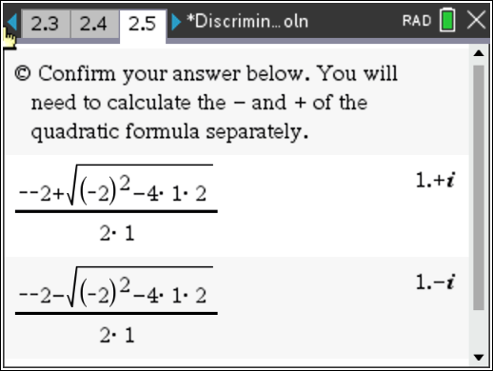
TI-Nspire Navigator Opportunity: Class Capture
See Note 2 at the end of this lesson.

Problem 3 – Exploring the Value of a
Students will now explore the graph from Problem 1 with the value of a. They should try both negative and positive values of a. The students will not be able to choose an a-value of zero.  They should see that a does not change the conclusions they came to in Problem 1. | 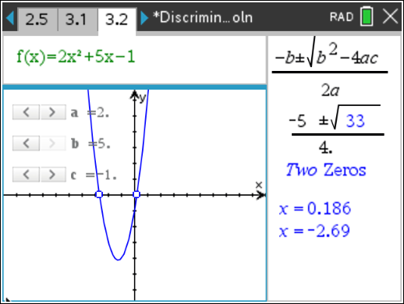
TI-Nspire Navigator Opportunity: Quick Poll
See Note 3 at the end of this lesson.
Problem 4 – Exploring Other Rational Numbers
On page 4.2, students will explore the values of a, b, and c but the values are not limited to integers. The arrows will change the values by 0.5. Remind students that repeating decimals are rational numbers. | 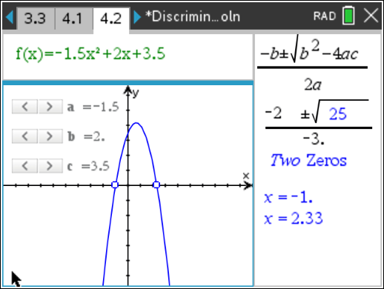

Students may think that their conclusions from Problem 1 do not apply in this case because numbers under the square root do not look like the typical perfect square. Have students convert the decimal to a fraction, and they will see that decimals that eliminate the square root are equivalent to fractions that have perfect squares in the numerator and denominator, such as
0.25 = 1 . Follow up with a formal discussion of the discriminant. 4
Practice
After students complete their investigation, follow up with a formal discussion of the discriminant.
Students can practice with problems from their book, determining the numbers and types of zeros they have by using the discriminant, or by changing the values on page 4.2.
Then, students are to use the quadratic formula to find the zeros. They can do this by hand or by using the Calculator application or the Scratchpad (»).
TI-Nspire Navigator Opportunities
Note 1
Problem 1, Quick Poll
This would be a good place to do a Quick Poll to assess student comprehension. Possible Questions:
When does the graph have 2 zeros?
When does the graph have 1 repeated zero? When does the graph have no real zeros?
When is the zero rational? When is the zero irrational? When is there no real zero?

Note 2
Problem 2, Class Capture
You may want to use Class Capture to verify that students are working through the problems on the handheld correctly.

Note 3
Problem 3, Quick Poll
You may choose to use Quick Poll to assess student understanding. The worksheet questions
can be used as a guide for possible questions to ask or ask the same questions as were asked in Problem 1.

Solutions to Student Worksheet
- 2 zeros: crosses the x-axis twice
1 zero: touches the x-axis in one place
no real zeros: does not touch the x-axis at all
- 2 zeros: number under the square root is positive 1 zero: number under the square root is equal to 0
no real zeros: number under the square root is negative
- rational: number under square root is a perfect square
irrational: number under square root is positive but not a perfect square not real: number under square root is negative
- Sample answer:
2 real, rational roots: b = –8, c = 7 2 real, irrational roots: b = 3, c = –3
1 real, double root (rational): b = –2, c = 1 no real roots: b = –5, c = 7
−3 ± 3² − 4 ⋅1⋅ −1
- x =
2 ⋅1
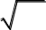
= −3 ± 13
2
−(−2) ± (−2)² − 4 ⋅1⋅ 2
- x =
2 ⋅1
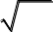
= 2 ± −4 2
= 2 ± −1⋅ 4
2
= 2 ± 2 ⋅ i
2
= 1± i
- Yes
- Yes
- 12.25, in fraction form, is 49 . Both the numerator and denominator are perfect squares.
4

