Open the TI-Nspire document Why_Bigger_is_Not_Necessarily_Better_Simulation.tns.

In this activity, you will investigate one consequence of an increase in volume of an object, which will be used to represent a single cell.

Move to page 1.2.

Did you know that the biggest cell on the planet is an ostrich egg? In contrast, most cells are FAR smaller. For example, red blood cells are only 7 or 8 MILLIONTHS of a meter in diameter, and the biggest bacterial cells are about 1/10th the size of red blood cells! Why are most cells so small? In Biology, whether you're considering tiny structures like cells, or huge animals like elephants and whales, surface area plays a key role in function and survival.
As you perform this experiment and graph the data you collect, think about how the surface area and volume of a cell affect how rapidly it can exchange materials with its environment. Also, think about the mathematical relationships that are occurring as the size of your “cell” changes. The underlying question is, “What happens to the ratio of surface area to volume as the volume increases?”

1. Follow the directions within the simulation .tns file. To watch the animation on the handheld, select Menu > Why Bigger is Not Better > Start Animation. To stop the animation, select Menu > Why Bigger is Not Better > Stop Animation.

 | Tech Tip: To watch the animation, select  > Why Bigger is Not Better > Start Animation. To stop the animation, select > Why Bigger is Not Better > Stop Animation. You may need to back-out to the main Tools Menu to see the desired menu option.
Move to pages 1.5 through 1.12.  Q1. What is the SA/V ratio when the radius is 1? |  | 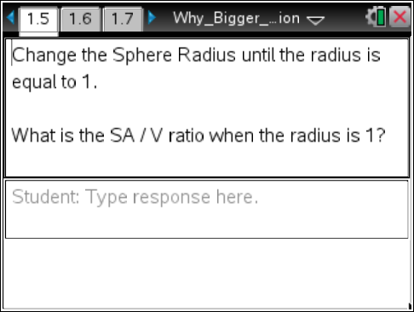
Q2. What is the SA/V ratio when the radius is 3?  Q3. What is the SA/V ratio when the radius is 5?  Q4. What is the SA/V ratio when the radius is 10? |  | 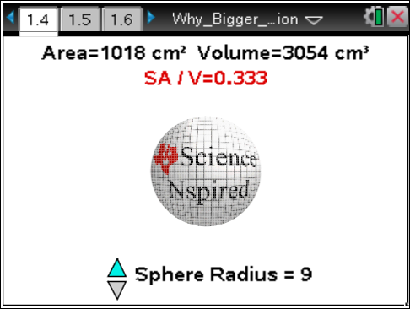
Q5. As the radius of the sphere (cell) increased, what happened to the surface area AND the volume of the sphere (cell)?
A. It increased. B. It decreased. C. It stayed the same.

Q6. If the sphere were a model for a cell, what would the "surface area" represent?
A. The nucleus B. The plasma membrane C. A ribosome D. A single cilium

Q7. As the radius of a sphere (cell) _______, the SA/V ratio of that sphere (cell) ________.
A. increases; increases B. decreases; decreases C. increases; decreases

Now, open Why_Bigger_Is_Not_Necessarily_Better_Data_Collection.tns.
Move to page 1.2.

2. Work through the data collection activity in pairs. One person needs to be the “balloon inflater,” and other needs to be the “measurer.”

3. Inflate the balloon to six different sizes, measuring each size of the balloon to the nearest centimeter.

4. In the spreadsheet on Page 1.5, enter these circumferences into rows 1 - 6 of Column A. After entering the circumference measurement, also enter a decimal point.
Tech Tip: To enter data into the spreadsheet on Page 1.5, tap a cell twice. The keyboard will appear. Enter the value and then select Enter.
Next, you’ll be graphing some of the data from the spreadsheet, so you can infer the relationship between the surface area and the volume of the balloon.
5. Page 1.7 is a Data and Statistics page. Select the horizontal axis, and select volume for your independent variable.
6. Select the vertical axis, and select sa_to_vol for your dependent variable.
7. Once you have plotted the data, determine which regression model best fits the data. To create a best fit line on the handheld, select Menu > Analyze > Regression.
 | Tech Tip: To create a best fit line, select > Analyze > Regression. Then, select the appropriate model. You may need to back-out to the main Tools Menu to see the desired menu option.
Move to pages 1.8 through 1.17.

Q8. As your balloon got bigger, what happened to the surface area?
A. It got bigger. B. It got smaller. C. It stayed the same.

Q9. As your balloon got bigger, what happened to the volume?
A. It got bigger. B. It got smaller. C. It stayed the same.

Q10. As your balloon got bigger, what happened to the SA/V ratio?
A. It got bigger. B. It got smaller. C. It stayed the same.

Q11. If you know the circumference of a circle or a sphere, how can you calculate the radius?
A. Multiply the circumference by 2π
B. Divide the circumference by 2π
C. Multiply the circumference by πr²
D. Divide the circumference by 2πr

Q12. Measurements for _______ are expressed as units², while measurements for _______ are expressed as units³.
A. volume; surface area B. surface area; volume C. surface area; diameter D. volume; radius

Q13. The formula for the SA of a sphere is 4πr². The formula for the volume of a sphere is (4/3)πr3. Plug these individual formulas into the fraction: SA/V. Then simplify the resulting fraction.

Q14. Two people are 6'3" tall. One weighs 170 pounds, while the other weighs 270 pounds. Which of these two people has a greater SA / V ratio?
A. The one weighing 170 pounds B. The one weighing 270 pounds

Q15. In really hot weather, which of the two people from the previous question would have a tougher time cooling off by getting rid of body heat?
A. The one weighing 170 pounds B. The one weighing 270 pounds

Q16. Mammals that live in the desert tend to be "lanky" with large, thin ears. Those that live in the arctic tend to be "round" shaped with very small, hair-covered ears. Why?
A. Managing body temperature is critical to survival in both environments.
B. It helps both be better camouflaged.
C. It helps them avoid predators.

