What is i?
by- Erin Chafe and Whitney Beaton

Activity overview
The purpose of our lesson is to allow students to foster an understanding of what happens geometrically when a number is multiplied by i. This shall be achieved by working through the lesson using an investigative approach.
Concepts
Complex numbers, plotting complex numbers, rotations, multiplication of complex numbers, powers of i, orientation of the complex plane

Teacher preparation
- Teacher must transfer the .tns file to the student handhelds before beginning the activity
- Teacher should make sure that students are familiar with the procedures necessary to complete the activity: button location of i, how to plot points on a graph, how to manipulate data in List & Spreadsheet, etc.
Classroom management tips
It is suggested that the .tns file is transferred to each handheld prior to the start of class. This will reduce transition time and allow the students more time to complete the activity.
Be prepared to facilitate student lead discussion about the activity. During the activity, the instructor should circulate through the classroom answering any questions that may arise.
TI-Nspire Applications
Notes, Lists & Spreadsheet, Graphs, Questions

Step-by-step analysis of the activity
Title Page – To allow students to view the objective of the lesson | 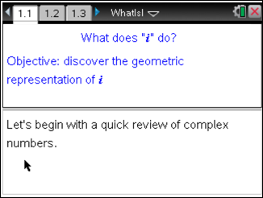
The purpose of this page is to review what students already know about the imaginary number i and its powers. | 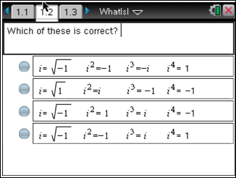
The page was included to make sure that students all have the same idea of how a complex number is represented. As a teacher, it may be useful to note for the students that bi+a is the same thing as a+bi. | 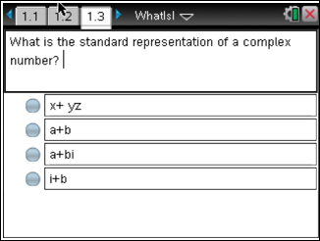
We chose to include this page so that students not only know that complex numbers have the standard form of a+bi, but also that they know that a and b are real numbers. | 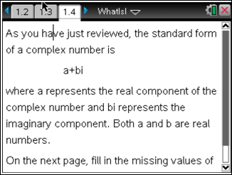
This activity page allows students to practice deciphering complex numbers and their components. Multiple versions of complex numbers have been suggested with hopes that students will come to terms with the idea that a+bi is the same as bi+a, and that it is possible for one component to have a value of 0.  The responses here should be collected and reviewed by the teacher or reviewed as a class. | 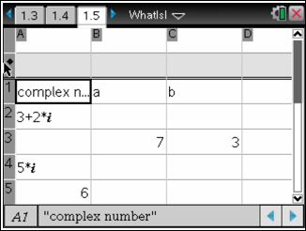
This page helps to get students thinking about how they would represent complex numbers on the coordinate plane. If they aren’t already familiar with the complex plane, the suggestions could differ from the standard orientation of the plane. | 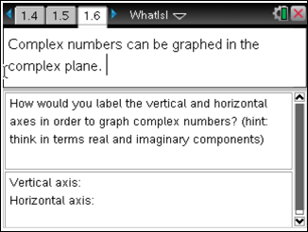
Students can use this explanation to compare their response on the previous page and to clarify what the complex plane typically looks like. | 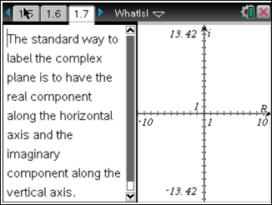
To illustrate what a complex number would look like in the complex plane, a general point has been constructed in the complex plane. | 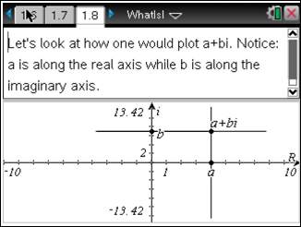
This page introduces the idea of multiplication by i, in an algebraic sense, to remind students of the general goal of the lesson. | 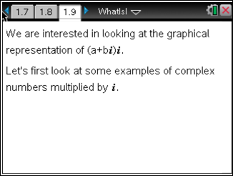
This page requires that students know how to multiply a given complex number by i. While it is the same thing as standard distribution, some students may be hung up on the notion of complex numbers as something entirely different.  These examples also challenge the students to remember how the powers of i change the values. | 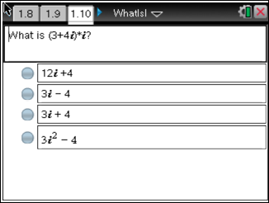
This is another example that requires the student to demonstrate knowledge of multiplication by i. | 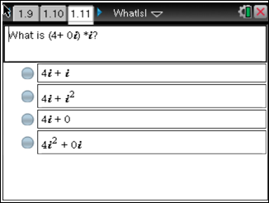
 | 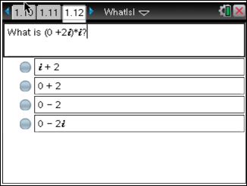
Here we have provided a general example using the standard form of complex numbers, to show the students that any complex number can be multiplied by i. | 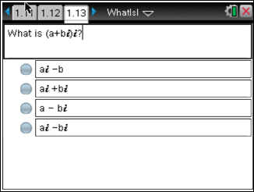
Again, we would like to focus on the geometrical interpretation of multiplication by i. This questions challenges students to think about how one complex number relates to itself when multiplied by i. | 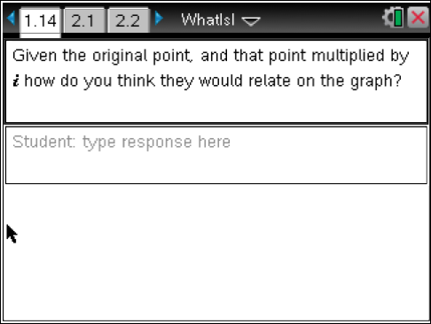
This is an instructional page directing students to explore manipulation of complex numbers by multiplication of i. As an instructor be prepared to assist student who may not be patient enough to discover that multiplying by i yields a 90° rotation. Also, if students are unable to make this connection now, there will be a similar page that will make the pattern more apparent. | 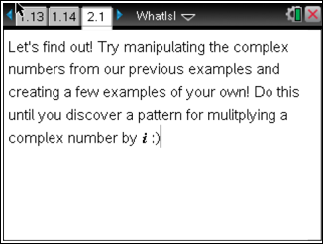
This page is intended to have students look at a complex number in relation to the same number multiplied by i. Students should focus particularly on where the points are located on the complex plane.  Even if students don’t notice the 90° rotation, have them make a conjecture on the next page. | 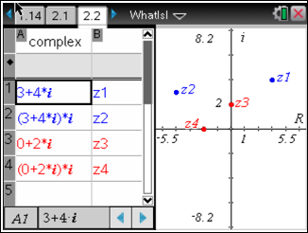
Conjecture page- Students should form a conjecture, based on what they noticed from the previous page, about multiplying by i.  Students’ responses should be collected by the instructor or review and discussed as a class. Remember students are still in the exploration stage of this lesson, so try to encourage student discussion of ideas, rather than teacher lead discussion. | 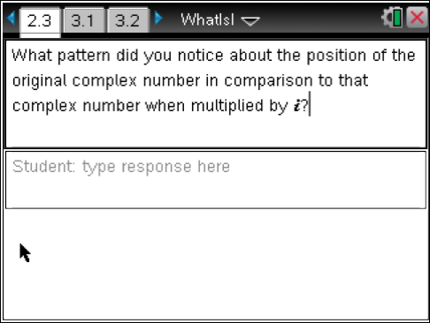
This page asks students to think about their conjecture in terms of a specific case. | 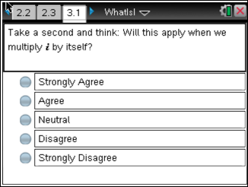
Activity page- Students will now being to test their conjecture in terms of the specific case from the previous page.  Note: Only the first four lines of the chart have been designed for students’ input, therefore to test beyond i³ students must return to cell A1 to continue entering their input.  e.g To test i⁴, students input i⁴ in cell A1. | 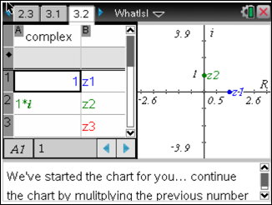
In case students have yet to discover the pattern that we have tried to illustrate throughout the various activity pages, this question is designed to make the connection between multiplying by i and a 90° rotation unmistakable.  If students get this question wrong, have them look back through the activities and think about why this answer makes sense. | 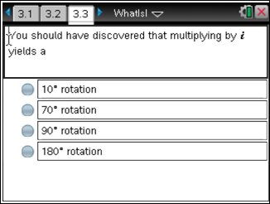
These final two pages are designed to help clarify why multiplying by i yields a 90° rotation.  This page gives an example students should have previously explored (multiplication by negative one). Instructors should be prepared to discuss this with the class. | 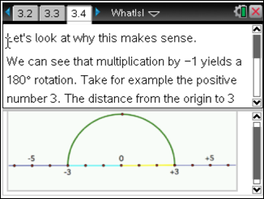
This page continues with the example from the previous page, breaking a rotation of 180° down into two rotations of 90°. This connection will help bridge the gap between multiplying by i and a 90° rotation. | 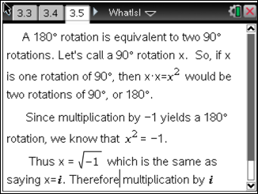

Assessment and Evaluation
- Using the discussions throughout the lesson and by collecting the completed lesson files, the instructor will be able to gauge student understanding.

