Open the TI-Nspire document Chemical_Reactions.tns.  What is similar about a fireworks explosion, a rusty nail, and a baked cake? It turns out that they are all examples of chemical reactions. Chemical reactions occur constantly in the world around us. In this activity, you will explore some of the properties of chemical reactions. |  |  | 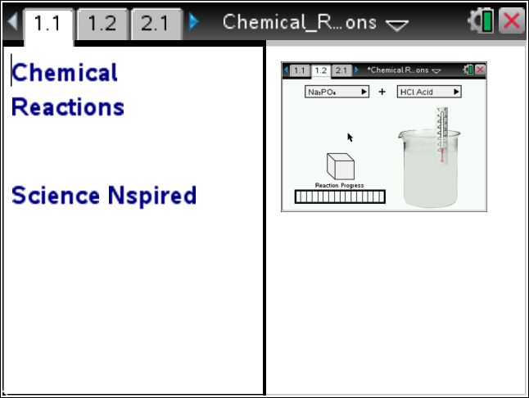
Read the background information for this activity.

A chemical reaction starts with one or more reactants, which are the initial substances in the reaction. These reactants interact with each other or the environment and undergo a chemical change. After the chemical change occurs, the reactants have turned into a product (or many products).

How can you tell when a chemical change has occurred? Over the course of a chemical change, the reactant changes into an entirely new chemical substance with a new molecular makeup. There are a variety of factors that we can use to determine whether a chemical change has occurred. Some of these factors are:

- temperature change (increase or decrease)
- color change or glow emitted from the substance
- burning or fire
- odors or sound produced
- gas produced
- precipitate (solid material) produced in a liquid solution

If a new substance is not produced in the reaction, then a physical change has occurred. Physical changes can include a change in the state or phase of the substance, or a change in the shape or appearance of the substance. Some examples of physical changes are boiling water, crushing a can, or shredding a piece of paper. In this activity, you will explore some of the factors associated with chemical reactions between a variety of solid substances and aqueous solutions. (Note: an aqueous solution is a solution of a substance dissolved into water.)
 | Move to page 1.2.  Read the instructions for the simulation.  1. In this simulation you will explore the chemical reaction between a number of solids and aqueous solutions. To begin, select “Zinc” from the first drop-down menu. Select “Water” from the second menu. Then, drag the solid cube of zinc into the beaker of water and release it. Observe the reaction that takes place and record your results in the table.  2. Repeat step 1 for each combination of solid and aqueous solutions. Be sure to record any observations from the reaction in the table. |  | 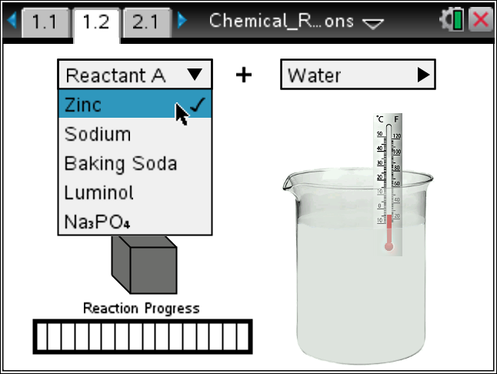  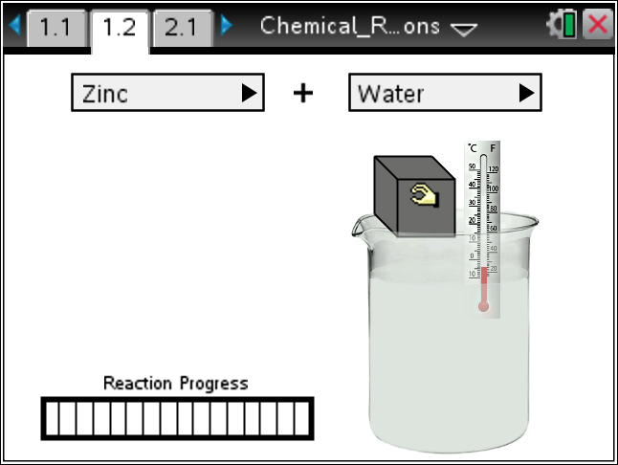
 | Tech Tip: To access the Directions again, select b or Document Tools () > Chemical Reactions > Directions.
 | Tech Tip: To access the Directions again, select > Chemical Reactions > Directions.
Solid Substance | Aqueous Solution | Chemical Reaction? (Yes/No) | Observations

Move to Pages 2.1 - 2.3. Answer questions 1 - 3 below and/or in your .tns file.
Q1. Give one example of a physical change.

Q2. Give one example of a chemical change.

Q3. List four different indicators of a chemical change that occurred in the simulation.

 | Move to Pages 3.1 - 3.2.  5. Now you will analyze and balance the chemical equations of a few of the chemical reactions that you explored in the simulation. The equations are given on Pages 3.2 - 3.8. To enter the reactants of the equation, select the dotted box to the left of the arrow. Then, enter the chemical formula for each reactant into the box. (Subscripts will be formatted automatically.) To enter the products of the equation, select the box to the right of the arrow and repeat the process.  6. Then, select the “Balance” button. Select the up and down arrows to modify the amounts of each reactant and product in the reaction. Your goal is to make sure that there are equal amounts of each element on both sides of the equation. |  | 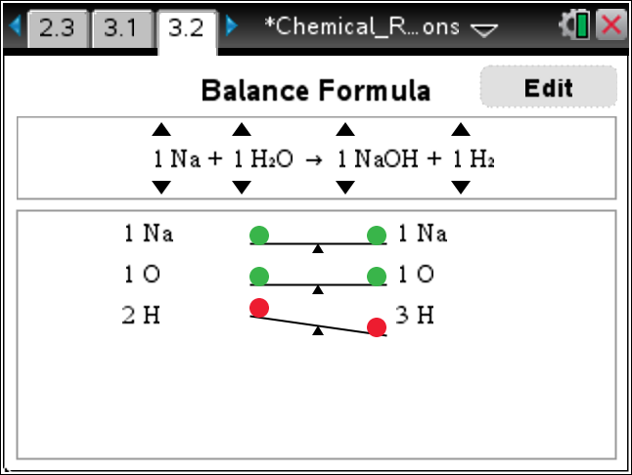
Move to Pages 3.3 - 3.6.
Answer questions 4 - 7 below and/or in your .tns file.

Q4. The reaction between zinc and HCl is given by the symbolic equation Zn + HCl ZnCl₂ + H₂. Note that H₂ is hydrogen gas. Did you observe any evidence of H₂ forming in the reaction? Explain.

Q5. Balance the equation from question 4: _____Zn + ______HCl _____ZnCl₂ + ______H₂

Q6. The reaction between sodium and water can be explosive. Based on your observations, give one reason why the container may have exploded.

Q7. The reaction between sodium and water is given by: _____Na + ______H₂O _____NaOH + ______H₂. Balance this equation.

