Math Objectives  - Students will use finite differences to find the degree of a polynomial that will fit data.  - Students will Use a polynomial function to model data.  - Students will graph functions, plot data in scatter plots, perform statistical calculations on a dataset, use simple formulas in a spreadsheet and apply them.  - Students will use appropriate tools strategically (CCSS Mathematical Practice).  Vocabulary  - common differences • constant • regression  - coefficient of determination • residual  About the Lesson  - This lesson involves plotting and analyzing data.  - As a result, students will:  - Plot data points and find a polynomial regression model.  - Find and discuss the coefficient of determination $\left(R^{2}\right)$.  - Make connections and predictions based on sample problems using the found regression models.  Teacher Preparation and Notes.  This activity is done with the use of the TI-84 family as an aid to the problems.  Activity Materials  - Compatible TI Technologies: TI-84 Plus*, TI-84 Plus Silver Edition*, TI-84 Plus C Silver Edition, TI-84 Plus CE  * with the latest operating system (2.55MP) featuring MathPrintTM _{functionality.} | 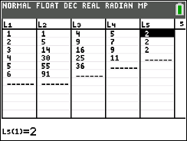  Tech Tips:  - This activity includes screen captures taken from the TI-84 Plus CE. It is also appropriate for use with the rest of the TI-84 Plus family. Slight variations to these directions may be required if using other calculator models.  - Watch for additional Tech Tips throughout the activity for the specific technology you are using.  - Access free tutorials at http://education.ti.com/calculators/pd/US/Online-Learning/Tutorials  Lesson Files:  Student Activity  Stacking_Bricks_84CE_  Student.pdf  Stacking_Bricks_84CE_  Student.doc

This activity presents a real-world situation—stacking bricks in a pile—that can be modeled by a polynomial function. Students create a small table to show how the number of bricks relates to the number of rows, then calculate the first, second, and third differences of the data to determine what degree of polynomial model to use. Next, they use the handheld's statistical calculation functions to perform the correct regression. Finally, they evaluate the model using a variety of methods: by graphing the model and the data together, by examining the value of $R^{2}$, analyzing Residual plots, and by discussing the model's applicability to the real-world situation. | 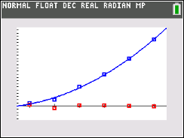

____________________________________________________________________________________

Tech Tip: If your students are using the TI-84 Plus CE have them turn on the GridLine by pressing y q to change the format settings. This activity is relying on the students being able to use both lists and regression on the handheld, therefore some time needs to be spent learning or refreshing those skills.

Problem 1 – A Flat Triangular Stack
In this problem, you are stacking bricks according to the pattern shown at the right. Each row contains one more brick than the row above it.  How many bricks will be in the stack when it is 50 rows high? |  |  |  | 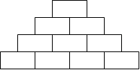
You can solve the problem easily by creating a polynomial model to describe the number of bricks in the stack, f(x), given a number of rows x.  Look for a pattern using a small table. Press … Í and enter the numbers in L1 as shown.  L1 = the number of rows in the stack  L2 = the number of bricks in the stack |  |  |  | 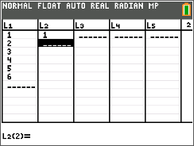
Complete list L2.  Which polynomial model should you use—linear, quadratic, cubic, or quartic?  To decide, calculate the successive differences.  Enter the first differences in L3 (by hand or by using the Delta List command on the handheld by moving your cursor to the top of L₃ and pressing 2nd stat, ops, 7: Delta List(L₂), then enter), the second differences in L4, and the third differences in L5. Record your lists at the right.
  Col A | Col B | Col C | Col D | Col E
  rows | bricks | Diff1 | Diff2 | Diff3
  1 | 1 | 2 | 1 | 0
  2 | 3 | 3 | 1 | 0
  3 | 6 | 4 | 1 | 0
  4 | 10 | 5 | 1
  5 | 15 | 6
  6 | 21
If the first differences are constant or close to constant, a first degree (linear) model is a good fit for the data. If the second differences are constant or close to constant, a second degree (quadratic) model is a good choice, and so on.

1. Which set of differences is constant?
Solution: Second Differences

2. What degree polynomial is the best fit for this data?
Solution: A second degree or quadratic polynomial

Return to the HOME screen. Use the regression command to create the model for the data.  Press …, arrow to the Calc menu, and choose appropriate Reg command. Enter L1, L2, Y1 after the command.  3. Record the equation of the model here:  Solution: $f\left(x\right)=0.5x^{2}+0.5x$ |  |  | 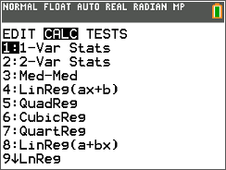
Check your model graphically by plotting the points with the model. Press y ,, select Plot1, and match the settings shown at the right.  Press q and select ZoomStat.  If the model is correct, its graph will pass through all the data points. |  |  | 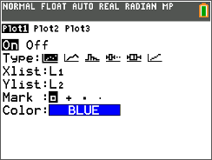
Now check your model by calculating the coefficient of determination, R². The closer the R² value is to 1, the better the model fits the data.  Press z, select ON next to STATDIAGNOSTICS, and press y 5.  Press Í to run the regression again. |  |  | 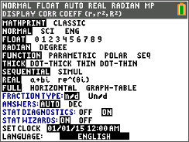
4. What is the R² value for your model? What does that mean?
Solution: $R^{2}=1$; This means that the model fits the data perfectly.
5. When you checked your model, did the function go through all the points?
Solution: Yes, the model seemed to pass through each and every point.

6. If your model is correct, use it to calculate the number of bricks in a stack 50 rows high. (Remember
that Y1(X) is the number of bricks and X is the number of rows.)
Solution: 1275 bricks
7. Discuss the shortcomings of the model for this situation. For what numbers of rows is it valid? For what numbers of rows does it not make sense?
Solution: It is valid for all whole numbered rows. The model does not make sense for
negative numbers of rows.

8. Write a domain for this model.
Solution: $\left\{x| x≥0\right\}$

Problem 2 – A Pyramidal Stack
In this problem, you are stacking bricks in pyramids.
The diagram below shows the stacks from above. | To see the pattern more clearly, the layers of the pyramids are shown separately below.
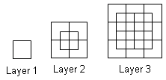 | 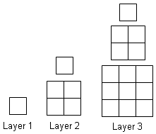
9. Use the method from Problem 1 to find the  number of bricks in a pyramid with 50 layers.  Calculate the successive differences and  record the values in the table. What do you  notice about the common differences?  Solution: The second differences are linear  and the third differences are constant.  10. Choose and perform a polynomial regression. Record it here.  Solution: $f\left(x\right)= \frac{1}{3}x^{3}+ \frac{1}{2}x^{2}+ \frac{1}{6}x$
  Col A | Col B | Col C | Col D | Col E
  rows | bricks | Diff1 | Diff2 | Diff3
  1 | 1 | 4 | 5 | 2
  2 | 5 | 9 | 7 | 2
  3 | 14 | 16 | 9 | 2
  4 | 30 | 25 | 11
  5 | 55 | 36
  6 | 91
11. Look at the R² value for the regression. What is it? What does this mean?
Solution: $R^{2}=1$; This means that the model fits the data perfectly.
12. Check your model. Graph total bricks vs. number of layers as a scatter and graph your model into Y₁. Does the model go through all the points?
Solution: Yes, the model passes through each point.

13. If your model is correct, use it to calculate the number of bricks in a pyramid 50 layers high.
Solution: 42,925 bricks

14. Discuss the shortcomings of your model for this situation. For what numbers of layers is it valid? For what numbers of layers does it not make sense?
Solution: The model is valid for all whole numbered layers of bricks. The model does not make sense for negative numbers of layers of bricks.

15. Write a domain for this model.

Solution: $\left\{x| x≥0\right\}$

Teacher Tip: In Problem 3, your class may or may not have discussed residuals. It might be a good idea to spend a little class time discussing this idea and its usefulness. Feel free to extend beyond and discuss when the values are over-estimates and under-estimates as well. Residuals are a nice connection to a Statistics class and could be used throughout any modeling activity.

Problem 3 – Extension, Beyond $R^{2}$

In this final problem, students will analyze the residuals created by the results in problem 2. A residual value is the difference between the actual value (given data) and the predicted value (value found by using the regression model). Students will examine the residual plot from problem 2’s model and discuss what they notice.

16. Go to the Data and Statistics page from Problem 2 and make sure your regression curve is still
passing through the data. Press menu, 4 Analyze, 7 Residuals, 2 Show Residual Plot. Discuss
with another student what you recognize about the residual plot. Explain what each of the values
represent.
Possible Solution: Since the residual values represent how far each data point is from the
prediction model, the residuals are indicating that they are extremely close to
the cubic model. The difference between the predicted values and the actual
values is almost zero.

17. Using the residual plot, how can you tell if the model found in Problem 2 is a good fit?

Possible Solution: When examining a residual plot, you are looking for a lack of a pattern. A lack of
a pattern means that the selected model is a good fit. For Problem 2, there is no
visible pattern, therefore this cubic model is a good fit.

Teacher Tip: If time permits, have the students go back to Problem 1 and look at the residuals for that as well and have them discuss what they see. Having them discuss and then write concise explanations is a very useful tool as they progress in mathematics.

