Playing with the Transformation Application

Here’s some timely data.

Men’s 200 m World Records from 1900-1996

Name | Year | Time (s)
Walter Tewksbury (U.S.A.) | 1900 | 22.2
Archie Hahn (U.S.A.) | 1904 | 21.6
Charles Paddock (U.S.A.) | 1921 | 20.8
Roland Locke (U.S.A.) | 1926 | 20.6
Jesse Owens (U.S.A.) | 1935 | 20.3
Melvin Patton (U.S.A.) | 1949 | 20.2
David Sime (U.S.A.) | 1956 | 20.0
Pietro Minnea (Italy) | 1979 | 19.72
Michael Johnson (U.S.A.) | 1996 | 19.32

Instructions:

1. Enter the data for the 200 m World Records into the lists in your calculator. For the years, start at 0 and then enter the number of years since 1900 for each subsequent record (i.e. 1904 would be 4; 1921 would be 21; etc...).

2. Go to your STAT PLOTS and activate Plot1.
3. Select an appropriate viewing window.
4. Observe the graph of the data.
5. Press the APPS key and select the Transfrm application. Hit . You should see this screen. | 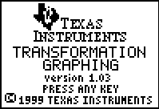
6. Press any key. The transformation graphing is running in the background. Press □ and enter the equation shown below in Y₁. | 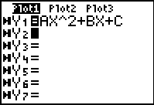
7. Now return to your graph. You might see the following graph. | 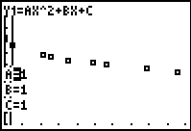
8. To change the value of one of the parameters, press  or . You can also type in the value. To move from parameter to another, press  or .
9. You can change the settings of the parameters (start values or step value) by pressing  and press  to get the SETTINGS menu.  Change the start values or step values to whatever you think. | 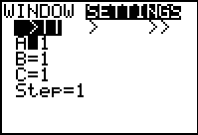
10. Once you think you have fit a curve to the given data note the values of a, b, and c. | 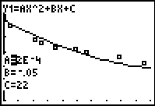
11. Perform a quadratic regression. Press , then  to get the CALC menu. Select 5: QuadReg. The QuadReg command is pasted onto the home screen. Hit . | 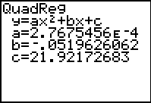
You can graph the regression equation given by the calculator and the one you derived to verify how well the curve fits the data. The transformation graphing application doesn’t allow you to graph two or more functions. You must uninstall the application by pressing APPS and selecting the Transfrm application. Select 1: Uninstall.  Now enter both equations in the Y= editor. | 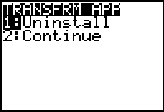  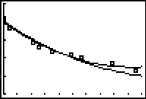

Using your model and the regression model, what will the time be in 2004? in 2100?

Does this model seem reasonable? Exlpain.

