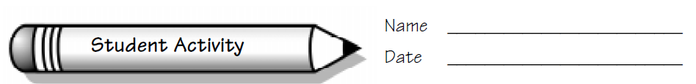
Focus: Create symmetrical designs with Pattern Blocks.
Symmetry with Pattern Blocks
Collecting and Organizing Data
Record your design below. Be sure to include your line of symmetry.

Analyzing Data and Drawing Conclusions
Half of my design is worth: _______ (my prediction) __________(actual value)
My whole design is worth: ________(my prediction) ___________(actual value)
Questions we thought of while we were doing this activity:

Symmetry with Pattern Blocks
