Part 1 – Magic Sum Part 1
Have you ever seen anyone do mental math tricks quickly and wonder how they did it? In this activity, you will learn a trick that will involve adding a list of ten numbers in a split second.

1. Fill in the following table with the numbers generated by your class.
1 | 2 | 3 | 4 | 5 | 6 | 7 | 8 | 9 | 10

2. Enter the two lists in L1 and L2. Find the sum of the numbers in the table above. On the Home screen, press ` ò ► ► and select 5:sum(. Press ` æ ) e to select L2 and carry out the command. | 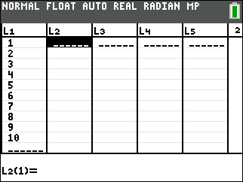
3. Was your teacher’s sum correct?

Part 2 – Magic Sum Part 2
4. Complete the table based on the rules discussed, using the numbers 7 and 5.
L1 | Each Element | Distributive Property | L2
1 | 7
2 | 5
3
4
5
6
7
8
9
10

5. In the table, how many 7s are there?

6. How many 5s are there?

7. Write the mathematical expression as: ____ × 7 + ____ × 5

8. What factor do 55 and 88 have in common?

9. Rewrite the expression as: (11)(5)(7) + (11)(8)(5) = 11(5 × 7 + 8 × 5). Verify that the expression is the same the one in Question 7. (Use your calculator to find the value of all three mathematical expressions.)
Are the expressions the same?

10. Is the number 5(7) + 8(5) in the numerically generated list in the table for Question 4? If so, what number in the list?

11. Use sum(L2) to find the sum of the numbers generated in your table. Press ` ò ► ► and select 5:sum(. Press ` æ ) e to select L2 and execute the command.  Sum =  What is the summagic rule? | 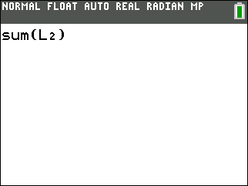
12. Work with a partner to choose your own numbers and find the sum using the summagic rule. Check your sum using sum(L2).

