Problem 1 – The Pet-Sitting Business
Suppose you and a friend want to start a pet-sitting business where you will watch your neighbors’ cats and dogs while they are on vacation. You both agree that in a given day you can safely care for no more than six animals at a time. You also mutually agree that you should care for no more dogs than you do cats. Since you love cats so much, you feel that your business should always care for at least one of these cute, furry animals.
Would caring for 3 cats and 2 dogs meet the criteria of your business plan?
One way to answer this question is to look at a graph of a system of linear inequalities that describes the constraints mentioned.  In this example, we will let x represent the number of cats and y represent the number of dogs.  The graph to the right considers all those constraints and the triangular region in the middle that was shaded three times represents the ordered pairs of x and y or the combination of cats and dogs you can watch at a given time.  Note that the ordered pair (3, 2) where the square is located represents 3 cats and 2 dogs. Since it lies within the region shaded three times, the point satisfies all three of the inequalities and thus meets the criteria of the business plan. |  | 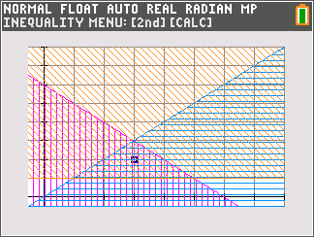
Problem 2 – Testing One Inequality
In this Problem, you will be determining if random points are solutions to inequalities. Before beginning the activity, you will need to set up the random number generator. Change the random seed using the last 4 digits of your phone number. Enter the digits, then ¿ » and arrow over to PROB and select 1:rand and press Í and then Í again to confirm.

On the next page, you are given the inequality y > –x – 2 and the coordinates of a point. Your first task is to generate random numbers in L1 and L2 as x- and y-coordinates respectively. To do this, press » and arrow over to PROB and choose 5:RandInt(. Enter the values –10, 10, and 3 afterwards as shown to the right and select Paste and press Í. |  | 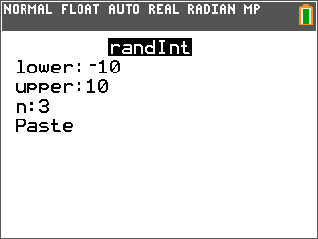
Next, repeat the process above replacing L1 with L2 to generate the y-coordinates. Press … and select Edit to see the x- and y-values in L1 and L2.

1. Using the table below, determine whether or not each point is a solution of the inequality

Point A (x, y) | y | –x – 2 | y > –x – 2 | T or F
(2, 2) | 2 | –2 – 2 | 2 > –4 | T

You can check each equation on the home screen using the y » [test] menu. You can also check the solution by graphing the inequality, tracing to the given x-value and checking to see if the y-value corresponds.  True is 1 and False is 0. |  | 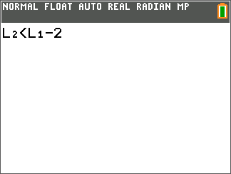
Problem 3 – Testing Two Inequalities
In this problem, you are given two inequalities, y ≤ 4 and y > –2. Again, generate random numbers in L1 (or x) and L2 (or y). Remember, True is 1 and False is 0.

2. Complete the table below. Generate coordinates until you find at least one solution to the inequality.

Point  (x, y) | Test: y ≤ 4  (T or F) | Test: y > –2  (T or F) | Final answer?  (T or F)
ex: (2, 0) | 0 ≤ 4  T | 0 ≥ –2  T | T

Problem 4 – Testing Three Inequalities
In this Problem, three inequalities intersect to form a triangular region. Again, generate random numbers in L1 and L2 (for x and y), and see if the coordinates are solutions to the system.
You can test the equations on the home screen using the list of elements instead of each individual coordinate.

You can also graph each inequality and test one of your randomly generated points by moving a free-floating cursor to approximately the location of that particular point. This can be done by simply pressing any of the arrow keys after the graph is generated. Then simply check to see if it falls inside the darkest interior shaded region. | 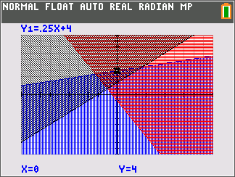
3. Complete the table below. Generate coordinates until you find at least one solution to the inequality.

Point  (x, y) | Test: y ≤ 0.25x + 4  (T or F) | Test: y ≥ –2x – 1  (T or F) | Test: y ≥ x + 2  (T or F) | Final answer?  (T or F)
ex: (2, 0) | T | T | F | F

