This activity presents a real-world situation—stacking bricks in a pile—that can be modeled by a polynomial function. Students create a small table to show how the number of bricks relates to the number of rows, then calculate the first, second, and third differences of the data to determine what degree of polynomial model to use. Next, they use the handheld's statistical calculation functions to perform the correct regression. Finally, they evaluate the model using a variety of methods: by graphing the model and the data together, by examining the value of $R^{2}$, analyzing Residual plots, and by discussing the model's applicability to the real-world situation. | 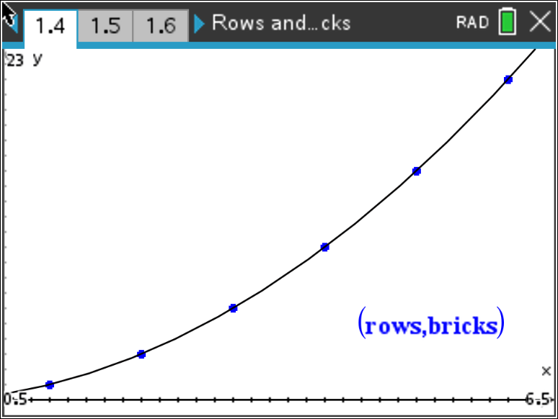

Problem 1 – A Flat Triangular Stack
In this problem, you are stacking bricks according to the pattern shown at the right. Each row contains one more brick than the row above it.  How many bricks will be in the stack when it is 50 rows high? |  |  |  | 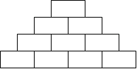
You can solve the problem easily by creating a polynomial model to describe the number of bricks in the stack, f(x), given a number of rows x.  Look for a pattern using a small table. Go to a List and Spreadsheet page, name column A rows, and enter the numbers as shown. Name column B bricks.  rows = the number of rows in the stack  bricks = the number of bricks in the stack |  |  |  | 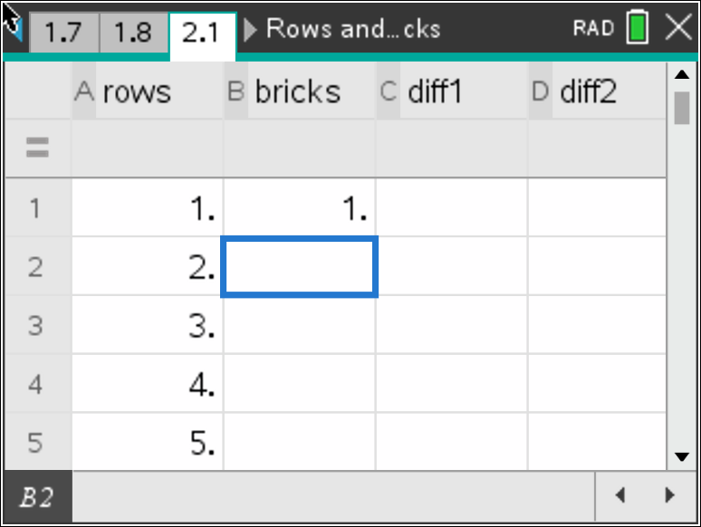
Complete column B (bricks).  Which polynomial model should you use—linear, quadratic, cubic, or quartic?  To decide, calculate the successive differences.  Enter the first differences in column C and name it diff1 (by hand or by using the Difference List command on the handheld by moving your cursor to the second row of diff1 and pressing menu, 3 Data, 7 List Operations, 2 Difference List(bricks), then enter), the second differences in column D and name it diff2, and the third differences in column E and name it diff3. Record your lists at the right.
  Col A | Col B | Col C | Col D | Col E
  rows | bricks | Diff1 | Diff2 | Diff3
  1 | 1
  2
  3
  4
  5
  6
If the first differences are constant or close to constant, a first degree (linear) model is a good fit for the data. If the second differences are constant or close to constant, a second degree (quadratic) model is a good choice, and so on.

1. Which set of differences is constant?

2. What degree polynomial is the best fit for this data?
Move your cursor to column F. Press menu, 4 Statistics, 1 Stat Calculations, and use the regression command to create the model for the data.  Press the arrow to choose the appropriate Regression command. Enter rows, bricks, for your X List and Y List respectively and store the equation into $f1$, press enter.  3. Record the equation of the model here: |  |  | 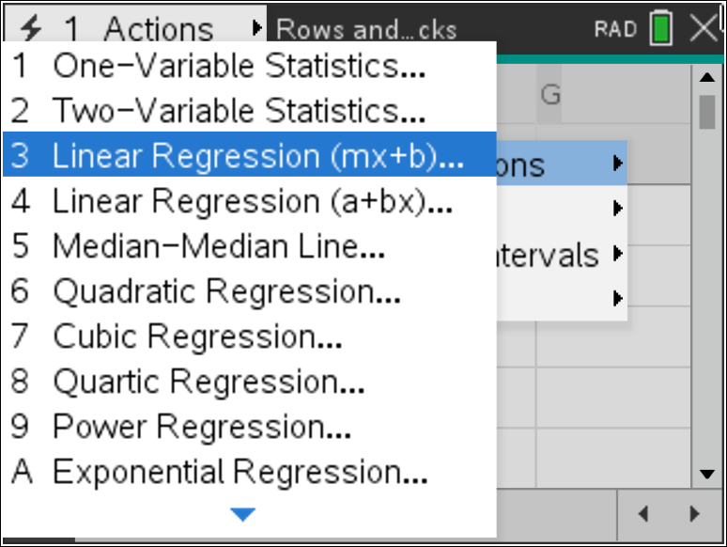
Check your model graphically by plotting the points with the model. Add a Data and Statistics page by pressing ctrl doc 5. Add rows as the horizontal variable along the bottom and bricks as the vertical variable along the left side. Press menu, 4 Analyze, 4 Plot Function, then type in $f1(x)$ enter.  If the model is correct, its graph will pass through all the data points. |  |  | 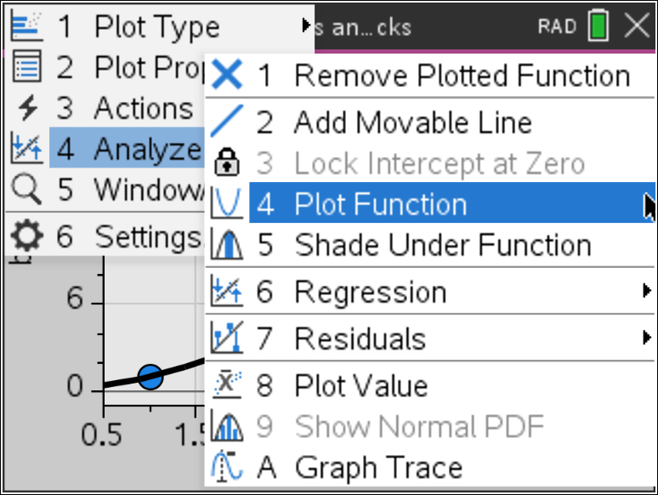
Now check your model by calculating the coefficient of determination, R². The closer the R² value is to 1, the better the model fits the data.  Press menu, 6 Settings and check the box that says Diagnostics.  If the $R^{2}$ value was not seen originally, run the regression again. |  |  | 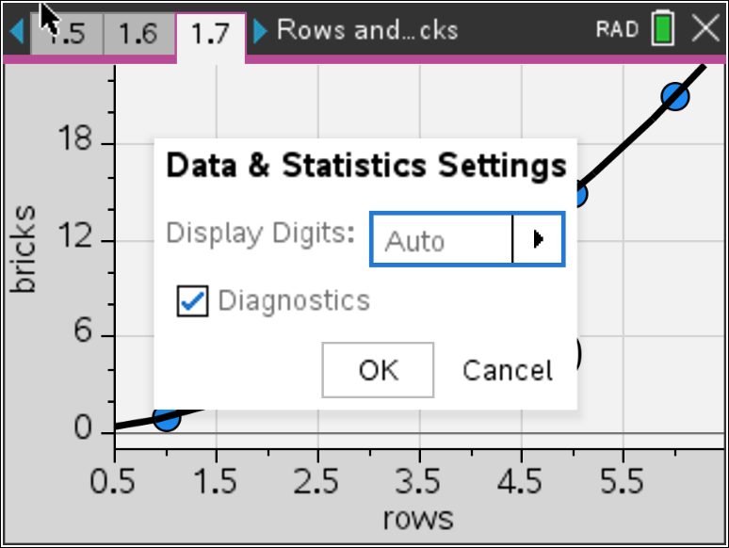
4. What is the R² value for your model? What does that mean?
5. When you checked your model, did the function go through all the points?

6. If your model is correct, use it to calculate the number of bricks in a stack 50 rows high. (Remember that $f1(x)$ is the number of bricks and $x$ is the number of rows.)

7. Discuss the shortcomings of the model for this situation. For what numbers of rows is it valid? For what numbers of rows does it not make sense?

8. Write a domain for this model.

Problem 2 – A Pyramidal Stack
In this problem, you are stacking bricks in pyramids.
The diagram below shows the stacks from above. | To see the pattern more clearly, the layers of the pyramids are shown separately below.
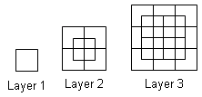 | 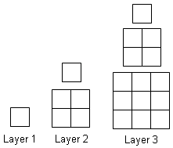
9. Use the method from Problem 1 to find the  number of bricks in a pyramid with 50 layers.  Calculate the successive differences and  record the values in the table. What do you  notice about the common differences?  10. Choose and perform a polynomial regression. Record it here.
  Col A | Col B | Col C | Col D | Col E
  rows | bricks | Diff1 | Diff2 | Diff3
  1 | 1
  2
  3
  4
  5
  6
11. Look at the R² value for the regression. What is it? What does this mean?

12. Check your model. Graph total bricks vs. number of layers as a scatter plot on a Data and Statistics page, and graph your model into $f1(x)$. Does the model go through all the points?

13. If your model is correct, use it to calculate the number of bricks in a pyramid 50 layers high.

14. Discuss the shortcomings of your model for this situation. For what numbers of layers is it valid? For what numbers of layers does it not make sense?

15. Write a domain for this model.

Problem 3 – Extension, Beyond $R^{2}$

In this final problem, students will analyze the residuals created by the results in problem 2. A residual value is the difference between the actual value (given data) and the predicted value (value found by using the regression model). Students will examine the residual plot from problem 2’s model and discuss what they notice.

16. Go to the Data and Statistics page from Problem 2 and make sure your regression curve is still passing through the data. Press menu, 4 Analyze, 7 Residuals, 2 Show Residual Plot. Discuss with another student what you recognize about the residual plot. Explain what each of the values represent.

17. Using the residual plot, how can you tell if the model found in Problem 2 is a good fit?

