Problem 1 – Infinite series
- Find the next three terms of the infinite series
a. . . . | b. . . . |  | c. . . .  Hint: Divide each of the terms by the first term. What do you notice?
2. Write an expression in terms of n that describe each of the above series
using sigma notation.

Problem 2 – Finding the sum of a geometric series
Find the sixth partial sum of two geometric series. To find the sum of a series, go to F3:Calc and select  sum.  3.  4. |  | 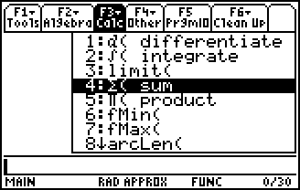

Problem 3 – Convergence and divergence of geometric Series
Use the Stats/List Editor application to display the terms of each series |  |  | 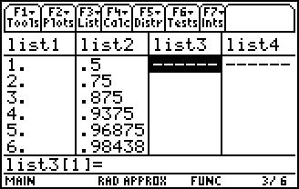
5. | 6. | 7.
Study this data. What do you notice about the terms?

Graph each of series.  Select Stats/List Editor from the Apps desktop.  In list1, enter seq(x,x,1,50). This function can be found by pressing  and scrolling down.  In list2, use ((.5)^x,x,1,list1). This will list the first 50 partial sums of the series. Repeat these steps for questions 6 and 7. |  |  |  | 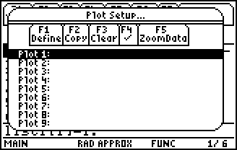
To create a scatter plot, select F2:Plots > 1:Plot Setup, then press F1 to define the graph. Select list1 for x and list2 for y, and press . To view the graph, select F5:ZoomData.
Sketch each graph below.
Decide if each geometric series converges or diverges. If the series converges, give your best guess as to its value.

