Sail Making

Sail makers use computers to create patterns for sails. After
Creating a pattern, they draw a chalk outline on the cutting floor.
After they cut out the panels of the sail, they sew them together to form the sail.

In the picture shown below, the panel seams are parallel. Find the lengths of x and y.

1.5 ft.
1.5 ft.
y
1.5 ft.
2 ft.
3 ft.
x
2 ft.

Problem Construction:

Prior to solving this problem, the relationships that exist in the sail will be explored using the Cabri Jr. application on the TI-84 plus graphing calculator. To access this application, select ❶, then you will view the following screen…

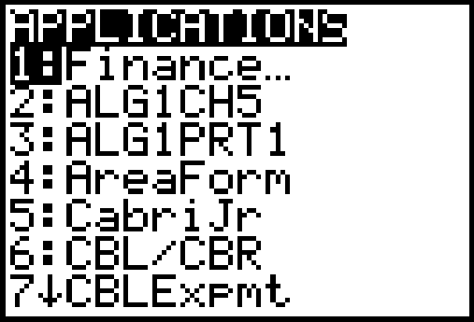

Select Cabri Jr.



Select any key and when you get into the Cabri Jr. program, select “new”.
This is accessed through the menu (□).



You will then proceed to a blank screen, where you will begin your construction of the sail figure.
To begin the sail construction, select , which also acts as the  key.

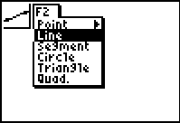

On this page, select the line tool.

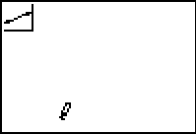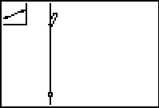

To get the vertical line segment, you need to first select a starting point by using your arrow keys to move the cursor/pencil. press  once the desired point is reached. Select another point on the line and press .

Next, the triangular sail will be completed using line segments. Again press () and select segment.

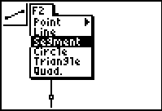

This time, a segment will be created by selecting an endpoint, pressing  and then selecting the second endpoint followed by .

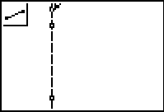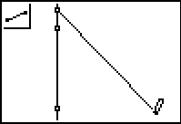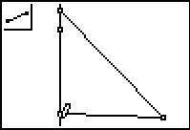

Note that the base of the triangle in the diagram is not perfectly horizontal. If you wish to fix this, press ❻ to quit the segment drawing tool and press  to bring out the “grab hand” which can grab points and move them where you wish.

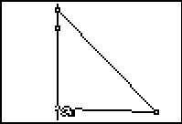

To use the hand, move it to a point until it “flashes”. Use your arrow keys to move the point as you wish.

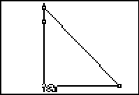

Now, create the parallel lines design. Press  () to select the line tool.

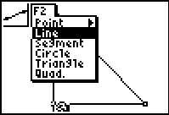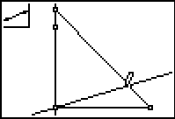

Now you need to create a line segment on top of the existing line, so using the  menu, select “segment”. This segment must extend from the sides of the triangle through the center of the triangle.
Next, we will hide the line so that only the segment is visible. Using the , or “graph” menu, select “hide/show”.

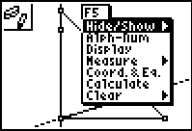

Use the arrow keys to move the cursor to the line you wish to hide. Once you reach the line it should “flash” and the cursor will turn into an eraser. Press  and the line will disappear, leaving only the desired segment once you move the cursor out of the way.

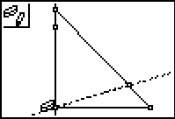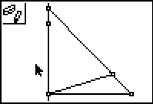

To create the remainder of the desired design, create 3 parallel lines, followed by 3 line segments overlaying each of those lines, so that the lines may be hidden, leaving only the parallel line segments in the triangle. To begin this process, select , the , button and choose “parallel”.

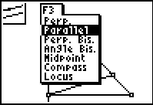

Move your cursor to select the line segment from which you want to create parallel lines. Press . Use arrow keys to move the line that appears up to the desired location. Press  when you reach the location you want.

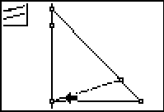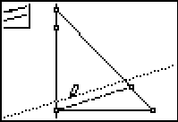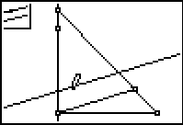

Repeat this procedure two more times for a total of 3 parallel lines.

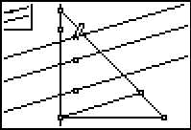

Overlay the newly created parallel lines with line segments using the segment tool under . Notice that when you approach the intersection of the triangle with a line, the line, point of intersection (if displayed on the figure), and the side of the triangle all flash. If you press  at this location, you will select that point of intersection.

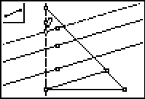

Next select hide/show under the  menu and hide the 3 parallel lines to leave behind the line segments.

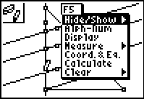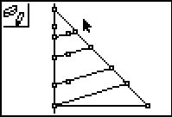

Next, we will explore the relationships involving segment lengths in the sail.

Using the , , menu, find the measure tool and use the right arrow to select distance and length.

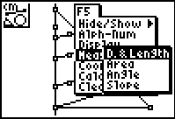

Using this tool, the lengths of the segments created by the 4 parallel line segments will be determined.
Press  and move the pencil cursor to one of the endpoints of a segment, press , then move to the other endpoint and press . A segment length will be displayed. Repeat this procedure 7 more times. When the length is determined, it appears on the screen with a “grab hand”. Use your arrow keys to move the measurements next to the appropriate line segments and press  to leave the measurement in the desired location.

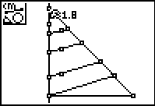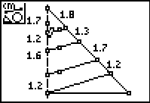

If you wish to see two decimal places rather than just one, you may press ❻ to get out of the “distance/length” tool and move the cursor to a measurement. Once it is underlined, you may select   and the additional decimal place will appear.

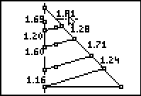

Using the “grab hand”, by moving your cursor until a point on one of the parallel line segments flashes, then pressing , you can use to move the line segments to adjust them to more “friendly” values. Press  to leave the line segment in the desired location. You may similarly use the “grab hand” to move the measurements to appropriate locations.

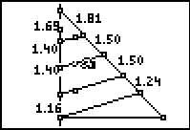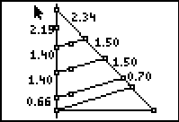

Exploration:

What relationship(s) exist with the line segments in the sail?

Test several proportional relationships using your sail! Press , , to get the calculate tool.

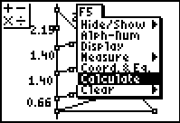

Next, select the numbers and operations desired. To check the proportional relationships of segments, use division with two separate pairs of segments. If the results are equal, the segments chosen have a proportional relationship.

Select the segment length you want for the numerator, press , then , followed by selection of the second number (the denominator). After pressing , the value of the ratio of lengths will appear with the “grab hand” so that you may move the number where you want it.

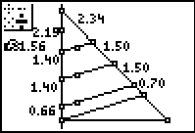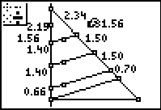

For this example, the ratio of the lengths of the upper two measured segments on the left was compared to the ratio of the lengths of the upper two segments on the right. Continue testing similar ratios in your sail. Use the space below for making note of your findings.

Test what happens when you change aspects of your diagram. Using the grab hand, try moving the lower right vertex of the triangle. What happens to the relationships you’ve observed? Try moving one or more of the parallel lines also using the grab hand. What do you find?

Generalization:

Given your observations, write an equation or equations that describe the relationship between segments a, b, c, and d. in the diagram below.

l
m
n
a
b
c
d
Equation(s):

Side-Splitter Theorem- If a line is parallel to one side of a triangle and intersects the other two sides, then it divides those sides proportionately.

Corollary- If three or more parallel lines intersect two transversals, then the segments intercepted are proportional.

Based on what you’ve observed, solve for x and y in the sail!

1.5 ft.
1.5 ft.
y
1.5 ft.
2 ft.
3 ft.
x
2 ft.

