HOW MANY SOLUTIONS?

Overview: Methods to obtain solutions to inequalities using the graphing calculator. Inequality application will be employed to graph, to determine intersections points, to find the feasible region, and as an aid in solving linear programming problems.

Solving Inequalities in One Variable
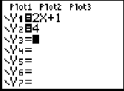
Given: 2x + 1 < 4
Method 1:
Press [y = ]
Left side of inequality is entered as y1
Right side of inequality is entered as y2

Press Graph

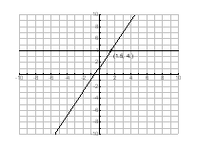
To find the x value of the intersection of the graph to the right
Press [2nd] [Trace] and select #5 [intersect]

Press [Enter] to select the equation entered under y1
Press [Enter] to select the equation entered under y2
Press [Enter] to bypass guessing the x value

Visually acknowledge where the equation of
y = 2x + 1 is less than the horizontal line of
y = 4.

ANSWER: The positive sloping line of 2x + 1 is less than y = 4 for all x values less than 1. (x<1.5)

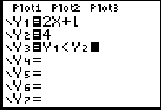
Method 2:
Repeat Steps from Method 1 to find the x value of the
intersection.

To determine the inequality
Press [y =] Under y3 enter the following to obtain
y1 < y2
[Vars][YVars] [Function] Select y1,
[2nd][Math] Select the appropriate inequality,
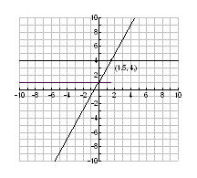
[Vars][YVars] [Function] Select y2.

Press Graph
The graph to the right will be shown which includes,
along with the functions, a graph at y = 1
revealing the x values that meet the criteria of
the inequality.

Relate to graphing on the number line.
Press [2nd][Trace][Value] and evaluate the functions y1
and y2 for the intersection point.
Note the x value.

P. Bailey 3/2005 1
Determine the y value for y3 at the intersection x value.

Students will conclude that the y value will equal 0 and
is therefore not part of the solution.
Continue evaluating y3 by selecting any x value that
meets the criteria for the given equation. The y
value will always be 1. It must have a y value of
1 before it is included as part of the solution
leading to an answer of x<1.5 .

TABLES

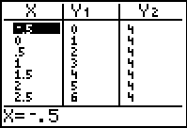
Method 1:
Given the equation 2x + 1 < 4
Press [2nd] [Graph] to view the table.
y1 = 2x + 1
y2 = 4
Looking at the table determine x values where y1 < y2.

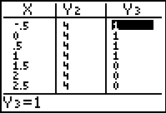
Method 2:
Enter the following equations under [y=]
y1= 2x + 1
y2 = 4
y1 < y2 (test)
Under the table note that y3 values are 0’s and 1’s.
0’s mean that the x value being evaluated is
NOT part of the solution.
1’s mean that the x value being evaluated IS part of the solution. May need to reset the table for increments to obtain
better solutions.

Solving Inequalities in Two Variables

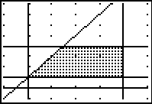
See steps detailed in the Linear Programming problem.

Answers to Systems of Inequalities have many solutions.
The solutions are all the points in the shaded region
shared by all equations in the system and is
called the feasible region.

Example of feasible region

P. Bailey 3/2005 2

