Let’s Go to the Furniture Market – Teacher Notes

Objectives:

This lesson is designed to have students use linear programming to relate this mathematical topic to the business world. Students calculate maximum profits for a furniture business to prepare for the famous, semi-annual “Furniture Market” in High Point, North Carolina. Upon completion of this lesson, students will:
- Use manipulatives to determine maximum profit in context of a real life application.
- Develop a model for profit as a function of two variables.
- Develop inequalities in two variables that represent constraints.
- Use a system of linear inequalities to locate corner points.
- Use a graphing calculator to create a visual, graphic image of the feasible region.
- Use a table to evaluate a function in two variables.

Materials:
- A total of 6 – 4 × 2 toy LEGOS® to represent table tops.
- A total of 10 – 1 × 1 toy LEGOS to represent chair backs.
- A total of 16 – 2 × 1 toy LEGOS to represent bases needed for both tabletops and chair backs.
- “Let’s Go to the Furniture Market” Student Activity
- A TI-83 Plus or TI-84 Plus graphing calculator with Inequality Graphing APPlication

Time Allowed: One 90-minute block period or two 55-minute regular periods

NCTM Standards Addressed:

Algebra:
- Understand relations and functions and select, convert flexibly among, and use various representations for them.
- Interpret representations of functions in two variables.
- Write equivalent forms of equations, inequalities, and systems of equations and solve them with fluency-mentally or with paper and pencil in simple cases using technology in all cases.
- Draw reasonable conclusions about a situation being modeled.
Geometry:
- Use Cartesian coordinates to analyze geometric situations (corner points).
Number Operations:
- Judge the reasonableness of numerical computations and their results.
Problem Solving:
- Build new mathematical knowledge through problem solving.
- Solve problems that arise in mathematics and other contexts.
- Apply and adapt a variety of appropriate strategies to solve problems.

Investigation Answers:

2. f(x, y) = 30x + 10y

3.
(Tables, Chairs)  (x, y) | Profit Function | Total Profit  f(x, y)
(0, 0) | 30(0) + 10(0) | 0
(0, 10) | 30(0) + 10(10) | 100
(3, 10) | 30(3) + 10(10) | 190
(6, 4) | 30(6) + 10(4) | 220
(6, 0) | 30(6) + 10(0) | 180

4. Tabletop constraint: $x≤6$
Chair back constraint: $y≤\text{10}$
Bases constraint: $2x+y≤\text{16}$
Non-negativity constraints: $\begin{aligned}x≥0 \\ y≥0\end{aligned}$

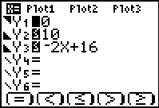
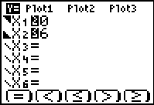
5.

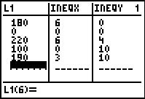
6.

Summarize your results:

1. 6 tables and 4 chairs for a maximum profit of $220.
2. Bases are needed for both tables (x) and chairs (y).
3. Because you would not produce a negative table (x) or a negative chair (y).
4. The five corner points correlate with the five constraints.
5. In the table developed by hand, possible combinations of tables and chairs were listed along with their respective profit totals. The values obtained on the calculator from corner points were the same values as developed by hand.
6. Because bases are needed to build both a table and a chair, an investment in bases would produce more profit.
Independent Practice Answers:

1. f(x, y) = 10x + 6.25y

2. Constraints:
35 hours total per week ⇒ x + y ≤ 35
Delivering furniture ⇒ 2 ≤ x ≤ 6
Counseling ⇒ 10 ≤ y ≤ 40
Non-negativity constraints: ⇒ x ≥ 0
⇒ y ≥ 0
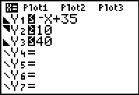
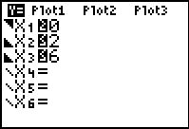
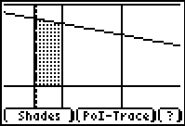
3.

4. Corner points are (6, 29), (2, 33), (6, 10), and (2, 10).

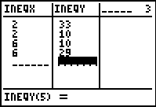
5.

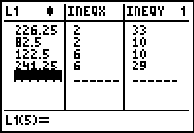
(Furniture, Counselor)  (x, y) | Maximum Earnings Function | Total Earnings  f(x, y)
(6, 29) | 10(6) + 6.25(29) | $241.25
(6, 10) | 10(6) + 6.25(10) | $122.50
(2, 33) | 10(2) + 6.25(33) | $226.25
(2, 10) | 10(2) + 6.25(10) | $82.50
6.

7. Yes

8. Nathan should work 6 hours delivering furniture and 29 hours at his counseling job for total earnings of $241.25.

9. If Nathan could work more than 35 hours per week, he should invest more hours in counseling (y).

