Time Derivatives  ID: 9536 | Name ___________________________
Time Derivatives  ID: 9536 | Class ___________________________

In this activity, you will explore:
- velocity and acceleration
- time derivatives of growth, decay, and cooling exercises
- the use of time derivatives in related rate problems
Use this document to record your answers.
Problem 1 – velocity and acceleration of position functions
A rollercoaster is on a launch system where the car is being pulled by the track and then is released at t = 11. The function s(t) = t³ – 15t² + 48t is the position or placement function for where the car is on the track (0< t<11) or in the air (11< t<15). The velocity is the change in height with respect to time. The acceleration is the change in velocity with respect to time. | 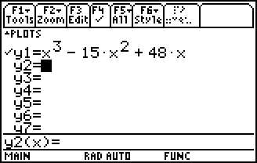
Graph the function on the calculator with [–2, 12] be the x dimensions and [–80, 80] be the y dimensions. Remember to replace t with x.
Find the first derivative, v(t), and the second derivative, a(t). Use the Derivative and Solve commands to answer the following questions.
- What is the velocity function?

- Where is the velocity positive? Negative? Zero?

- What is the acceleration function?

- Where is the acceleration positive? Negative? Constant?

The action of a boat sitting in an ocean can be modeled by the function . Sea level is at y=0 and the value s(t) is the position of the boat. The boat is on the top of a wave when y=s(t)=1and is in the trough then y=s(t)= –1. Also, the boat can be somewhere in between. The velocity is the change in the height of the boat, and acceleration is the rate of change of the velocity. | 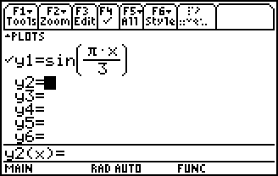
Graph this function with [–2, 12] for the x dimensions and [–3, 3] for y dimensions. Find the first derivative, v(t), and the second derivative, a(t) and answer the following questions.
- What is the velocity function?

- Where is the velocity positive? Negative? Zero?

- What is the acceleration function?

- Where is the acceleration positive? Negative? Constant?

If a ball is shot vertically upward with a velocity of 112 ft/s, then its height above the ground after t seconds is . Ground is considered s(t)=0.  - What is the maximum height? Use the fMax command to find the answer.  - When will the ball hit the ground on the way down? | 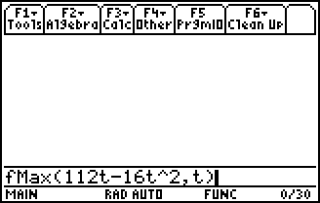
Problem 2 – Use the Chain Rule in Related Rates problems
A spherical balloon is being inflated. The radius of the balloon is increasing at a rate of 3 cm/min . How fast is the volume changing when the radius is 8 cm?
- What are the changing quantities?
The equation for the radius in terms of time is r = 3t.
- What is the value of t when r = 8 cm?
Since we want to find how fast the volume is changing we need to use the formula and then take the derivative of both sides with respect to t.
Now substitute the known values to find the rate the volume is changing when r = 8.
A stone is thrown into a lake, creating a circular ripple that travels outward at a speed of 40 cm/s. Find the rate at which the area of the circle is changing when t = 1, t = 3, and t = 5.
- What is the equation for the length of the radius at time t?
- What is the area of the ripple for any radius, r?
 | t = 1 | t = 3 | t = 5
r

Two cars leave an intersection simultaneously. One car travel east on the interstate at 75 mph. The other car travels north on a gravel road at 20 mph. How fast is the distance between the two cars changing?
- Let x equal the distance to the east.
x =
- Let y represent the distance to the north.
y =
- The distance between them is s(t). Hint: What is the distance formula?
s(t) =
s′(t) =

Problem 3 – Growth and Decay Derivatives
Growth and decay problems start with the same premise that the rate of increase is proportional to the amount present, whether the amount is increasing in the case of growth or the amount is decreasing in the case of decay.
, k > 0 for growth, k < 0 for decay

A bacteria culture initially contains 200 cells and grows at a rate proportional to its size. After an hour, the population has increased to 450.
- Use the cell count at t = 0 and t = 1 to find the value of k.
A(0) =
A(1) =
k =
- Find an expression for the number of bacteria after 3 hours.
A(3) =
- Find the rate of growth after 3 hours.
A′(3) =
- When will the population reach 50,000? Use the nsolve command to find the answer.
t =

The half-life of cesium 137 is 30 years. Suppose we have a 200 mg sample.
- Use the mass at t = 0 and t = 30 to find the value of k.
A(0) =
A(30) =
k =
- How much remains after 100 years?
A(100) =
- What is the rate of decay after 100 years?
A′(100) =
- After how long will only 1 mg remain? Use the nsolve command.
t =

Extension – Cooling derivatives
The Law of Cooling states that the change in temperature of an object is proportional to the difference in temperature (T) of an object to the temperature of the surroundings, T(sur). So,
, where c is the T–T(sur).
A cup of coffee has temperature 120° F and takes 30 minutes to cool to 100° F in a 70° F room.
- What are the values of T(0), T(sur), T(30), and k?
- What is the equation of the cooling function?
- How long will it take for the coffee to cool to 75° F?

